****

TABLE OF CONTENTS

[1. GENERAL ASSEMBLY AND COUNCILS 1](#_Toc46314833)

[1.1 GENERAL ASSEMBLY 1](#_Toc46314834)

[1.2 PERMANENT COUNCIL 1](#_Toc46314835)

[1.3 INTER-AMERICAN COUNCIL FOR INTEGRAL DEVELOPMENT (CIDI) 5](#_Toc46314836)

[2. GENERAL SECRETARIAT 8](#_Toc46314837)

[2.1 OFFICE OF THE SECRETARY GENERAL 8](#_Toc46314838)

[2.1.1 Office of Protocol 14](#_Toc46314839)

[2.2. OFFICE OF THE ASSISTANT SECRETARY GENERAL 15](#_Toc46314840)

[2.2.1 Office of the Chief of Staff of the Assistant Secretary General 15](#_Toc46314841)

[2.2.2 Department of Conferences and Meetings Management 20](#_Toc46314842)

[2.2.3 Coordinating Office for the Offices and Units of the General Secretariat in the Member States 21](#_Toc46314843)

[2.3 SECRETARIAT FOR STRENGTHENING DEMOCRACY 23](#_Toc46314844)

[2.3.1 Department of Electoral Cooperation and Observation 25](#_Toc46314845)

[2.3.2 Department of Sustainable Democracy and Special Missions (DSDSM) 29](#_Toc46314846)

[2.4 EXECUTIVE SECRETARIAT FOR INTEGRAL DEVELOPMENT (SEDI) 34](#_Toc46314847)

[2.5 SECRETARIAT FOR MULTIDIMENSIONAL SECURITY 41](#_Toc46314848)

[2.5.1 Executive Secretariat of the Inter-American Drug Abuse Control Commission (CICAD) 41](#_Toc46314849)

[2.5.2 Secretariat of the Inter-American Committee against Terrorism (CICTE) 43](#_Toc46314850)

[2.5.3 Department of Public Security (DPS) 46](#_Toc46314851)

[2.5.4 Department against Transnational Organized Transnational (DTOC) 47](#_Toc46314852)

[2.6 SECRETARIAT FOR ADMINISTRATION AND FINANCE 50](#_Toc46314853)

[2.6.1 Department of Human Resources (DHR) 51](#_Toc46314854)

[2.6.2 Department of Financial Services (DFS) 54](#_Toc46314855)

[2.6.3 Department of Information and Technology Services (DOITS) 55](#_Toc46314856)

[2.6.4 Department of Procurement Services 57](#_Toc46314857)

[2.6.5 Department of General Services (DGS) 58](#_Toc46314858)

[2.7 SECRETARIAT FOR LEGAL AFFAIRS 60](#_Toc46314859)

[2.7.1 Department of International Law (DIL) 61](#_Toc46314860)

[2.7.2 Department of Legal Cooperation (DLC) 62](#_Toc46314861)

[2.7.3 Department of Legal Services (DLS) 62](#_Toc46314862)

[2.8 SECRETARIAT FOR ACCESS TO RIGHTS AND EQUITY 63](#_Toc46314863)

[2.8.1 Department of Social Inclusion 64](#_Toc46314864)

[2.9 SECRETARIAT FOR HEMISPHERIC AFFAIRS 69](#_Toc46314865)

[2.9.1 Department of Effective Public Management (DEPM) 71](#_Toc46314866)

[2.9.2 Summits of the Americas Secretariat 74](#_Toc46314867)

[2.9.3 Department of Strategic Initiatives and Public Diplomacy 77](#_Toc46314868)

[2.10 OFFICE OF THE STRATEGIC COUNSEL FOR ORGANIZATIONAL DEVELOPMENT AND MANAGEMENT FOR RESULTS 81](#_Toc46314869)

[2.10.1 Department of Planning and Evaluation 82](#_Toc46314870)

[2.10. 2 Department of External and Institutional Relations (DEIR) 86](#_Toc46314871)

[2.10.3 Department of Press and Communication 88](#_Toc46314872)

[3. AUTONOMOUS ENTITIES AND ORGANIZATIONS 93](#_Toc46314873)

[3.1 SECRETARIAT OF THE INTER-AMERICAN COURT OF HUMAN RIGHTS 93](#_Toc46314874)

[3.2 EXECUTIVE SECRETARIAT OF THE INTER-AMERICAN COMMISSION ON HUMAN RIGHTS (IACHR) 96](#_Toc46314875)

[3.3 SECRETARIAT OF THE ADMINISTRATIVE TRIBUNAL 98](#_Toc46314876)

[3.4 INTER-AMERICAN CHILDREN’S INSTITUTE 100](#_Toc46314877)

[3.5 EXECUTIVE SECRETARIAT OF THE INTER-AMERICAN COMMISSION OF WOMEN (CIM) 102](#_Toc46314878)

[3.6 SECRETARIAT OF THE INTER-AMERICAN TELECOMMUNICATION COMMISSION (CITEL) 104](#_Toc46314879)

[3.7 OFFICE OF THE INSPECTOR GENERAL 106](#_Toc46314880)

[3.8 OFFICE OF THE OMBUDSPERSON 107](#_Toc46314881)

[3.9 BOARD OF EXTERNAL AUDITORS 108](#_Toc46314882)

[4. SPECIALIZED ENTITIES AND ORGANIZATIONS 110](#_Toc46314883)

[4.1 INTER-AMERICAN DEFENSE BOARD 110](#_Toc46314884)

[4.2 INTER-AMERICAN INSTITUTE FOR COOPERATION ON AGRICULTURE(IICA) 113](#_Toc46314885)

[4.3 INTER-AMERICAN JURIDICAL COMMITTEE (CJI) 115](#_Toc46314886)

[4.4 PAN AMERICAN HEALTH ORGANIZATION (PAHO) 116](#_Toc46314887)

[4.5 PAN AMERICAN INSTITUTE OF GEOGRAPHY AND HISTORY (PAIGH) 120](#_Toc46314888)

[5. ACTIVITIES OF THE SECRETARY GENERAL AND ASSISTANT SECRETARY GENERAL AWAY FROM HEADQUARTERS 122](#_Toc46314889)

[5.1 ACTIVITIES OF THE SECRETARY GENERAL AWAY FROM HEADQUARTERS 122](#_Toc46314890)

[5.2 ACTIVITIES OF THE ASSISTANT SECRETARY GENERAL AWAY FROM HEADQUARTERS 126](#_Toc46314891)

[6. APPENDICES 133](#_Toc46314892)

[APPENDIX A: ORGANIZATIONAL CHART 133](#_Toc46314893)

[APPENDIX B: FINANCIAL STATEMENTS 135](#_Toc46314895)

1. GENERAL ASSEMBLY AND COUNCILS

* 1. **GENERAL ASSEMBLY**

**General Assembly**

* **Forty-ninth Regular Session of the General Assembly**

The forty-ninth regular session of the General Assembly was held in Medellín, Colombia, from June 26 to 28, 2019. The Assembly adopted four declarations and 15 resolutions on topics including: Commemoration of fifteen years of the Mission to Support the Peace Process in Colombia; The threat of terrorist groups to international security and the full enjoyment of human rights; Effective participation of Indigenous peoples and people of African descent in the activities of the Organization of American States; Hemispheric efforts to combat the use of mobile terminal devices that have been stolen, lost, or tampered with; Leading role of the Organization in developing telecommunications/information and communication technologies through the Inter-American Telecommunication Commission; Increasing and strengthening the participation of civil society and social actors in the activities of the Organization of American States and in the Summits of the Americas process; Strengthening the organs, agencies, entities, initiatives, and mechanisms of the OAS; Strengthening democracy; Advancing hemispheric security: A multidimensional approach; Final report of the working group to prepare an institutional strengthening proposal for the Organization of American States; Promotion and protection of human rights; Strengthening ethics, oversight, and transparency in the Organization of American States; Resolution on the situation in Nicaragua; The situation of Venezuela and the Venezuelan migrant crisis; and International law.

This session of the General Assembly also decided to adopt the 2020 Program-Budget of the Organization.

* 1. **PERMANENT COUNCIL**
* **Chairs and Vice Chairs**

Listed below are the officers of the Permanent Council in 2019:

January to March

Chair: Ambassador Carlos Alberto Calles Castillo, El Salvador

Vice Chair: Ambassador Alejandro Ordóñez Maldonado, Colombia

April to June

Chair: Ambassador Carlos Trujillo, United States of America

Vice Chair: Ambassador Hernán Salina, Chile

July to September

Chair: Ambassador Yolande Yvonne Smith, Grenada

Vice Chair: Ambassador Jennifer May Loten, Canada

October to December:

Chair: Ambassador Rita Claverie De Sciolli, Guatemala

Vice Chair: Ambassador Fernando Simas Magalhães, Brazil

* **Declarations and resolutions**

Between January and December 2019, the Council and its subsidiary organs held some 200 formal and informal meetings. <http://www.oas.org/en/council/>

The Permanent Council adopted 2 declarations and 26 resolutions, the full texts of which are available on its website <http://www.oas.org/en/council/CP/documentation/res_decs>

* **Topics**

Below are some of the topics addressed by the Permanent Council in its meetings during the year:

* Protocolary matters
* Administrative and budgetary matters
* Parliamentary procedures
* The situation in the Bolivarian Republic of Venezuela
* The situation in Nicaragua
* Electoral observation missions
* 27th anniversary of the peace accords in El Salvador
* International Women’s Day
* Strengthening the nexus between science and policies for effective cooperation in integrated water resources management
* Vulnerability and resilience: a crosscutting approach (Climate change)
* Remembering slavery: Power of the arts for justice
* International Day for the Right to the Truth Concerning Gross Human Rights Violations and for the Dignity of Victims
* Dialogue with the permanent observers on cooperation, information exchange, and promotion of partnerships
* Community of Democracies
* International Day Against Homophobia, Transphobia and Biphobia
* Strengthening regional coordination in response to the impacts of forced displacement
* Progress on efforts to advance international religious freedom
* Commemoration of the birth of Liberator Simón Bolívar
* Commemoration of Inter-American Week for Indigenous Peoples and International Year of Indigenous Languages
* Challenges posed by drug trafficking to democratic institutions
* Convocation of the Organ of Consultation of the Inter-American Treaty of Reciprocal Assistance
* Anniversary of the creation and installation of the Inter-American Commission on Human Rights
* Encounter of Two Worlds
* Mission to Support the Peace Process in Colombia
* The importance of multi-sectoral action to deal with non-communicable diseases effectively
* Cooperation among the International Consortium for Higher Education, Civic Responsibility and Democracy, the Council of Europe, and the Organization of American States
* Prevention and eradication of violence against women
* Fiftieth anniversary of the adoption of the American Convention on Human Rights (Pact of San José, Costa Rica) and the Fortieth anniversary of the installation of the Inter-American Court of Human Rights in San José, Costa Rica
* International Day of Persons with Disabilities
* Consideration of the proposed Strategic Plan 2020-2021
* International Day against Corruption
* **Presentations**

The Secretary General and the Assistant Secretary General addressed the Permanent Council on several occasions to report on a variety of matters on the Organization’s agenda.

The Permanent Council received the following reports:

* Electoral observation missions conducted in Ecuador, Costa Rica, Grenada, Paraguay, Brazil, Colombia, and El Salvador.
* Mission to Support the Fight Against Corruption and Impunity in Honduras (MACCIH-OAS)
* Mission to Support the Peace Process in Colombia (MAPP/OAS)
* **Visits to the Permanent Council**

During its regular and special meetings, the Permanent Council received the following visits: President of the Republic of Colombia, His Excellency Iván Duque Márquez; President of Honduras, His Excellency Juan Orlando Hernández Alvarado; President of Ecuador, His Excellency Lenin Moreno Garcés; Her Excellency Epsy Campbell Barr, Vice President of Costa Rica; His Excellency Wilfred Elrington, Minister of Foreign Affairs of Belize; Her Excellency Sandra Jovel Polanco, Minister of Foreign Affairs of Guatemala; His Excellency Diego Pary, Minister of Foreign Affairs, Plurinational State of Bolivia; His Excellency Carlos Holmes Trujillo García, Minister of Foreign Affairs of Colombia; Minister of Foreign Affairs and Human Mobility of Ecuador, Ambassador José Valencia; Minister for Foreign and CARICOM Affairs of the Commonwealth of Dominica, H.E. Francine Baron; Minister of Foreign Affairs of Chile, H.E. Teodoro Ribera; H.E. Manuel Ventura Robles, Minister of Foreign Affairs and Worship of Costa Rica; Hon. Ancelma Perlacios Peralta, Senator, Plurinational State of Bolivia; Ms. Petita Ayarza, Representative of the National Assembly of Panama; President of the Inter-American Court of Human Rights, Judge Eduardo Ferrer Mac-Gregor; Vice Minister for Multilateral Affairs of Colombia, Adriana Mejía Hernández; Hon. Carmen Vásquez, Minister of Culture, Colombia; Ms. Sandra Terena, Secretary for Policies for the Promotion of Racial Equality, Brazil; Mr. Saúl Vicente Vázquez, head of the International Affairs Office of the National Institute of Indigenous Peoples and People of African Descent (INTI); Minister of Justice and Institutional Transparency of the Plurinational State of Bolivia, Dr. Héctor Arce Zaconeta; His Excellency Danilo Türk, Former President of Slovenia and Chairman of the Global High-Level Panel on Water and Peace; Ms. Francesca Bernardini, Secretary of the Convention on the protection and use of cross-border waterways and international lakes; Mr. François Muenger, Director of UN Water Hub for Cooperation; Mr. Marcos Regis da Silva, Executive Director of the Institute for Global Change Research (IAI); Brigadier General DEM and Chairman of the Council of Delegates of the Inter-American Defense Board, Luis Rodríguez Bucio; Founder and President of Burned Children Foundation (COANIQUEM), Dr. Jorge Rojas Zegers; Ms. Lisa Viscidi, Director of Inter-American Dialogue’s Energy, Climate Change, and Extractive Industries Program; Ms. Johanna Mendelson Forman, Distinguished fellow of the Stimson Center; Ms. Moises Rendon, Associate Director and Associate Member, CSIS Program; Mr. José Pallais, former Vice Minister of Foreign Affairs of Nicaragua; Mr. Rubén Perina – Adjunct Professor, George Washington University; Mr. Harold Rocha - President, Nicaraguan-American Center for Democracy; former consulting professor and fellow/visiting professor, University of Iowa Faculty of Law; Ms. Haydee Castillo Flores, President of the Leadership Institute of Las Segovias and of the Women’s Forum for Central American and Caribbean Integration; member of the Blue and White National Unity Policy Council (Nicaragua); Mr. Jaime Aparicio, former Chair of the Inter-American Juridical Committee, former chief of the Electoral Mission in Nicaragua (Carter Center); Ms. Daphne Pellegrino, Reporter Without Borders (RSF); Mr. Carlos Alberto Patiño, Professor, Universidad Nacional de Colombia; Ms. Maria Werlau, Executive Director, Cuba Archive; Mr. Vladimir Rouvinski, Professor, ICESI, Cali, Colombia; Mr. José Gustavo Arocha; Mr. Thomas E. Garrett, Secretary General, Community of Democracies; Ambassador Piotr Wilczek, Ambassador of Poland to the United States; Capt. William Scouten, USNAVSO/IV United States Fourth Fleet; Ambassador at Large for International Religious Freedom, Sam Brownback; Ms. María Soledad Cisternas, United Nations Secretary-General’s Special Envoy on Disability and Accessibility; Executive Director of World Jewish Congress, Ms. Betty Ehrenberg; Ms. Valentina Ballesta, Amnesty International; Ms. Tamara Taraciuk Broner, Human Rights Watch; Ms. Tamara Suju, Executive Director of the CASLA Institute; Mr. Juan Gregorio Regino, Director General of the National Indigenous Languages Institute (INALI); Ms. Esther Kuisch-Laroche, Director and Representative, UNESCO Office for Central America; Mr. Luis Felipe Duchicela, Indigenous Affairs Expert, former advisor to the President of Ecuador and Principal Advisor on issues related to Indigenous peoples, United States Agency for International Development (USAID); Ms. Patricia Velásquez, OAS Goodwill Ambassador for the Rights of Indigenous Peoples; Dr. Eric Patterson, Executive Vice President, Religious Freedom Institute; Dr. Anselm Hennis, Director, Noncommunicable Diseases and Mental Health Department, PAHO/WHO; Dr. Fabio Da Silva Gomes, Nutrition and Physical Activity Advisor, Risk Factors and Nutrition Unit, Noncommunicable Diseases and Mental Health Department, PAHO/WHO; Ira Harkavy, Associate Vice Chair and founding Director of the University of Pennsylvania’s “Barbara and Edward Netter Center for Community Partnerships,” President of the Uruguay Chamber of LGBTI Commerce and Business; Ms. Bianca Jagger, Bianca Jagger Human Rights Foundation; Mr. Manuel Orozco, Inter-American Dialogue; Mr. Roberto Courtney, Executive Director of Ethics and Transparency; Mr. Edwin Carcache; Ms. Susana López Gutiérrez; Ms. Verónica Ordóñez Obando; José Thompson J, Executive Director of the Inter-American Institute of Human Rights; Judge Thomas Buergenthal; Ms. Ann Cody, Special Advisor for International Disability Rights; US State Department’s Office of Democracy, Human Rights, and Labor; Mr. Anderson Sant’Anna, Chair of the Committee for the Elimination of All Forms of Discrimination against Persons with Disabilities (CEDDIS); Mr. Javier Vázquez, Principal Advisor to the United Nations Secretary-General’s Special Envoy for Disabilities and Rehabilitation; Vice President of the ONCE Foundation, Ms. Patricia Sanz; Former President of Bolivia, Delegate to the International Community, H.E. Jorge Quiroga Ramírez; Mr. Gualberto Cusi, former magistrate of the Plurinational Constitutional Court; Ms. Jheanisse Daza, representative of the *Ríos a Pie* Organization; Mr. Álvaro Andrade, elections technology expert.

## 1.3 INTER-AMERICAN COUNCIL FOR INTEGRAL DEVELOPMENT (CIDI)

2019 Officers:

|  |  |  |
| --- | --- | --- |
| January-June | Chair | Ambassador Yolande Yvonne Smith, Permanent Representative of Grenada |
| Vice Chair | Ambassador Denis R. Moncada, Permanent Representative of Nicaragua |
| July-December | Chair | Ambassador Rita Claverie de Sciolli, Permanent Representative of Guatemala |
| Vice Chair | Ambassador Luz Elena Baños Rivas, Permanent Representative of Mexico |

In 2019, CIDI continued to deepen its substantive dialogue and to address strategic issues of interest to the member states and in preparation for the sectoral meetings of ministers and high-level authorities held within its purview. The chairs of CIDI held regular coordination meetings with the officers of its subsidiary bodies. At the regular meetings of CIDI, the topics proposed by its chairs were discussed and each session was attended by experts.

At regular meetings during the same period, the member states discussed and exchanged experiences on the following topics:

* Innovative and sustainable financing for resilience building for sustainable development CIDI/INF.304/19 rev. 2
* Allocation of resources in 2019 for the OAS Scholarship and Training Programs, which began to streamline the programs for transitioning to a sustainable and cost-efficient scholarship program, based on an IACD Management Board decision
* Building the resilient economies of the future: Blue, Green, and Orange Economies CIDI/INF.310/19
* Public-private partnerships and digitization of micro, small, and medium-sized enterprises CIDI/INF.318/19 corr. 1
* De-carbonizing development in the Americas: CIDI/INF.324/19
* Competitiveness: CIDI/INF.331/19
* Childhood malnutrition: Adequate food as a right and sustainable goal, the current scenario, and challenges posed by food insecurity in the region: CIDI/INF.333/19
* The water and sanitation crisis and its effects on human health: CIDI/INF.335/19

CIDI held joint meetings with the Permanent Council to consider the following issues:

* The importance of multilateral action to deal with non-communicable diseases effectively (NCDs)
* Strengthening the nexus between science and policies for effective cooperation in integrated water resources management

At its August 27, 2019 meeting, CIDI received the Minister of Foreign Affairs of Guatemala, Ambassador Sandra Jovel Polanco.

The following CIDI ministerial-level sectoral meetings were held:

* The IV Meeting of Ministers and High Authorities of Social Development, held March 28 and 29, 2019 in Guatemala City, Guatemala. Delegations from 24 member states participated at the highest level. The ministers adopted the Inter-American Declaration of Social Development Priorities and the 2019-2021 Plan of Action of Guatemala, the latter including concrete steps on such issues as multidimensional poverty, strengthening social protection systems, and promotion of regional cooperation.
* The Tenth Inter-American Meeting of Ministers of Education, held July 8 and 9, 2019, in Washington, D.C., adopted the Plan of Action of Antigua and Barbuda: (CIDI/RME/doc.6/19 [Spanish](http://scm.oas.org/IDMS/Redirectpage.aspx?class=V.13.1%20CIDI/RME/doc&classNum=3&lang=s) – [English](http://scm.oas.org/IDMS/Redirectpage.aspx?class=V.13.1%20CIDI/RME/doc&classNum=6&lang=e)). The Meeting focused on: sharing concrete initiatives for implementing the Inter-American Education Agenda; deepening synergies among global, hemispheric, and sub-regional education initiatives; and promoting inter-sector cooperation with other social actors in order to help achieve the goals set forth in the 2030 Agenda for Sustainable Development.
* The Eighth Inter-American Meeting of Ministers of Culture and Highest Appropriate Authorities, held in Bridgetown, Barbados, September 19 and 20, 2019. It brought together ministers and high-level officials from 22 member states, and the discussions focused on "Strengthening the creative economy and the cultural sector: reorienting the cultural sector to strengthen sustainable development." <http://www.oas.org/en/sedi/desd/imc/2019/>

To support of the ministerial processes and prepare for ministerial-level meetings, the following sectoral events were held:

* Meeting of the Working Groups of the Twentieth Inter-American Conference of Ministers of Labor, December 3 to 5, 2019, in Quito, Ecuador, bringing together delegations from 20 ministries of labor, worker and employer representatives, and ILO, World Bank, IOM, OAS, and CIM experts, to discuss and share experiences about priority issues in labor administration, such as the economics of platforms, gender equity, inclusion of vulnerable populations in the labor force, labor mobility, and prevention and eradication of child labor, etc.
* Intersectoral Workshop "The skills of the future: Contributions from the Ministries of Education and Labor,” May 16 to 17, 2019 in Santiago, Chile. It brought together education and/or labor ministry technicians from 18 member states, representatives of international organizations, academia, worker and employer representatives, and the private sector including Google, Fundación Telefónica, Nestlé, and Ford.

The Inter-American Agency for Cooperation and Development (IACD), meanwhile, held the:

* Technical Meeting on Cooperation for Development, as a follow-up to the Second CIDI Specialized Meeting of High-Level Cooperation Authorities, held October 31 to November 1, 2019, in Washington, D.C., to consider, *inter alia*, the role of the IACD in development cooperation; the Inter-American Cooperation Network (CooperaNet); evaluating the effectiveness of the Development Cooperation Fund (DCF), and aligning ministerial processes with cooperation.

The following activities were carried out in other sectors that support CIDI's sectoral work:

* The first Prospecta Americas Regional Seminar held in Lima, Peru, to improve the social appropriation of knowledge and build a platform for regional collaboration in 10 transformative technologies. It brought together more than 1,000 participants onsite and more than 20,000 virtually.
* Inter-American Competitiveness Network: 78 good practices by innovation hubs, advanced research, manufacturing, and technology centers shared among 79 decision-makers from 22 countries for the two [Americas Competitiveness Exchanges (ACE)](http://riacevents.org/ace/) held in 2019 (Puerto Rico, United States, and Chile).
* Launch of the MSME Digitalization Initiative, in association with the KOLAU digital platform, which will digitize more than 450,000 MSMEs in Latin America and the Caribbean over the next three years.
* In the sustainable development sector, programs on disaster risk management, integrated water resources management, and energy continue to support the member states’ efforts to combat disaster challenges, water management, and adaptation to new anti-poverty technologies.

CIDI’s day-to-day work was pursued through the Committee on Partnership for Development Policies, the Committee on Migration Issues (CAM), and the Committee on Program-Budget and Evaluation. All official CIDI documents, including the reports from its meetings and the extensive report to the General Assembly, are on the CIDI website [www.oas.org/en/cidi](http://www.oas.org/en/cidi)

**2. GENERAL SECRETARIAT**

**2.1 OFFICE OF THE SECRETARY GENERAL**

During 2019, Secretary General Luis Almagro redoubled his efforts to defend and promote the principles and values of the Charter of the Organization of American States, of the Inter-American Democratic Charter, and of the inter-American human rights system throughout the region, along with his efforts to implement his vision for securing more rights for more people in the Americas. This is all with a view to promoting the four pillars of the Organization, namely: democracy, human rights, integral development, and multidimensional security.

In addition to guiding the Organization’s thematic and administrative responsibilities, the Secretary General paid particular attention to the various especially difficult situations emerging in a number of member states. These efforts were focused mainly on restoring democracy in certain countries of the Americas, which are facing severe political crises, in addition to the acute humanitarian crisis in the case of Venezuela.

Venezuela

Venezuela is experiencing a political, economic, and humanitarian crisis the likes of which have not been seen in recent Latin American history. Civil and political rights have been completely eroded. Political leaders and members of civil society are frequent targets of threats from the regime, as well as violence, arbitrary arrests, torture, and death. The regime's security forces systematically persecute anyone not toeing the line. The judicial system only serves the interests of the executive, granting Maduro sweeping powers to override the constitutional authority of Parliament and to persecute individuals and groups that criticize the regime. Even in urban areas of the country that have traditionally been loyal to the regime, the Government sends in Special Action Forces of the Venezuelan National Police, as well as paramilitary groups, to control them and thus prevent dissent. Poor governance, coupled with widespread grand corruption, has led to what is now recognized as a humanitarian catastrophe and the worst economic disaster not caused by civil war. The health system had suffered collapse years before the COVID-19 pandemic, and shortages of basic medical supplies across the country had already resulted in countless deaths and complications from treatable diseases, as well as the re-emergence and spread of diseases already considered to have been eradicated.

In response to this situation, the Secretary General has relentlessly undertaken efforts to restore democracy, the rule of law, and respect for human rights in Venezuela, meeting with political leaders, Venezuelan civil society organizations, international actors, states, and international organizations, to document and denounce the Maduro regime’s abuses and to galvanize international action to defend Venezuelan democracy. Among specific steps taken the Secretary General in 2019:

On January 5, 2019, the Secretary General expressed his support for Juan Guaidó’s swearing-in as the new President of the Venezuelan National Assembly, the only branch of government to be elected by the Venezuelan people, to begin Venezuela's transition to democracy. The Permanent Council decided a few days later not to recognize the Nicolás Maduro regime’s tenure as legitimate, effective January 10, 2019. On January 23, the Secretary General recognized Juan Guaidó as Interim President of Venezuela, following his swearing-in amidst a massive demonstration in Caracas. He was sworn in based on a January 15 National Assembly agreement concerning the “usurpation of the presidency” by Nicolás Maduro.

As humanitarian aid was blocked on February 23 and 23, the Secretary General condemned this blockage by the Regime and condemned the violence perpetrated against Venezuelan demonstrators who were blocked from reentering the country and suffered numerous attacks leading to injury of varying degrees of seriousness, and we once again condemned the violence targeted at the Pemón community and the assassination of indigenous people.

On March 20, the Secretary General and the CASLA Institute/Center for Studies and Analysis for Latin America signed an agreement for both institutions to join forces to prevent crimes against humanity in the region by creating an early warning system. The Secretary General explained that under the agreement, both organizations would establish general mechanisms for coordination on possible widespread human rights violations and crimes against humanity in the region. In March as well, the Secretary General condemned a Russian military incursion into Venezuelan territory without the authorization of the National Assembly, as required under the Venezuelan Constitution. Even so, that operation supported a government declared to be illegitimate.

Stemming from the aforementioned agreement, the Office of the Secretary General and the CASLA Institute drafted a technical report on the acts carried out by the Nicolás Maduro regime on February 22 and the ensuing days in 2019 in Gran Sabana municipality in Bolívar State, where various communities of the Pemón ethnic group and residents of the municipal capital, Santa Elena de Uarién, were the target of a military attack and forced displacement – part of the Nicolás Maduro regime’s systematic clampdown on the majority of the Venezuelan population. The report was prepared based on 29 direct interviews with victims, relatives of victims, witnesses, a possible perpetrator, and other information that a GS/OAS-CASLA technical team collected during a visit to the Brazil-Venezuela border region from April 23 to 27, 2019.

The report was lodged with the International Criminal Court.

The Working Group to Address the Regional Crisis of Venezuelan Migrants and Refugees delivered a report to the forty-ninth regular session of the OAS General Assembly, detailing the unprecedented Venezuelan migrant and refugee crisis in the region.  At the time of publication, Venezuelans numbering at least 4 million, or just over 13 percent of the total population, had fled their country. At the global level, Syria is the only country – with a war stretching for more than 8 years – to surpass Venezuela in terms of migrant and refugee flows. The report looked into the health crisis, food insecurity, human rights violations, persecution and repression, the collapse of public services in Venezuela, the status of Venezuelans in Latin America and the Caribbean, *prima facie* recognition of Venezuelan refugees, international cooperation, and the financial challenges, etc., that Venezuelan migrants have faced.

On July 11, the Secretary General hosted a press conference on “International Crimes in Venezuela: Extrajudicial Killings, Torture, Political Prisoners, and Forced Displacement,” at the Organization's headquarters in Washington, DC. Participating alongside the Secretary General were, among others, CASLA Institute Executive Director Tamara Suju; former Chief of Citizen Security for the Caracas Mayor’s Office and former political prisoner, Iván Simonovis; and United States Special Representative for Venezuela, Elliott Abrams.

The Secretary General participated actively in the meetings of the Organ of Consultation of the Inter-American Treaty of Reciprocal Assistance (TIAR), after the Permanent Council adopted a resolution on September 11 to form this Organ and to convene a Meeting of Ministers of Foreign Affairs, which took place on Monday, September 23, in New York. He also participated in the Thirtieth Meeting of Ministers of Foreign Affairs of the States Party to the TIAR, which was held in Colombia on December 3, 2019. There, the ministers adopted a resolution titled “The Crisis in the Bolivarian Republic of Venezuela and its Destabilizing Effects on the Hemisphere.”

On September 30, the Secretary General issued a communiqué warning of the Nicolás Maduro dictatorship’s ties to terrorist activities of armed groups. He identified support for terrorism and drug trafficking in another country as a crime against peace and security in the Hemisphere – for example, aggression used to support the terrorist activities of FARC and ELN dissidents, as well as support for funding them, are a crime against peace. Supporting other terrorist organizations such as Hezbollah and financing them through drug trafficking is also a crime against peace. The Secretary General noted that Colombia had been the country most affected by these Maduro regime crimes against peace.

Lastly, on December 11 the Secretary General received a CASLA Institute presentation on new repression and torture in Venezuela. In it, CASLA presented its 2019 annual report on systematic repression and torture, Cuban influence, and substantial changes in the methods of torture in Venezuela.

Nicaragua

After the Government of Nicaragua confirmed its acceptance of the release of political prisoners (more than 600) over a certain period, the Secretary General confirmed that the General Secretariat would be at the Negotiating Table between the opposition Civic Alliance and the Government of Nicaragua. The Secretary General appointed Mr. Luis Rosadilla as witness and observer and Ms. Tania Pschepiurca as advisor.

Out of those negotiations a negotiating agenda was drawn up, under which agreement was reached to strengthen democracy and electoral reforms for how electoral processes are to be conducted. They also agreed on strengthening citizen rights and guarantees; on releasing, within a period of 90 days, in accordance with the country's legal system, all persons imprisoned and detained during the events that occurred starting April 18, 2018; and on working for truth, justice, reparation, and non-repetition.

The prisoner release agreement approved was the only one implemented almost fully; the other agreements were not followed through, by Government of Nicaragua political decision. Negotiations were suspended and then cut off in the wake of the death of a political prisoner in mid-May.

Since then, the Secretary General has continued with efforts through the General Secretariat, as well as in conjunction with the Organization's deliberative bodies, to enable possible mechanisms for restoring institutions in the country.

The SG's endeavors and intervention with the policy-making bodies are in addition to the General Secretariat’s involvement at the policy and technical levels through the OAS High-Level Commission established by the General Assembly in Medellín, which delivered a timely report to the Permanent Council with recommendations on the need to restore institutions in Nicaragua.

Cuba

In December 2018, the Office of the Secretary General organized a conference on human rights in Cuba. It launched an effort to delegitimize the Cuban regime by highlighting the situation of political prisoners, the persecution of human rights defenders, the criminalization of free expression, and even crimes against humanity committed at different points throughout the long Cuban dictatorship.

In 2019, the Secretary General remained insistent that Cubans had a right to democracy and to have their human rights and fundamental freedoms respected; and that they had the right to live under a system that fully complied with all the essential elements of democracy as set forth in the Inter-American Democratic Charter and other inter-American instruments.

Accordingly, on February 12 the Office of the Secretary General held a conference to examine whether the new Cuban constitution was adhering to the principles and elements of the Inter-American Democratic Charter. The conference featured presentations by three experts on different aspects of the Cuban constitutional system, and was moderated by Cuban activist Rosa María Paya. The three experts were Laritza Diversent, Director of Cubalex, the legal aid center; the Executive Director of *Transparencia Electoral América Latina*, Leandro Querido; and former Chair of the Inter-American Juridical Committee, Jaime Aparicio. They all agreed that, far from adhering to democratic principles, the new Cuban constitution consolidates control by the Communist Party and its leaders on the island. The Office of the Secretary General also organized a May 23 to 24 working meeting with 10 Cuban human rights activists living in Cuba and abroad, to come up with a set of recommendations to raise the visibility of the absence of democracy and human rights in Cuba. These recommendations, among others, will guide the future work of the Office of the Secretary General. And finally, in December 2019, the Office of the Secretary General organized, jointly with the Victims of Communism Memorial Foundation, a conference on Cuban medical missions, which Cuban diplomacy has used for many years as a vehicle for building relations with other countries and for fomenting the illusion of normality and solidarity, thereby to help avoid any discussion about the lack of human rights and democracy on the island. Through the testimonies of Cuban doctors who participated in the missions in Latin America, as well as several experts, the conference demonstrated how the missions have served as a cover for the Cuban regime's biggest source of revenue and foreign currency, at the expense of medical personnel exploited to work under slavery conditions. The conference also brought out how these missions are used as a tool for control and intelligence in Havana-based schemes for political destabilization around the Americas.

Bolivia

The General Secretariat supported the electoral process in the Plurinational State of Bolivia from the beginning, demonstrating utmost commitment to democracy at all times. Every time the Bolivian authorities requested the Organization’s assistance, OAS technical teams were made available on instructions from the Secretary General.

This was done in early 2019 when, after being invited by the Supreme Electoral Tribunal (TSE), the Secretary General gave instructions for a technical team to be deployed to do follow-up on the January 27 primary elections. Likewise, the TSE's invitation to observe the general elections was accepted. On May 17, the Secretary General traveled to La Paz to sign with the government, the agreements on the immunities and privileges that would provide the necessary guarantees for the independent work of the observers.

In response to the TSE request, the OAS General Secretariat deployed an Observation Mission for the October general elections, headed by former Costa Rican Foreign Minister Manuel A. González Sanz. Comprising 92 experts and observers from 24 nationalities, the OAS EOM was deployed across the country's nine departments and in three of the countries where overseas voting was conducted: Argentina, Brazil, and the United States.

Days after the elections, with the public lacking confidence that the election results were transparent, the Secretary General accepted a new request from the Bolivian authorities and agreed to conduct an election process integrity analysis. On instructions from the Secretary General, a team of 36 specialists was formed. They did an analysis of the core aspects of the elections and concluded that, given the numerous irregularities and manipulations detected, the results could not be validated.

Following the resignation of the officials involved, the General Secretariat dispatched an exploratory mission to establish contact with the new authorities and to get information on the deadlines envisaged for calling new elections. In addition, a document was delivered with more than 90 recommendations based on the field work done by the experts from the Observation Mission and the auditing team.

The purpose of these recommendations was to draw up a roadmap that could serve the elections body in organizing fresh elections. To that end, the Secretary General has given instructions for a team of experts to be put together to continue to support, with utmost technical rigor and professional independence, the Bolivian institutions in their efforts to undertake a transparent, high-quality process for the new general elections.

Honduras

In 2019, the Mission to Support the Fight against Corruption and Impunity in Honduras (MACCIH) continued its active and successful collaboration with Honduran institutions to address the country’s endemic corruption problem. It is worth noting that its joint efforts with the Honduran Attorney General's Office resulted in 133 persons prosecuted, 14 cases tried, and, most importantly, national capabilities strengthened to combat corruption and impunity.

Even so, negotiations between the Government of Honduras and the General Secretariat – ongoing since the end of 2019 – on renewing the Mission's mandate ended on 17 January 2020 without any outcome. The lack of an agreement in the negotiations focused on MACCIH inability to continue supporting and collaborating actively through the MACCIH-UFECIC (Specialized Prosecutor’s Unit against Impunity and Corruption) teams. The General Secretariat felt it was critical for the MACCIH cooperation mechanism to continue to enjoy a support component for investigative capabilities and activities of the Public Prosecutor's Office. For further information on the work performed by the Mission in 2019, see the chapter on the MACCIH, in section 2.3.2 on the Department of Sustainable Democratic and Special Missions.

Responsibility to Protect

On March 21, 2019, the Office of the Secretary General and the Stanley Foundation jointly organized a conference on the Responsibility to Protect, or R2P, in the Americas. Two panel discussions explored what responsibility to protect meant in the Americas, and how to implement R2P in the region. Speakers on the first panel included Jennifer Welsh, former Special Advisor to the UN Secretary-General on the Responsibility to Protect; Mariana Salazar Albornoz, Professor, *Universidad Iberoamericana-*Mexico City; and Andrei Serbin Pont, Research Director, Regional Coordinator of Economic and Social Research (CRIES). The second panel had Simon Adams, Executive Director, Global Centre for the Responsibility to Protect; Bruno Stagno Ugarte, Associate Director, Human Rights Watch; and Diego Arria, former Governor of Caracas and former Ambassador of Venezuela to the UN.

The first panel reintroduced the concept, reviewing its background and evolution. The discussion focused on how the concept was established and how it was understood historically in the Americas. The second panel discussed the application of the R2P concept in the current political climate.

Awards

Lastly, in recognition of his work defending democracy and human rights, the Secretary General received several awards in 2019, including the following:

* Annual Usina Justice Forum award, recognizing the Organization of American States for its Hemispheric Plan to Prevent and Reduce Intentional Homicide.
* "Freedom of Expression Flame" award from the Center for the Study of Regulations in Telecommunications in Latin America (CERTAL).
* Americas Society Gold Medal.
* “Champion of Democracy" Award from the American Jewish Committee (AJC).
* Ileana Ros-Lehtinen International Award given by the Congressional Hispanic Leadership Institute (CHLI).
* Global Equality Champion, from the Human Rights Campaign.
* Rómulo Betancourt Award for Democratic Diplomacy, Human Rights Foundation.
* Honorary member, Rotary Club of Bethesda-Chevy Chase, Rotary International

2.1.1 Office of Protocol

In 2019, the Office of Protocol held the following events: protocolary meetings (6), signature/deposit/protocol ratification ceremonies (42), wreath-laying (3), presentation of credentials of (12), farewells to Ambassadors (9), change-over of the Chair of the Council (4), and CIDI (2), as well as planning/management of cultural heritage donations (1).

Representations were made for senior OAS officials to be accredited to the UN General Assembly and other meetings. At the General Assembly, 60 bilateral meetings were coordinated, breakfasts were organized with CARICOM and SICA, and a donation from OMA was made with the Assistant Secretary General.

In terms of the Main Building management, missions, nonprofit organizations, and private individuals made some 103 reservations for MNB rooms. There were 94 receptions/lunches/dinners/ conferences. The Department also provided support for external events organized by missions, such as Country Weeks, Lunch with Peru, etc., and helped OMA organize the Food Festival of the Americas and coordinated two teas at the Secretary General’s residence.

The Department of State entered approximately 2,454 applications into the E-Gov system for mission and OAS staff (detailed below), including other procedures on behalf of diplomatic/administrative/ domestic staff/senior officials of the OAS. Letters were also sent to U.S. consulates requesting visas abroad for mission and OAS personnel. In addition, the Department coordinated and managed Escort Services for trips by the Secretary General (43 requests).

Finally, *notes verbales* were sent to the Missions about Department of State procedures, building use, national celebrations, invitations from member countries to official/cultural events, and Christmas cards from the Secretary General. The Department also kept the "Directory of Missions, Heads of State, Senior Government Officials, OAS Organs and Affiliated Entities" updated on the Intranet, as well as a monthly calendar of activities and the biweekly diplomatic gazette.

**List and specifications of achievements discussed in the previous section:**

\*Details of major events:

* Protocolary meetings: Birth of Simón Bolivar, Meeting of Two Worlds, Pan American Week, Visits by the Presidents of Colombia, Honduras, Ecuador.
* Planning and management of cultural heritage donations: "Ceremony to Inaugurate Statues in the Main Building Gardens."

\*Dealings with the Department of State on behalf of the personnel of the Missions and the OAS:

* Diplomatic staff of Missions: Accreditations, terminations of functions, visa changes/renewals, extensions of stay, work permits/renewals, import/acquisition of duty-free items, obtaining/renewal of tax exemption cards/driver’s licenses, applications related to registration/renewal of records, insurance verification, sale/export of vehicles.
* Non-Diplomatic staff of Missions: letters for driver's licenses.
* OAS Staff: Visa renewals, 660 letters for driver's licenses for OAS staff, eight accreditations to UN meetings for SG and senior officials.

***Links to information on services provided by the Office of Protocol:***

<http://www.oas.org/en/protocol/> ; <https://www.oas.org/en/protocol/use_main_building.asp>

**Photos of important events:**

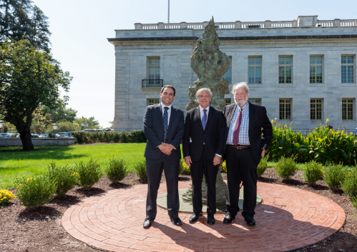

***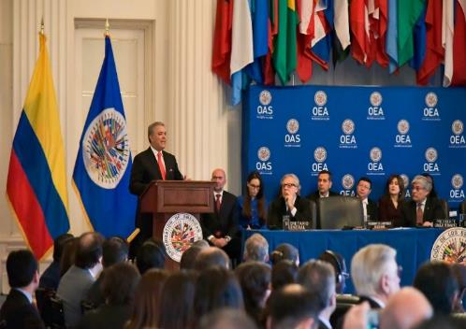***

*Ceremony to inaugurate the Greg Wyatt statues in the OAS Main Building Gardens - 09-04-2019*

**2.2. OFFICE OF THE ASSISTANT SECRETARY GENERAL**

2.2.1 Office of the Chief of Staff of the Assistant Secretary General

**Inter-American Week for People of African Descent in the Americas**

In 2019, the Office of the Assistant Secretary General continued its leadership in planning and orchestrating activities to commemorate the Second Inter-American Week for People of African Descent in the Americas. Under the theme "Remembering Slavery: The power of the arts for justice,” the Inter-American Week was staged March 25 through 29, in collaboration with the Secretariat for Access to Rights and Equity (SARE).

The Second Inter-American Week featured a number of activities, all designed to advance implementation of the OAS Plan of Action for the Decade for People of African Descent in the Americas (2016-2025), AG/RES. 2891 (XL VI-O/16):

* **Special Meeting of the Permanent Council**: To mark International Day of Remembrance for the Victims of Slavery and the Transatlantic Slave Trade, the Permanent Council held a special meeting on March 25. The panel of speakers included H.E. Epsy Campbell-Barr, Vice President of Costa Rica; H.E. Carmen Vásquez, Minister of Culture of Colombia; H.E. Ancelma Perlacios Peralta, Bolivian Senator; H.E. Sandra Terena, Secretary for the Promotion of Racial Equality in Brazil; and Mr. Saúl Vicente Vázquez, Head of the Office of International Affairs of the National Institute of Indigenous and Afro-Mexican Peoples (INTI)

Photos: <https://www.flickr.com/photos/oasoea/albums/72157690575792773>

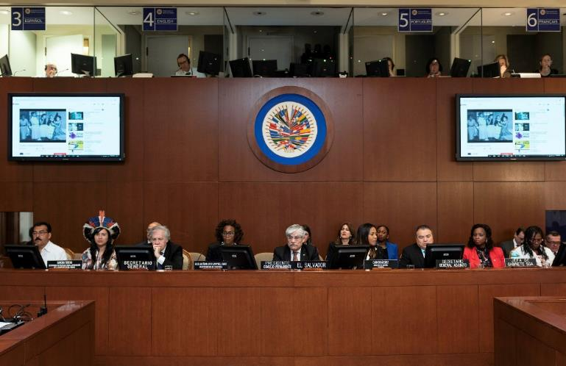

* **Unveiling of a commemorative painting**: At the end of the special Permanent Council meeting, the Assistant Secretary General unveiled for the participants a triptych commissioned by his Office to honor the victims of slavery and the slave trade. The work, valued at $30,000, was painted by Haitian artist Vanessa Craan and paid for from a private donation secured by the Office of the Assistant Secretary General.
* **Private tour of the National Museum of African American History and Culture (NMAAHC):** For the third year running, the Assistant Secretary General partnered with the Smithsonian Institution to organize a private tour for the permanent representatives, alternate representatives, permanent observers, and senior OAS officials. There were 48 individuals on the tour, which took place on March 26.

Photos: <https://www.flickr.com/photos/oasoea/albums/72157677410095937>

* **Forum on the Power of the Arts for Justice:** In keeping with the theme for the Second Inter-American Week, discussions were organized around the use of the arts for advocacy and awareness of past and current injustices faced by communities of people of African descent. The Forum concluded with a performance by a Brazilian artist.

Photos: <https://www.flickr.com/photos/oasoea/albums/72157704298860182>

**Inter-American Week for Indigenous Peoples**

In 2019, the Office of the Assistant Secretary General continued to take the lead in planning and staging activities to mark the Second Inter-American Week for the Indigenous Peoples of the Americas.

Under the theme "Indigenous Languages of the Americas," the Inter-American Week ran from August 5 through 9, as a collaborative effort with the Secretariat for Access to Rights and Equity (SARE).

The Second Inter-American Week included various activities, all designed to advance the OAS Plan of Action for the Implementation of the American Declaration on the Rights of Indigenous Peoples (2001-2011) and Permanent Council resolution CP/RES. 1094 (2144/18) of February 2018, which declares around August 9 of each year as Inter-American Week for Indigenous Peoples of the Americas.

* **Opening of the art and book exhibition:** The aim of this exhibition was to highlight the importance of language as a conduit for cultural expression and preservation. The paintings, photographs, books, sculptures, and musical instruments on display in the Marcus Garvey Hall of Culture were on loan from permanent mission delegations to the OAS, permanent observer delegations to the OAS, the OAS General Secretariat, and from officials of the Organization.
* **Permanent Council-CIDI Joint Special Meeting:** This joint meeting was called to commemorate Inter-American Week for Indigenous Peoples and International Year of Indigenous Languages. Indigenous people and member state national authorities responsible for indigenous policies were among those in attendance to discuss the preservation, promotion, and revitalization of the indigenous languages of the Americas.

Photos: <https://www.flickr.com/photos/oasoea/albums/72157704298860182>

* **Forum on globalization and the preservation of indigenous languages and cultures – the role of youth and technology:** Presentations were delivered by indigenous peoples’ spokespersons, national indigenous peoples’ policy officials, and representatives of specialized organizations. The event included musical performances by a Chilean opera singer and a young Guatemalan pianist.

Photos: <https://www.flickr.com/photos/oasoea/sets/72157710184492097/>

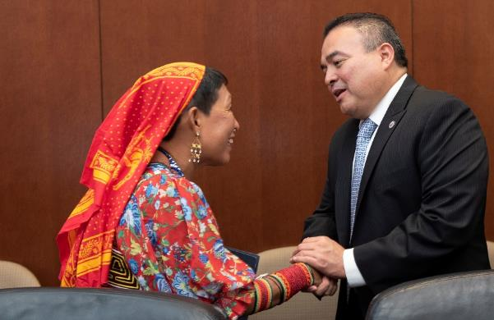

* **Private guided tour of the National Museum of the American Indian** For the second year in a row, the Assistant Secretary General partnered with the Smithsonian Institution on organizing a guided private tour for member state permanent representatives and alternate delegates to the OAS, permanent observer delegations, and senior OAS officials. The visit took place on August 6, with 50 people on the tour.

Photos: <https://www.flickr.com/photos/oasoea/albums/72157710141467096>

**Model OAS General Assembly (MOAS)**

In 2019, the Model Organization of American States (MOAS) program for young people of the Americas brought together some 1,150 university and high school students and more than 150 teachers from a number of OAS member states.

Specifically, four editions of MOAS were held:

* **34th Model OAS for Universities of the Hemisphere**: This year, the Model OAS for Universities was reactivated in Spanish in Costa Rica. The Model Assembly was held from March 11 to 13 as a joint venture with *Universidad Latina de Costa Rica*, on that university's campus.

Photos: <https://www.flickr.com/photos/modelooea/albums/72157708174243395>

* **2019 Washington Model OAS (WMOAS):** The Model OAS for Universities in the Hemisphere, which took place from April 1 to 5 at OAS headquarters, was successfully organized by the Institute for Democratic Dialogue in the Americas (IDDA) and GS/OAS.
* **First MOAS for High Schools in the Andean Region of Colombia:** This MOAS was held June 5 through 7 at EAFIT University in Medellín, Colombia. It brought together students, mostly from public schools and some from private schools. The Model was organized with support from the Office of the Mayor of Medellín, the Secretariat for Education, and the Ministry of Foreign Affairs of Colombia. The main objective was to familiarize young people with the issues that the member states would be addressing at the forty-ninth regular session of the OAS General Assembly in Medellín.

Photos: <https://www.flickr.com/photos/modelooea/albums/72157709144793452>

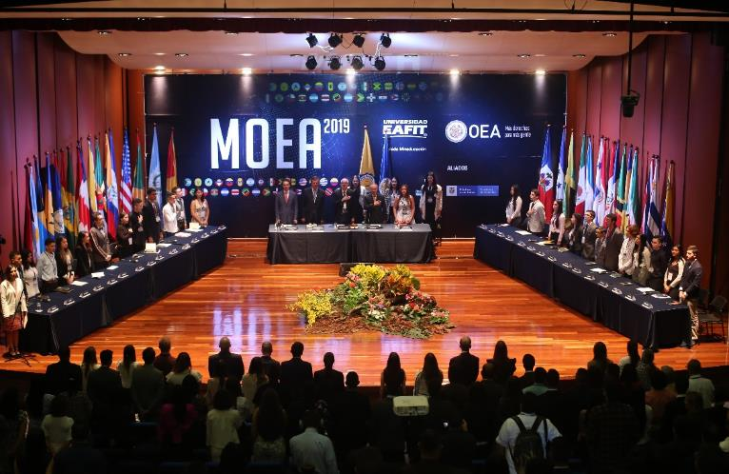

* **38th MOAS for high schools:** The thirty-eighth edition of the Hemispheric MOAS for high school students in English was held at OAS headquarters in Washington, D.C., from November 13 through 15.

Photos: <https://www.flickr.com/photos/modelooea/albums/72157711782092106>

Ties were also established with several universities, resulting in:

* Cooperation Agreement between *Universidad Euro Hispanoamericana* and the OAS General Secretariat for execution of the 35th MOAS for Universities of the Hemisphere, to be held in Xalapa, Veracruz, Mexico, April 22 to 24, 2020.
* Invitation for the MOAS Program to participate again in the Global Ethics Day organized by Texas Tech University, on October 16, 2019.
* Interest in staging various MOAS in 2020. Among them: Honduras National MOAS, jointly with *Universidad Tecnológica Centroamericana* (UNITEC); OAS for high schools, in collaboration with Universidad de San Martín de Porres (USMP) in Lima, Peru; Hemispheric Model for university students, jointly with the USMP; Central American MOAS, jointly with *Universidad de El Salvador*, in commemoration of its 50th Anniversary.

### 2.2.2 Department of Conferences and Meetings Management

The Department of Conferences and Meetings Management (DCMM) managed a total of 765 meetings held in 2019.

DCMM provided the services needed for 253 meetings of the Permanent Council, its committees, and working groups; 66 meetings of CIDI; and the forty-ninth regular session of the General Assembly, as well as the other meetings and conferences conducted under the auspices of the four pillars of the Organization.

It also provided support by offering the conference services needed to hold eight meetings of senior authorities or ministers and Meetings of Consultation of Ministers of Foreign Affairs acting as the Organ of Consultation in Application of the Inter-American Treaty of Reciprocal Assistance (TIAR):

* Fourth Meeting of Ministers and High-Level Authorities on Social Development within the Framework of CIDI. Guatemala City, March 28 and 29, 2019.
* International Seminar on Mechanisms and Tools for Regional Emergency Services Cooperation (ECU 911). Quito, April 25 and 26, 2019.
* Sixty-Fifth Regular Session of the Inter-American Drug Abuse Control Commission (CICAD). Buenos Aires, May 8 to 10, 2019.
* Tenth Inter-American Meeting of Ministers of Education within the Framework of CIDI. Washington, DC, July 8 to 9, 2019.
* Thirtieth Meeting of Consultation of Ministers of Foreign Affairs acting as the Organ of Consultation in Application of the Inter-American Treaty of Reciprocal Assistance (TIAR). New York, September 23, 2019.
* Eighth Inter-American Meeting of Ministers of Culture and Highest Appropriate Authorities within the Framework of CIDI. Bridgetown, September 19 and 20, 2019.
* Seventh Meeting of Ministers Responsible for Public Security in the Americas (MISPA VII). Quito, October 30 and 31, 2019.
* Sixty-Sixth Regular Session of the Inter-American Drug Abuse Control Commission. Miami, November 19 to 21, 2019.
* Thirtieth Meeting of Consultation of Ministers of Foreign Affairs acting as the Organ of Consultation in Application of the Inter-American Treaty of Reciprocal Assistance (TIAR). Bogotá, December 3, 2019.
* Ninth Regular Meeting of the Inter-American Committee on Science and Technology (COMCyT). Washington, DC, December 11 and 12, 2019.

DCMM provided regular maintenance for the 10 conference and meeting rooms at headquarters. DCMM has modernized its services to meet demand from the OAS units, organizing meetings with video conferences in two languages.

It has also provided conference services to member states, other agencies of the inter-American system, and other organizations.

The Documents Section provided document reproduction and distribution services for the different meetings held in 2019, and continues to strengthen the graphic and digital design areas as overall requests from the different areas of the OAS increased compared to 2018.  Nearly 400 orders for printing publications and brochures have been completed – a 10% increase in reproduction this year.

Marketing products were designed for promoting programs, products, and/or activities, including postcards, banners, logos, digital invitations, calendars, and other items.  In addition, around 634 documents were reproduced for a total of 17,262 copies for meetings of the Permanent Council and its committees.

The Documents Section continued to help bolster the institutional image of the OAS by collaborating with the Department of Press and Communications on standardizing and unifying OAS documents and stationery.

The Language Section provided simultaneous interpreting in English, French, Portuguese, and Spanish for 322 meetings of the organs, agencies, and entities of the Organization, both at and away from headquarters. With this service provided internally, the OAS saved approximately US$23,100.

Regarding document translation, close to 8 million words were translated in the Organization’s four official languages, with the help of SDL Trados Translation Memory software. And with the provision of these translation services internally, savings of US$388,222.06 were generated for the OAS.

Additionally, the Language Section updated two important documents and published them on its website: the OAS Institutional Glossary and the OAS Style Manual, in the Organization's four languages.

The Language Section also collaborated with the Department of Information and Technology Services (DOITS) to develop new resources for the document management system (EDMS). By 2020, the necessary training in the use of the new software will be provided.

The Language Section also hosted students visiting from Middlebury Institute of International Studies (MIIS), and welcomed and trained interns who came in under the OAS Internship Program.

2.2.3 Coordinating Office for the Offices and Units of the General Secretariat in the Member States

In 2019, the Coordinating Office stepped up its efforts to maximize the efficiency of its operations through increased oversight of the National Offices, taking advantage of improved technical infrastructure and opportunities for one-on-one training and streamlining the processes established for submitting administrative and financial reports. The communication and information gap with headquarters was bridged through a concerted thrust to ensure better interaction with other units of the General Secretariat and by presenting the CAAP with a Revised Comprehensive Strategy, providing a forum for addressing the concerns of the member states. Given the severe fiscal constraints, the National Offices continued to support technical cooperation programs and to exemplify the visible impact of the Organization by proactively promoting its values, role, and relevance in the Americas.

The following paragraphs give a general overview of the most salient accomplishments of the Coordinating Office:

* **Revised Comprehensive Strategy for the Offices of the General Secretariat in the Member States, submitted to the CAAP pursuant to AG/RES. 1 LIII-E/18:**  The Coordinating Office sent back to the CAAP the Revised Comprehensive Strategy for the National Offices in the Member States and in response to the concerns and questions raised by the member states, a substantive presentation was given on the document. The Coordination Office is still awaiting the member states’ approval of the guidelines to be able to continue fulfilling the objectives that were set.
* **Institutional mechanism proposed by the Coordinating Office and implemented through DHR to fill vacancies in the National Offices:** In collaboration with the Department of Human Resources, the Coordinating Office established a mechanism whereby staff could indicate their interest in filling vacancies for OAS Representatives in National Offices. To date, one such vacancy has been filled through this mechanism.
* **Visits to National Offices to evaluate operations and logistics and to provide administrative training to staff:** Visits by the Coordinating Office to the National Offices in Mexico, Ecuador, and Saint Kitts and Nevis to continue training staff and advise on administrative and operational routines, thereby making it easier to review the Offices' overall needs in order to optimize space, security, and other logistics infrastructure.
* **Start of the process of updating the websites of the national offices in consultation with the Department of Press and Communications:** In consultation with the Department of Press and Communications, the Coordinating Office embarked on the process of updating the websites of the National Offices, seeking to raise the Organization's visibility while strengthening mechanisms for promoting its performance, impact, and relevance in the member states.
* **Strengthening of Cyber Meetings – Office of the General Secretariat, inter-American agencies, and National Offices to improve information exchange, collaboration:** Through this process, the National Offices are included in the process of direct information exchange to keep them abreast of the activities carried out by other areas. To that end, they are kept informed of the work of the entire Organization, with a forum provided for questions and information on how the Offices could better support the activities and projects of the Secretariats and agencies of the inter-American system.
* **Cost- and space-sharing agreements:** There are five with the Inter-American Program of Judicial Facilitators (National Offices in Costa Rica, Guatemala, El Salvador, Honduras, and Panama); one with the IACHR (National Office in Mexico); and one with PADF (National Office in Haiti).
* **Languages as Bridges project:** Project conceptualized and proposed institutionally as a language tool for the hemisphere, garnering initial interest and support from the member states and observers.

## 2.3 SECRETARIAT FOR STRENGTHENING DEMOCRACY

Pursuant to the mandates and instruments established under the inter-American system, the Secretariat for Strengthening Democracy (SSD) provided strategic policy guidance to ensure timely handling of requests received from the member states regarding strengthening democracy and peace in the Hemisphere. In 2019, SSD planned, coordinated, and executed a range of electoral observation and cooperation activities; managed the creation of a new mission to combat impunity in El Salvador and continued the work of other special missions in operation, such as the MAPP in Colombia, the MACCIH in Honduras, and the Mission in the Belize-Guatemala Adjacency Zone. Various projects and programs were also carried out in the area of democratic sustainability and promotion of peace, and work continued with the parliaments of the region. The main accomplishments in 2019 are outlined below.

**Executive OFFICE of SSD**

**International Commission against Impunity in El Salvador (CICIES)**

* On September 6, 2019, the General Secretariat of the Organization of American States (GS/OAS) and the Government of the Republic of El Salvador created the International Commission against Impunity in El Salvador (CICIES), the purpose of which is to, without restrictions, support, strengthen, and actively collaborate with institutions responsible for preventing, investigating, and punishing acts of corruption and other related crimes in El Salvador, including crimes related to public finances, unlawful enrichment, money laundering, and national and transnational organized crime. CICIES has signed agreements with the main institutions of the Salvadorian state: The Attorney General's Office, the Supreme Court of Auditors, and the Ministry of Justice and Security. This entity, which began operations with Salvadorian support, will expand its activities under the terms of the Establishment Agreement and in keeping with the laws of the Republic of El Salvador.

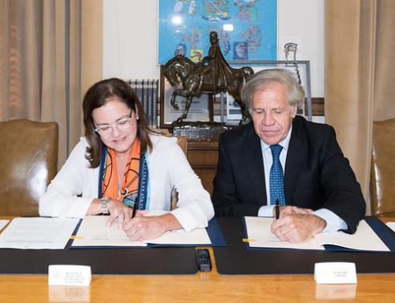

**International Electoral Accreditation Body**

The International Electoral Accreditation Body (IEAB) undertook its election authorization and accreditation program in 2019, delivering the following results:

* Certifications: ISO/TS54001:2019 quality certifications were given to and/or renewed for Mexico City’s Electoral Institute (IEDF), Peru’s National Jury of Elections (JNE), Peru’s National Office of Electoral Processes (ONPE), and Colombia’s National Registry of Civil Status (RNEC).
* Training: Forty elections agency officials from Mexico, Costa Rica, Panama, Argentina, and Colombia were trained in the fundamentals of the Electoral ISO. Additionally, a new course was created to become an ISO 54001 Implementer.
* Authorization of lead auditors: Ten lead auditors from Bolivia, Mexico, Colombia, Dominican Republic, and Peru were authorized to conduct external certification audits under the IEAB methodology.
* Technical advice: Technical advice was provided to the Colombian National Registry of Civil Status, which resulted in the certification of its key electoral processes. Likewise, during 2019, advice was provided to the Superior Electoral Court of the Dominican Republic.
* Renewal of the Electoral ISO Standard: The OAS as the coordinating institution of the ISO-TS176-WG3 Working Group led the work that culminated in the renewal of the new Electoral ISO standard, approved as a new certification instrument for electoral processes worldwide, known as ISO/TS 54001:2019.

**Legislative Branches**

In 2019, the Executive Office of the SSD provided technical assistance to the congresses of Argentina, Paraguay, Peru, the Dominican Republic, and Mexico under initiatives to modernize and strengthen institutions, generate knowledge, and promote inter-parliamentary cooperation. Specifically, a process of "accreditation in legislative innovation and openness" was carried out with the Peruvian Congress. Similarly, an event for young political leaders was held in the Dominican Republic to address the challenges facing young people in 21st century democracy, and a project was launched with the Mexican Senate on the subject of sustainable mobility.

SSD collaborated with the Forum of Speakers of the Legislative Branches of Central America and the Caribbean Basin (FOPREL) on the publication of the Regional Framework Law on Migration with a Human Rights focus. The Cybersecurity Laboratory for Legislative Branches was created as a joint effort with the Autonomous Technological Institute of Mexico (ITAM) and the Madrid Distance University (UDIMA) in coordination with the Inter-American Committee against Terrorism (CICTE).

Six online workshops were held, with full scholarships covering digital transformation and big data. They brought together 120 people from 16 countries (Mexico, El Salvador, Ecuador, Venezuela, Costa Rica, Chile, Colombia, Argentina, Peru, Honduras, Paraguay, Bolivia, Dominican Republic, Guatemala, Nicaragua, and United States). The Digital Leadership project was activated, aimed at training politicians and parliamentarians to be able to deal with digital transformation in Latin America.

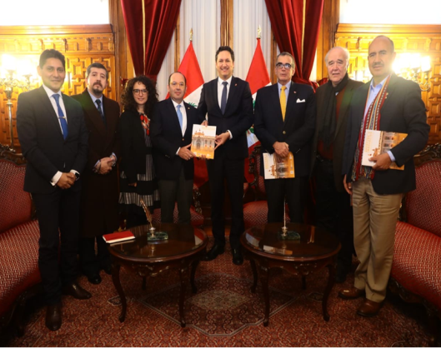

### 2.3.1 Department of Electoral Cooperation and Observation

The most significant accomplishments of the Department of Electoral Cooperation and Observation in 2019 were:

Seven countries of the region went to the polls in presidential, general, and local government elections, with the OAS deploying eight electoral observation missions in those seven countries: El Salvador (presidential elections), Ecuador (municipal elections), Panama (general elections), Guatemala (general and run-off presidential elections), Bolivia (general elections), Colombia (local elections), and Dominica (general elections). With financial support from 22 donors, a total of 494 international experts and observers were deployed, ensuring an OAS presence at more than 3,600 polling places.

In the area of electoral technical cooperation, DECO conducted an electoral integrity analysis of the October 20 general elections in Bolivia. In addition, at the request of the President of the Honduran National Congress, DECO drafted a proposal for electoral reform, which resulted in the Honduran electoral system being restructured and two new institutions created: the National Electoral Council and the Electoral Court of Justice. In Dominica meanwhile, DECO participated in a joint Special Mission with CARICOM and the Commonwealth to assist that country's efforts to effect electoral reform.

DECO promoted inter-agency exchanges with its electoral counterparts in the region and globally. In November, the OAS brought together 30 officials and representatives of 29 electoral bodies from 17 countries for the Fourteenth Inter-American Meeting of Electoral Authorities. Held in Panama City, the meeting sought to apply good practices and lessons learned from the 2019 presidential elections, and to share experiences around issues such as electoral reforms, political strategies in digital media, and violence in electoral settings.

A political communication workshop for electoral authorities was also held.

**Electoral Observation**

* 8 electoral missions deployed in 7 countries.
* 494 experts and electoral observers deployed.
* More than 3,600 voting centers observed.
* 38 nationalities represented on the Missions.
* 11 electoral observation methodologies/topics covered, including: electoral justice, electoral organization, electoral technology, political and election financing, women's political participation, political participation of indigenous peoples and people of African descent, election violence, mass media and social media, election security, direct democracy, and civic education.
* 5 preliminary reports submitted by EOMs to electoral authorities and to the public.
* 2 final reports delivered to the Permanent Council.

**Electoral technical cooperation**

* DECO conducted an electoral integrity analysis of the October 20 General Elections in Bolivia.
* It also drafted an electoral reform proposal for Honduras, resulting in a restructured Honduran electoral system and the creation of two new institutions: the National Electoral Council and the Electoral Court of Justice.
* In Dominica meanwhile, DECO participated in a joint Special Mission with CARICOM and the Commonwealth to assist that country's efforts to effect electoral reform.

**Interagency Exchange**

* Exchange on challenges and successful practices among 30 authorities and representatives of 29 electoral bodies from 17 countries in the Americas on issues such as electoral reforms, political strategies in digital media, and violence in electoral settings.
* Publication of the *Observing Electoral Justice* Systems – *A Manual for OAS Electoral Observation Missions* and the *Guide to guarantee freedom of expression regarding disinformation in electoral contexts.* Both documents were prepared by DECO specialists in collaboration with experts from other organizations.
* Strengthening of DECO’s relationship with authorities in the region and horizontal cooperation among the region’s electoral authorities.
* Participation of DECO specialists in nine professional/academic exchanges on electoral issues in the United States, Latin America, Europe, and Asia.
* Launch of the Elections Observatory at University of Sao Paulo (USP). The aim of this Center is to promote the values of democracy and the exercise of civil and political rights by citizens, through monitoring and observation of processes in Brazil.
* Meeting of experts to create the Security Protocol for Electoral Observation Missions. This project, which is being organized in conjunction with the OAS Department of Public Security, seeks to professionalize observation and technical assistance on procedures and for security procedures and practices.

Department of Electoral Cooperation and Observation: <http://www.oas.org/en/spa/deco/>

OAS/EOM database: <http://www.oas.org/eomdatabase/default.aspx?lang=en>

Technical cooperation: <http://www.oas.org/en/spa/deco/Coop_Tecnica.asp>

Social media – Electoral observation and cooperation <https://www.facebook.com/deco.oea/>

**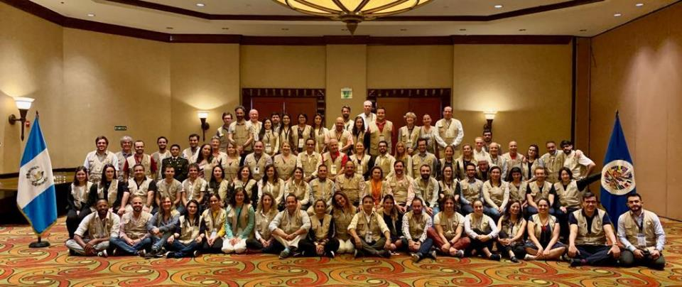**

**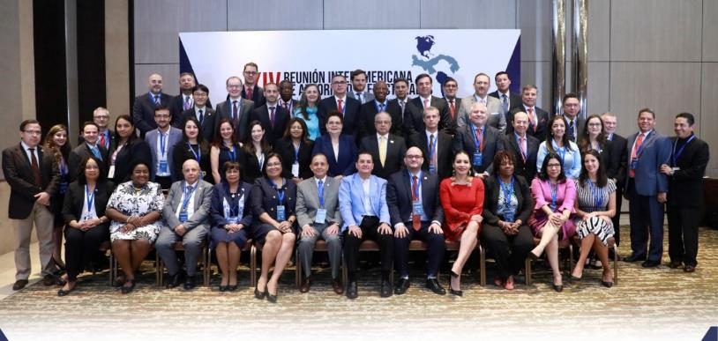**

**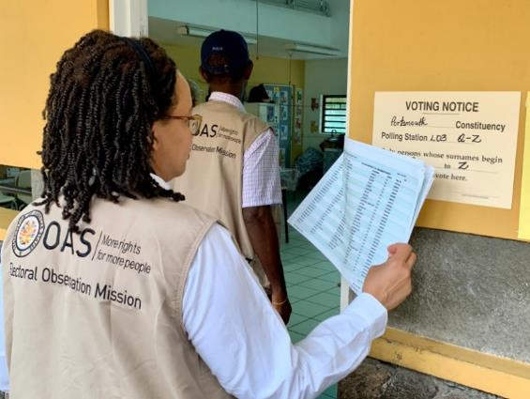**

**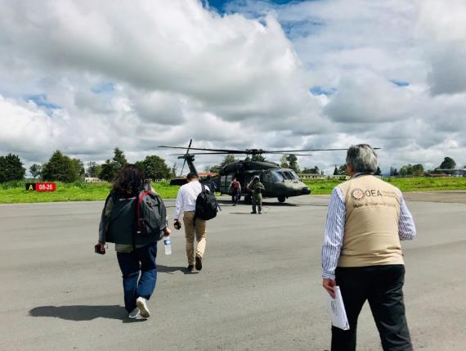**

2.3.2 Department of Sustainable Democracy and Special Missions (DSDSM)

The Department of Sustainable Democracy and Special Missions offers timely support for countries so requesting to strengthen and preserve their democratic institutions and for peaceful resolution of conflicts. Of particular note are the Mission to Support the Fight against Corruption and Impunity in Honduras (MACCIH), the work of the Mission to Support the Peace Process in Colombia (MAPP), and the implementation of confidence-building measures between Belize and Guatemala under the auspices of the OAS Office in the Adjacency Zone.

**Mission to Support the Fight against Corruption and Impunity in Honduras (MACCIH)**

In 2019, the MACCIH continued to consolidate the Honduran Public Prosecutor’s Office Special Prosecution Unit against Corruption Impunity (UFECIC-MP) and the Integrated Investigation and Criminal Prosecution Teams comprised of the UFECIC-MP and the international experts of MACCIH. With active MACCIH support for the UFECIC-MP in investigating and prosecuting high-level cases of corruption, four new criminal corruption cases and three new cases of seized assets were tried between January and December 2019, bringing to 15 the total number of cases brought by UFECIC with the support of MACCIH since its creation.

On August 20, 2019, the Sentencing Court with National Jurisdiction in Corruption Matters issued its first judgment in a case prosecuted by UFECIC-MP with the active support of MACCIH.

It should be recalled that the creation of the National Anti-Corruption Jurisdiction was a MACCIH-OAS promoted initiative approved by the Supreme Court of Justice in Agreement No. 01-2016 of May 12, 2016.

Regarding anti-corruption reform, the MACCIH-OAS prepared and followed up on several proposed laws which, if passed, would improve the operations of the new specialized units, created under the auspices of the MACCIH-OAS, in both the Public Prosecutor's Office and the Judicial Branch, including the bill on Effective Collaboration, which the Executive Branch introduced in Congress on April 22, 2019, and the draft amendment to Article 319 of the Constitution of the Republic to establish guarantees for judges and magistrates. In August 2019, the MACCIH also presented an analysis of the new Honduran Criminal Code (Legislative Decree No. 130-2017) featuring provisions which, if enacted unchanged, would affect investigation and criminal prosecution of corruption-related crimes in the country.

The MACCIH supported institutional strengthening for UFECIC-MP and the Office of the Attorney General of the Republic (PGR) by instituting an anti-corruption diploma course in partnership with the Central American Technological University (UNITEC) and the School of Public Prosecutions. The Department also participated in a new process to certify, select, and appoint prosecutors, investigators, and analysts to expand UFECIC-MP’s operational capacity, in keeping with the Interagency Mechanism for Bilateral Cooperation signed between the Public Prosecutor's Office and GS/OAS.

In pursuit of its objectives with respect to criminal justice system reform, in March 2019 MACCIH presented a Justice Studies Center of the Americas (JSCA) report entitled *Proposals for the Honduran Criminal Justice System to Handle and Manage Cases of High Social Impact and Corruption*.

The Criminal Justice Observatory (OSJP) held its first National Assembly on October 10, 2019, paving the way for the creation of the Decentralized System of Criminal Justice Observation and Monitoring based on the provisions of the MACCIH-OAS Agreement. The National Assembly was the culmination of the six regional assemblies held between July and August bringing together 267 organizations from 19 sectors of civil society and academia, and elected the members of the National Executive Committee and the OSJP National Fiscal Committee. A redesigned and updated Observatory website was also launched ([www.observatoriohonduras.org](http://www.observatoriohonduras.org)).

To meet its public security objectives, MACCIH provided the judicial branch of Honduras with support for putting in place the Unit for Protection of officers working in the Judicial Branch. The Supreme Court of Justice had approved the creation of the Unit and its operating regulations in 2018 following the proposed regulatory framework presented by MACCIH pursuant to the Law on Protection of Human Rights Defenders, Journalists, Social Communicators, and Justice System Officers.

Lastly, recommendations were presented and several activities were undertaken for institutions of the Honduran national public security system to strengthen the incorporation of the gender and human rights perspectives.

MACCIH Communications Center: <http://www.oas.org/es/sap/dsdme/maccih/new/comunicacion.asp>

Sixth Semi-Annual Report: <http://scm.oas.org/pdfs/2019/CP40861ESIXTHBIANNUALREPORTMACCHI.pdf>

Social media:

Twitter: @OEA\_MACCIH

<https://www.facebook.com/OEAMACCIH/>



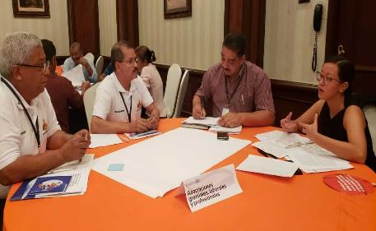

**Belize/ Guatemala: Implementation of Confidence-Building Measures**

The OAS provides policy and technical support in the search for a peaceful and definitive solution to the territorial, maritime, and insular *differendum* between Belize and Guatemala.

The Governments of Belize and Guatemala reaffirmed their political will to comply with the provisions of the 2008 Special Agreement and to settle the dispute through the International Court of Justice (ICJ). Belize held its referendum on May 8, 2019, with 53.38% of the population giving approval for any territorial, maritime, or island claim against Belize to be resolved by the ICJ. Guatemala’s popular consultation took place in April 2018, resulting in an overwhelming “yes” vote of 95% of the population agreeing to refer the dispute to the ICJ for a final decision. The Mission supported activities to promote participation in the Belize referendum, especially through information campaigns on the process.

Seeking to create channels for cooperation to ease tensions between two countries’ public officials in the Adjacency Zone, the GS/OAS Office in the Adjacent Zone (OAS-AZ) organized 28 inter-institutional coordination meetings between a variety of officials and institutions of the two countries on follow-up to agreements, security, the environment, tourism, etc. Between January and December 2019, the OAS-AZ received a total of 26 verification requests, 32.5% of them for plantations and pasturelands for livestock, 22.5% for construction, and 20% for deforestation. Of the 26 verifications, 5% were incidents involving arrests.

To ease tension and promote an atmosphere of collaboration between the Guatemalan Army and the Belize Defense Forces in the AZ, the Mission held 18 meetings among its officers (six meetings of senior officers and 12 meetings of mid-level officers) to exchange information on the current state of security in the Adjacency Zone, to operate more effectively and efficiently when patrolling the Zone, and to have better communication between the armed forces and security officers.

To improve the livelihood of the communities in the AZ, the Mission organized humanitarian assistance for families and individuals affected by the conflict, including provision of sports equipment and help with migration procedures.

During this period, the Mission continued to execute the Culture of Peace Program to foster trust among the communities, at four locations (Melchor cultural center, Benque, El Arenal, and OAS/AZ). Under this program, 592 students were trained in painting, music, languages, woodwork, and entomology.

Over the last quarter of 2019, the Mission did a diagnosis of the situation of the Adjacency Zone communities, with a view to developing productive projects tailored to the needs of these communities. This diagnosis covers several aspects, including: way of life, access to public services (water, electricity, and health, among others), education, productive activities carried out in the communities, and an evaluation of governmental or non-governmental organizations and institutions working on these issues.

During 2019, the office began a process to systematize the verifications and the Culture of Peace Program. In 2019, the information verifications for 2011 to 2019 was systematized. Information on the different Culture of Peace Program courses offered in 2019 has been automated as well. This information will be used to determine the impact of the work of the office in the AZ.

Social media

Twitter: @OEA\_BelizeGuate

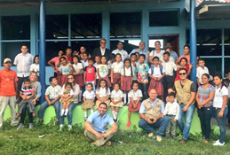

**Inter-American Judicial Facilitators Program (PIFJ/OAS)**

Under Strategic Line 3 of the Secretariat for Strengthening Democracy, "Contributing to the strengthening of democratic institutions and promoting inclusive dialogue in the Hemisphere," the Inter-American Judicial Facilitators Program (PIFJ/OAS) has helped establish a National Judicial Facilitators Service in Argentina (2011), Costa Rica (2013), El Salvador (2014), Guatemala (2010), Honduras (2012), Nicaragua (2003), Paraguay (2007), and Panama (2008). There were expected to be some 13,000 judicial facilitators in the region by the end of 2019.

During the year, PIFJ/OAS made a number of efforts to help institutionalize national judicial facilitator services in the region. Especially noteworthy therefore are the preparation of a diagnostic study on the status of the National Judicial Facilitators Service in Central America and the organization of the First Inter-American Meeting of the National Judicial Facilitators Service of in San José, Costa Rica, to exchange good practices and lessons learned in the region. It should be noted that not all the services have the same features and mechanisms, given that they each started at different times, with their own problems and contexts and, thus, the service has rolled out differently (although they have some things in common).

Social media:

<https://twitter.com/PIFJOEA>

<https://www.facebook.com/FacilitadoresJudicialesOEA/>

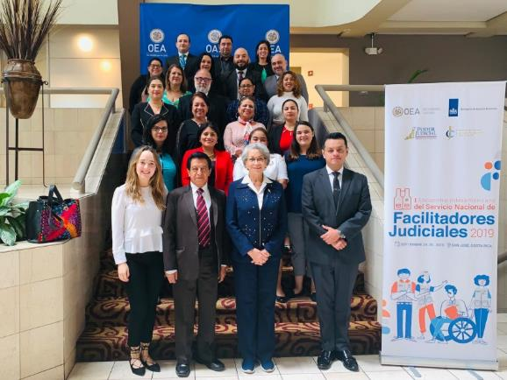

**Portfolio of projects in Haiti**

DSDSM teamed up with the OAS Office in Haiti to promote a series of projects to create an agenda for strengthening Haitian institutions and democracy.

Small Grants Fund: the OAS joined forces with the Pan American Development Foundation (PADF) to support local organizations in Haiti with grants and technical assistance to build their capacity to tackle key development challenges. The first activity under the Small Grants Fund is the Reforestation Grants Fund, designed to protect the ecosystems in communities around Haiti’s key forest reserves. Among the main achievements at the end of 2019 were: 11 institutions with improved capacity to deal with sustainable landscape issues; US$127,980 raised in investments for sustainable landscape; and 188.14 hectares of land under forest cover, agroforestry, and evergreen vegetation.

Community-driven development: the OAS teamed up with PADF to increase citizen participation in local government planning and decision-making and to improve delivery of public services such as clean water, sanitation, and education. This will be implemented in 15 municipalities around the country. Some 2,000 jobs were created through activities under this project in 2019.

Institutional strengthening to support the fight against corruption in Haiti: Following a Haitian Government request for support to set up anti-corruption infrastructure in Haiti, in 2019 GS/OAS developed a project to be implemented jointly with Haitian institutions to establish integrated teams to investigate corruption crimes. Notable objectives under the anti-corruption system include: reviewing national legislation to ensure that it provides for sufficient means to combat corruption; promoting the participation of civil society organizations in anti-corruption matters; and improving the capabilities of national authorities to manage humanitarian aid in accordance with anti-corruption protocols by incorporating corruption risk management into emergency preparedness strategies.

Social media:

<https://twitter.com/OEAHaiti>

**Mission to Support the Peace Process in Colombia (MAPP/OAS)**

In 2019, the MAPP/OAS marked its 15th anniversary with various activities, such as the event on the sidelines of the forty-ninth regular session of the OAS General Assembly, held in Medellín in **July 2019**; MAPP/OAS Week at the Columbus Memorial Library of the General Secretariat at OAS headquarters in Washington, and other regional events.

In an effort to meet the needs of the peace process, MAPP/OAS opened two new regional offices – in Caucasia and Ocaña – and kept a mobile team in Bogotá. It also created the area of capacity building to improve capabilities for dialogue, negotiation, social conflict transformation, and consensus building among key actors from state institutions and civil society.

In 2019, MAPP/OAS conducted 2,721 field missions, slightly increasing the number of monitoring missions as opposed to support missions and placing special emphasis on monitoring border cities, municipal border headwaters, particularly land and river transit crossings, formal and informal alike.

MAPP/OAS remained a relevant advocate for the peace process, thanks to a management model that is close to the institutions and civil society and facilitates close ties and bridge-building between them while strengthening participatory decision-making processes.

Social media:

<https://twitter.com/MAPPOEA>

<https://www.mapp-oea.org>

## 2.4 EXECUTIVE SECRETARIAT FOR INTEGRAL DEVELOPMENT (SEDI)

The Executive Secretariat for Integral Development (SEDI) supports, facilitates, and fosters integral development by promoting inter-sector dialogue, public-private partnerships, and consensus-building in incorporating government policies on sustainable human development. In 2019, SEDI programs and initiatives further helped member states meet the objectives of the OAS Comprehensive Strategic Plan 2016-2021 and the 2030 Agenda for Sustainable Development.

In terms of promoting inclusive and competitive economies, the emphasis continued to be on micro, small, and medium-sized enterprises (MSMEs) as critical production units in the region. SEDI initiatives such as the OAS’ MSME Digitization Plan, Chile's Scholarship Program, the online database, and the MSME Newsletter expanded the tools and resources available to them and strengthened the MSME ecosystem in the member states. The Caribbean Small Business Development Centers (SBDC) Program contributed even more to economic development by supporting over 526 new business launches and the creation and retention of over 12,000 jobs.

As the member states seek to better position themselves to meet the challenges and opportunities of the fourth industrial revolution and fulfill the 2030 Agenda goals, the *Prospecta Américas* program, which was launched in 2019, will improve the use of projection as a practical tool for formulating policies and programs to exploit emerging and vital technologies to promoting sustainable and innovative development, economic growth, and environmental and social benefits at the national and regional levels.

The Americas Competitiveness Exchange (ACE) program, established as the premier hemispheric network for innovation, entrepreneurship, and economic development, has accelerated collaboration among countries and key social actors to foster inclusive regional economic development, innovation, and entrepreneurship. Through the two editions of the program held in 2019, more than 120 decision-makers from the private and public sectors and academia directly experienced the diverse range of projects, strategic investments, public-private partnerships, and best practices in science, technology, innovation, and entrepreneurship from Puerto Rico, United States, and Santiago, Chile. More than 300 collaborations and partnerships in science, technology, innovation, and entrepreneurship were pursued through the ACE network.

The OAS is also working with the member states to better capitalize on the creative and cultural sectors as engines of sustainable growth. The partnership established with the Andrés Bello Agreement to tailor its Methodological Guide for putting satellite accounts for culture in place in the CARICOM region will help to measure the contribution of culture to the economy and evidence-based policy decisions for the allocation of resources to the sector.

In the area of sustainable development, the OAS has mobilized new funding for the Silver Account project; provided energy directors in 22 member states with technical assistance for promoting the use of reliable, scientific, and empirical data for energy management, renewable energy development, and air quality monitoring; and provided post-disaster assistance to the Bahamas following Hurricane Dorian, as well as health care to displaced persons in the Venezuela-Colombia border region.

SEDI's education and human development efforts provided more than 6,644 citizens of the Americas with access to quality, inclusive, and equitable education, through the OAS Scholarship and Training Program and the Rowe Fund. The Inter-American Teacher Education Network launched the First Hemispheric Fellowship for STEM Teachers and provided an initial group of 36 classroom teachers with an opportunity to improve their teaching practice and leadership skills and to contribute to the debate on international education policy. The "Global Classroom Project" agreement signed with Fairfax County Public Schools in Virginia promotes the establishment of student collaboration to address local, national, and regional issues and provides teachers with SDG 4-related professional development opportunities. The *ProFuturo* Education Program, which aims to narrow the digital divide and improve the quality of education, was expanded to include Barbados and Saint Lucia.

Renewal of the Inter-American Cooperation Network (CooperaNet), the online platform launched under the SEDI cooperation strategy, has strengthened the Organization’s capacity to leverage development assistance and to meet the need for more demand-driven technical cooperation in the Americas, while facilitating regional fulfillment of the Sustainable Development Goals (SDGs).

The programs, projects, and initiatives featured in this report offer a brief description of the contribution of the Executive Secretariat for Integral Development (SEDI) – as the OAS’ executing arm for development – to achieving economic, social, human, inclusive, and sustainable development in the Americas. Some of SEDI’s primary achievements highlighted in this section:

**Strategic Line 1: Promoting inclusive and competitive economies**

* ***Caribbean Small Business Development Centers (SBDC) Program*** 
  + Economic impact: 526 new businesses started; more than 7,624 jobs created and retained; $14.6 m in sales revenue and $1.1m in profit; and $3m in capital contributions raised through loans and funding in eight Caribbean member states.
  + Launch of the Caribbean SBDC Network as a focal point for SBDC programs in the Caribbean to connect Western Hemisphere programs and partners, strengthen the exchange of best practices, and improve SBDC connection to multilateral trade opportunities.
* ***OAS MSME Digitization Plan***
  + Execution of a three-year plan was embarked upon in collaboration with Kaolau, to digitize more than 450,000 MSMEs with a view to making them more visible, accessible, feasible, and resilient.
* ***Chile Fellowship Program*** 
  + This involves senior professionals from 17 member states on technical visits to small enterprise development centers in Chile, through the Chile Technical Cooperation Service (SERCOTEC), to share innovative practices in MSME development.
* ***OAS Foreign Trade Information System (SICE)***
  + An online database and the MSME Newsletter were launched to strengthen exchange on the inventory of horizontal cooperation best practices, initiatives, policies, programs, and projects to support MSMEs in OAS member states.
* ***Science, Technology, and Innovation (STI)***
  + *Prospecta Americas* was launched as a program to establish 10 inter-American centers of excellence in future transformational technologies of the fourth industrial revolution to provide sustainable solutions for development in member states.
* ***The Inter-American Competitiveness Network (RIAC)***
  + 120 decision-makers from the private and public sectors and academia were provided with innovative tactics on investment strategies, public-private partnerships, and best practices in science, technology, innovation, and entrepreneurship in Puerto Rico, United States, and Santiago, Chile.
* ***Working Group of Experts on Subnational Competitiveness (GTECS)***
  + The report on "Simplifying Construction Licensing: Diagnosis, Proposal and Guide" was published with Mexico's National Commission for Regulatory Improvement (CONAMER) on Mexico's best practices in designing and implementing a single window system for construction licensing.
* ***Culture and Tourism*** 
  + A partnership was established with the Andrés Bello Agreement to adapt its Methodological Guide for putting satellite accounts for culture in place in the CARICOM region to help measure the contribution of culture to the economy and evidence-based policy decisions for allocation of resources to the sector.
* ***The OAS Inter-American Committee on Ports (CIP)***
  + 273 scholarships and co-sponsorships awarded to port officers from 31 member states under the Scholarship and Training Program through the CIP Secretariat, to pursue 16 courses of study in professional development, two certified technical workshops, and two Master’s degree programs in priority areas.

**Strategic Line 2: Strengthening the implementation of sustainable development goals in accordance with the Inter-American Program for Sustainable Development 2016-2021**

* ***Energy and Climate Partnership for the Americas (ECPA)***
  + Energy directors in 22 countries of the Americas were provided with technical assistance via workshops and exchange missions, and expert advice was sought for recommendations on the use of reliable, scientific, and empirical data in energy management, renewable energy development, and air quality monitoring.
* ***Integrated Transborder Water Resources Management*** 
  + The Río de la Plata Basin Project Execution Plan, developed through a US$2 million funding secured through the Global Environment Facility (GEF), was approved for implementation of the Strategic Action Plan (SAP) to speed up activities in the priority areas of water security, climate resilience, and ecosystem health.
* ***Disaster Risk Management and Adaptation to Climate Change***
  + Post-disaster assistance was provided to The Bahamas in the immediate aftermath of Hurricane Dorian, under the OAS-Amazon Web Services Agreement; and medical care to displaced persons in Cúcuta, Colombia (Venezuela-Colombia border) under the OAS-White Helmets program.

**Strategic Line 3: Promoting education and human development in the Americas**

* ***The Educational Portal of the Americas***
  + A “Global Classroom Project” agreement was signed with Fairfax County Public Schools in the state of Virginia to promote the establishment of collaboration among schools in Latin America and the Caribbean to provide teachers with SDG 4-related professional development opportunities.
  + A Memorandum of Understanding was signed between the Governments of Barbados and Saint Lucia, under the Caribbean phase of the *ProFuturo* Educational Program, whose goal is to narrow the digital divide and improve the quality of education by providing technology equipment to 92 primary schools, training 1,200 teachers, and virtual academic content adapted to the local curriculum for over 23,000 children in vulnerable environments in five member states.
* ***Inter-American Teacher Education Network (ITEN)***
  + The First Hemispheric Fellowship for STEM Teachers was launched and an initial group of 36 classroom teachers was provided with an opportunity to improve their teaching practice and leadership skills and to contribute to the development of international education policy.
* ***OAS Scholarship and Training Program and the Rowe Fund***
  + 6,644 scholarships and interest-free loans were awarded to citizens of 34 member states; 750 Caribbean nationals were trained in disaster risk management and climate resilience.

**Strategic Line 4: Promoting decent, dignified, and productive work for all**

***Inter-American Network for Labor Administration (RIAL)***

* The Department provided technical assistance to the ministries of labor and education of 18 member states, international organizations, representatives of the private sector, educational institutions, workers, and employers to make policy recommendations for strengthening coordination among ministries of labor, ministries of education, and vocational training institutions; developing skills for the future; closing the skills gap; and harmonizing education and training offerings with the future needs of the workforce through the “Skills of the Future” hemispheric workshop.

**Strategic Line 5: Fostering development cooperation and partnerships**

* The revamped Inter-American Cooperation Network (CooperaNet), a consolidated space to optimize alliances, establish partnerships and networks, leverage development assistance, and meet the need for more demand-driven technical cooperation in the Americas, while regional achievement of the Sustainable Development Goals (SDGs) is facilitated.
* SEDI Partnership Strategy was developed and launched to involve the private sector, foundations, academia, and other relevant nongovernmental and multilateral stakeholders in the dialogue to address the SDGs in a sustainable manner and on a larger scale.

# 2.5 SECRETARIAT FOR MULTIDIMENSIONAL SECURITY

2.5.1 Executive Secretariat of the Inter-American Drug Abuse Control Commission (CICAD)

The Commission held two regular sessions in 2019: CICAD 65 in Buenos Aires, under the chairmanship of Argentina; and CICAD 66 in Miami, under the chairmanship of the United States.

**2019 Achievements and Outcomes**

**Inter-American Drug Observatory (IDO)**

* Publication and launch of the Report on Drug Use in the Americas 2019, Drug Contaminants and their Effects on Users’ Health: A Critical Review, Standardized Indicators for National Drug Information Networks in Latin America, Multicenter Studies on Brain Function Changes in Crack Cocaine Users, and Follow-up Analysis of Crack Cocaine Users in Care and Treatment Programs Two Years after Admission.
* Regional workshop for 16 member states on drug supply control information and a subregional workshop for national drug observatories (NDOs) of seven member states on implementation of standardized indicators for national drug information networks, drug early warning systems (EWS), and treatment information systems.
* Technical meetings held to develop and strengthen NDOs, EWS, and forensic laboratories, training participants from 12 member states.
* Support for studies on heroin, opioids, and other emerging drugs in five member states.
* Publication of EWS alerts from four countries in the Early Warning System on Drugs in the Americas ([SATA](http://www.cicad.oas.org/Main/Template.asp?File=/oid/sata/default_spa.asp)).)

**Multilateral Evaluation Mechanism (MEM)**

* Publication of 33 national evaluation reports from the [7th round of the MEM](http://www.cicad.oas.org/Main/Template.asp?File=/mem/septima_ronda/default_eng.asp).
* Publication of MEM 7th round hemispheric report, which analyzes trends, strengths, and weaknesses of regional drug policies.
* Presentation of MEM national evaluation reports with high-level authorities and technical personnel in five countries, as well as international and regional organizations.

**Supply Reduction:**

* Capacity building for 540 analysts and researchers from agencies involved in combating drug trafficking in Latin America and the Caribbean, with a view to increasing their awareness and skills to reduce the production, marketing, and distribution of illicit drugs.
* Under the [Inter-American Program for Strengthening Gender Equality in Counterdrug Law Enforcement Agencies (GENLEA),](http://www.cicad.oas.org/reduccion_oferta/linea_genlea/GENLEA%20Article-Format-4Oct.pdf) more than 130 counter-narcotics officers of the region were sensitized to the importance of strengthening gender equality in their institutions.
* The Meeting of the CICAD Expert Group on Chemicals and Pharmaceuticals reviewed and updated the [Model Regulations for the Control of Chemicals Used in the Illicit Manufacture of Narcotic Drugs and Psychotropic Substances.](http://www.cicad.oas.org/reduccion_oferta/resources/chems/Reglamento%20Modelo-Aprobado%20CICAD%2066-Final.pdf)

**Demand Reduction:**

* The Meeting of the Group of Experts on Demand Reduction was held in Cartagena de Indias, Colombia, drawing participation from 21 member states under the chairmanship of Chile.
* Eighteen experts were trained in drug use treatment in the Universal Treatment Curriculum (UTC) and 22 Latin American experts from eight countries were trained in drug use prevention in the Universal Prevention Curriculum (UPC).
* 42 young people from 13 Caribbean countries participated in the First Youth Forum on Drug Use Prevention.
* 345 health professionals from 10 countries successfully completed the online course on “Universal Treatment Curriculum (UTC) for Health Professionals.”
* The First Meeting to Develop the Drug Prevention, Treatment, and Recovery Curriculum for Faith-Based Organizations was organized in Washington D.C.

**Institutional Strengthening:**

* Support for five Caribbean member states to design, implement, and monitor national and local drug policies, strategies, and action plans through technical assistance.
* With respect to developing local drug policies, a new phase of work began at the subnational/local level, through the Health and Life Development Program in the Americas (SAVIA), revolving around identifying and promoting good practices in programs for integrating people into society and the labor market in municipalities in four countries.
* Support for new programs for drug offenders in two countries, and publication of six evaluations of processes using the drug treatment court model.
* Publication of the first manual on monitoring and evaluation of alternatives to imprisonment.
* Development of an innovative Case Management and Care Curriculum to train professionals in the design of integrated systems to facilitate reintegration of drug offenders into society and the labor market.
* First study on gender in the criminal justice system in five member states.
* The Group of Experts on Comprehensive and Sustainable Alternative Development, under Uruguay’s chairmanship, presented the document "Framework for Understanding the Concept of Comprehensive and Sustainable Alternative Development (CSAD)," approved by CICAD in November.

**CICAD Photos**

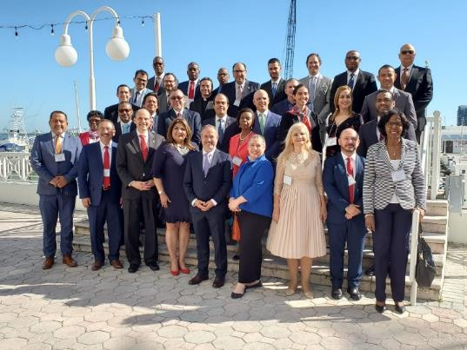

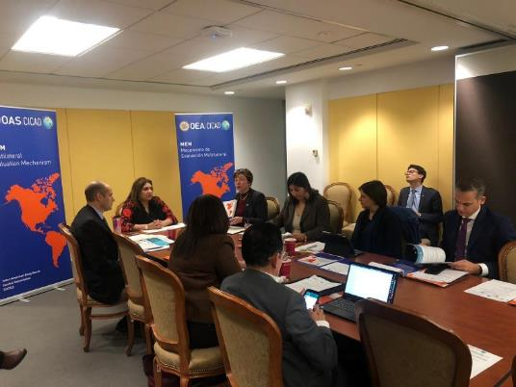

* + 1. Secretariat of the Inter-American Committee against Terrorism (CICTE)

The CICTE Secretariat provided support for the Committee’s XIX Regular Session, began designing the Inter-American Counter-Terrorism Network, and took part in the specialized terrorism meetings of the United Nations system and other regional organizations.

The CICTE Secretariat provided technical and legislative assistance to strengthen the regulatory and operational framework to combat terrorism financing and to combat the proliferation of weapons of mass destruction. Also noteworthy was support it provided Panama and Paraguay in their efforts to implement regulations to combat terrorism financing, and the exchange of experiences among various countries and peer reviews conducted pursuant to UN Security Council resolution 1540 (2004) on the non-proliferation of weapons of mass destruction to non-state actors.

The CICTE Secretariat supported the formulation of national and regional public policies, capacity building, and the generation of knowledge on cybersecurity. It gave support to develop national cybersecurity strategies in Belize and Ecuador, which would join the twelve regional countries that have such strategies. The Secretariat also provided specialized cybersecurity training for young people, women, officials, and various segments of society. In addition, it promoted knowledge generation through various publications on the subject.

Through its specialized programs, the CICTE Secretariat provided several countries with technical support to build border control capacity in tourism security, cargo and container security, supply chain security, and maritime security.

**2019 Achievements and Outcomes**

**Dialogue/cooperation to prevent, combat, and eradicate terrorism**

* The nineteenth regular session of CICTE held.
* Strengthening of cooperation relationship with UN and other international/regional agencies.
* Participation in policy dialogue forums on combating terrorism at the global, hemispheric, and regional levels, including attending the Second Hemispheric Ministerial Conference on Counter-Terrorism.
* Designed hemispheric cooperation mechanisms, such as the new Inter-American American Counter-Terrorism Network.

**Technical and legislative assistance/implementation of international anti-terrorism instruments**

* Training for more than 300 officials in Panama and Paraguay in combating terrorism financing, implementation of targeted financial sanctions regimes, and domestic designations systems.
* Training for more than 50 officials from Argentina, Brazil, and Paraguay in money laundering and terrorism financing risks and vulnerabilities at the Triple Border.
* Technical assistance for the authorities of Colombia, Dominican Republic, Jamaica, Panama, Paraguay, and Uruguay to implement United Nations Security Council resolution 1540 (2004) on the non-proliferation of weapons of mass destruction to non-state actors and facilitation of two peer reviews on effective practices in this area (Uruguay/Paraguay-Dominican Republic/Panama).

**Capacity-building in cybersecurity**

* Support in developing national cybersecurity strategies in Belize and Ecuador, and in strengthening the Hemispheric Computer Security Incident Response Team (CSIRT) Network, which has 26 CSIRTs in 18 countries.
* Specialized cybersecurity training for 3,500 persons from various sectors of society, who have responsibilities in this area, 790 women participating in the Cyberwomen Challenge initiative, and 181 university students who are part of the program titled "Creating a Career in Cybersecurity.”

**Capacity-building in border controls**

* The first bi-national technical training in cargo and container security at the Haiti-Dominican Republic land border was held, drawing participation from more than 50 officials from both countries and trainers from the region.
* Training of more than 100 officials – with land border and port responsibilities – from Argentina, Dominican Republic, Haiti, and Peru in security, cargo control and inspection, and land and maritime modes of transportation.
* Specialized training in tourism security for more than 148 participants from Central America, Mexico, and the Caribbean, as well as publication of the document “Tourism Security in Mexico, Central America, and the Caribbean 2016-2019: Main conclusions and recommendations.”
* Launch of the initiative to support the development of national maritime security strategies in Antigua and Barbuda, Barbados, Dominica, Grenada, Saint Kitts and Nevis, Saint Lucia, and Saint Vincent and the Grenadines.
* Training for 49 government officials and private sector representatives from MERCOSUR countries, and technical assistance to Argentine customs officers in aspects of international supply chain security through authorized economic operator programs.

**Information Links**

CICTE website - www.cicte.oas.org and social media @OEA\_CICTE and @OEA\_Cyber

**PHOTOS:**

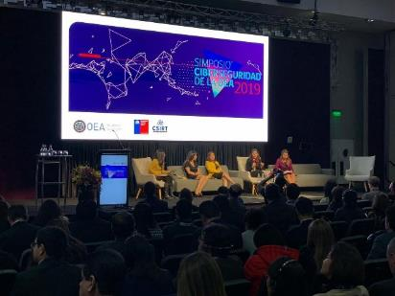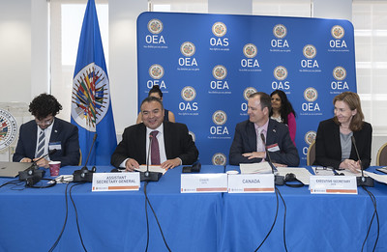

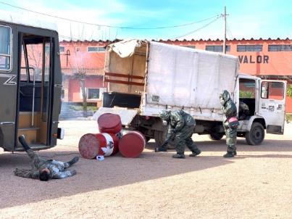

* + 1. Department of Public Security (DPS)

Pursuant to General Assembly resolutions and mandates from Meetings of Ministers Responsible for Public Security in the Americas (MISPA) and meetings of national authorities, as well as under the Inter-American Convention against the Illicit Manufacturing of and Trafficking in Firearms, Ammunition, Explosives, and Other Related Materials (CIFTA), the Department, in close collaboration with the member states, carried out a variety of activities in the areas of: information and knowledge, preventing violence and crime, preventing intentional homicides, assistance and protection for human trafficking victims, police force development and professionalization, rehabilitation and reintegration of youth who run afoul of the law, tackling the proliferation of and illicit trafficking in small arms and light weapons, and anti-personnel mine action, thereby contributing to the development and implementation of public policies capable of promoting a more secure and peaceful Hemisphere.

**2019 Achievements and Outcomes**

**Seventh Meeting of Ministers Responsible for Public Security in the Americas (MISPA)**

* Adoption of the Quito Recommendations for Strengthening International Cooperation in the Area of Public Security, Preventing and Fighting Transnational Organized Crime

**Prevention of violence and crime**

* First Hemispheric Plan of Action to Guide the Design of Public Policies to Prevent and Reduce Intentional Homicide, approved and in force
* 100 highly vulnerable young people benefited from the project for the prevention of youth violence through music in Honduras
* 140 government and non-government officials strengthened their capacity to assist and protect victims of human trafficking in Honduras and Guatemala

**A New Path**

* 550+ young people in Jamaica benefited, 70% of them were trained in educational programs, took part in entrepreneurship initiatives, and received job opportunities
* Case Management System developed and implemented at all youth centers; and more than 100 prison officers trained
* Construction of multi-purpose classrooms at South Camp Correctional Center started

**Inter-American Network for Police Development and Professionalization**

* 60 police officers (20 women and 40 men) from 27 member states enhanced their police skills at the second onsite course held in Ecuador, which ran for 180 hours and was certified by the University of São Paulo
* Virtual platform for police information-sharing, developed; and Educational Guide for implementation of the first Virtual Course on Police Investigation of Transnational Organized Crime, prepared

**Countering the proliferation of and illicit trafficking in small arms, light weapons, and ammunition and their impact in Latin America and the Caribbean**

* Member states officials enhanced their technical expertise in physical security and stockpiles management, in firearms marking techniques, and in level 3 explosive device disposal (EOD3).
* 1,109 confiscated small arms and light weapons and 341,186 small-caliber ammunition weighing 5,399 tons in total, destroyed.

**Program for Comprehensive Action against Antipersonnel Mines (AICMA)**

* 1,015 operational evaluations conducted on eight humanitarian demining organizations (civilian and military).
* Monitoring of 88.2% of all demining operations executed in Colombia
* Assistance with physical, psycho-social, and socio-economic rehabilitation of identified mine survivors and family members.
* Mine-risk education (MRE) for around 12,254 men, women, and children in 242 communities located in 40 different municipalities.

**Information Links**

1. [Department of Public Security](http://www.oas.org/es/sms/dps/)
2. Department of Public Security Twitter: @OEA\_Seguridad
3. [Plan of Action to Guide the Design of Public Policies to Prevent and Reduce Intentional Homicide](https://www.oas.org/ext/es/seguridad/red-prevencion-crimen/Recursos/Multimedios/ArtMID/1608/ArticleID/2628/Plan-de-Acción-Hemisférico--para-Orientar-la-Elaboración-de--Políticas-Públicas-de-Prevención-y-Reducción-del--Homicidio-Intencional)

**Photos**

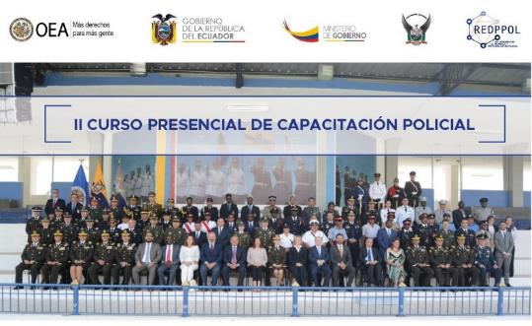

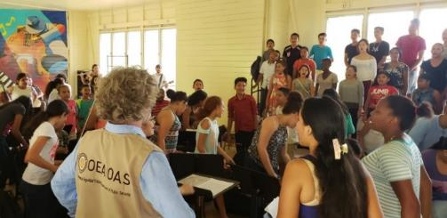

* + 1. Department against Transnational Organized Transnational (DTOC)

In 2019, the first Director of the Department against Transnational Organized Crime (DTOC) was appointed, thus consolidating DTOC leadership both in relation to other bodies within the OAS and to its member states, permanent observers, and other international organizations.

DTOC published the “Practical Guide to Special Investigative Techniques (SITs) in Transnational Organized Crime Cases" and trained 124 Latin American investigators, prosecutors, and criminal intelligence analysts in SIT application. In addition, 55 prosecutors, police officers, and labor inspectors from El Salvador, Guatemala, and Honduras were trained in prosecution of human trafficking and migrant smuggling, in keeping with national and international legislative frameworks.

DTOC supported Suriname with its National Risk Assessment (NRA) of money laundering and terrorism financing, specifically in the process of collecting and analyzing information for the NRA. More than 20 virtual and onsite training sessions were conducted for about 200 public and private sector officials.

Through the Group of Experts on Money Laundering Control (GELAVEX), DTOC provided technical secretariat services for its two annual meetings. In 2019, GELAVEX approved five new hemispheric reference documents on the subject.

In Peru, the DTOC launched the project “Strengthening the Anti-Money Laundering/Combating the Financing of Terrorism (AML/CLF) System,” introducing its objectives and expected outcomes to national authorities, to support implementation of the National AML/CFT Plan. Under this project, 25 Financial Intelligence Unit (FIU) analysts were trained in forensic auditing and creative accounting; and 150 public and private sector officials took part in an AML/CFT seminar on casino and gaming operations. DTOC began giving the FIU advice in strategic analysis.

**2019 Achievements and Outcomes**

* Practical Guide to Special Investigative Techniques (SITs) in Transnational Organized Crime Cases published;
* 124 investigators, prosecutors, and criminal intelligence analysts from Latin America trained in effective application of special investigative techniques (SITs)
* 55 prosecutors, police and labor inspectors from El Salvador, Guatemala, and Honduras trained to investigate and prosecute human trafficking and migrant smuggling crimes;
* Information gathering phase for Suriname’s National Risk Assessment (NRA) of money laundering and financing of terrorism (ML/FT) completed;
* Increased awareness about money laundering and terrorism financing risks in various sectors of Suriname’s economy;
* 200 public and private sector officials in Suriname trained in money laundering and terrorism financing (ML/CFT) risk-analysis;
* 5 new GELAVEX-approved reference documents on confiscation of ill-gotten assets and investigation of money laundering and financing of terrorism (ML/FT);
* 25 analysts from Peru’s Financial Intelligence Unit (FIU) trained to apply forensic auditing procedures to the investigation of ML/FT and creative accounting;
* 150 public and private sector officials learn more about prevention and detection of ML/FT in casino and gaming operations;
* Strengths and weaknesses in strategic analysis of the Financial Intelligence Unit (FIU) of Peru diagnosed and plan of action designed.

**Information Links**

* Practical Guide to Special Investigative Techniques (SITs) in Transnational Organized Crime Cases: <http://www.oas.org/es/ssm/template.asp?file=/es/ssm/ddot/publicaciones/default_spa.asp>
* GELAVEX: Study on Comparative Legislation and Technical Guidelines of international organizations Regarding the Probative Value of Intelligence Reports in the Region:

<http://www.cicad.oas.org/cicaddocs/Document.aspx?Id=5585>

* GELAVEX: Best practices guide for expert reports to prove money-laundering crimes: <http://www.cicad.oas.org/cicaddocs/Document.aspx?Id=5586>
* GELAVEX: Study on migrant trafficking and smuggling as money-laundering based crimes in OAS countries: <http://www.cicad.oas.org/cicaddocs/Document.aspx?Id=5584>
* GELAVEX: Study on application and handling of forfeited assets of equivalent value and mixed assets in OAS member states:

<http://www.cicad.oas.org/cicaddocs/Document.aspx?Id=5473>

* GELAVEX: Study on self-sustainability of seized and forfeited assets in OAS member states: <http://www.cicad.oas.org/cicaddocs/Document.aspx?Id=5474>

**Photos**

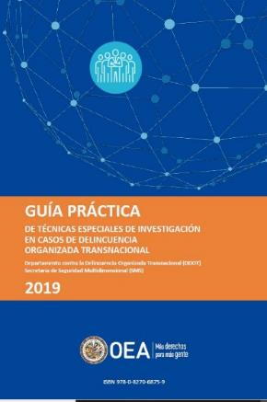

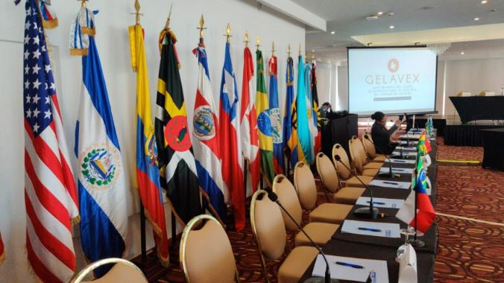

* 1. **SECRETARIAT FOR ADMINISTRATION AND FINANCE**

The SAF comprises the Executive Office of the Secretary for Administration and Finance (EOSAF) and the following divisions: Department of Human Resources; Department of Financial Services; the Department of Information and Technology Services; the Department of Procurement Services; and Department of General Services.

The EOSAF provides leadership, direction, and guidance to all areas on administrative and financial support activities while it directly performs the critical administrative functions of the General Secretariat.

In 2019, The Office of the Secretary (EOSAF) continued to support the Organization's regulatory bodies, primarily the Committee on Administrative and Budgetary Affairs (CAAP), serving as the principal link between the CAAP and the General Secretariat. The EOSAF also provided support for the efforts of the Permanent Council’s working group to implement the Plan for Management Modernization. It also provided ongoing support with logistics and resource management during implementation of the Technology Project.

Achievements:

* The EOSAF coordinated with all areas of the General Secretariat to facilitate the execution of programs from an administrative and financial standpoint. Despite the limitations of the budgetary execution ceiling established for 2019, the EOSAF, thanks to careful management of expenditures and revenues, was able to accommodate various budgetary needs during this year of financial austerity.
* The review of internal controls and procedures to strengthen the recording of financial information continued. This is a critical matter for cementing the donors’ trust regarding the capacity of the GS/OAS to properly control the execution of contributions to Specific Funds directed to OAS projects.
* Under resolution CP/RES. 1100 (2160/18), the Permanent Council authorized the necessary resources consigned in a technology fund to finance the updating of the Integrated Cloud Management Control System (OASCORE), implementation of which began and will run until January 2021.
* The SAF continues to work diligently to overcome the challenges caused by the excessive workload and, at the same time, to compensate for the tasks of positions that remained vacant during 2019.
* At the request of the General Secretary, the SAF was assigned the task of preparing the Program-Budget for 2020, which was successfully adopted at the General Assembly in June 2019.

The SAF routinely discloses its progress and challenges to the member states through the “Semiannual Resource Management and Performance Report of the OAS." This covers the activities of the SAF and responds to the recommendations from the Board of External Auditors of the OAS, as well as the mandates derived from the budget resolution.

### 2.6.1 Department of Human Resources (DHR)

Activities carried out by DHR in 2019 were geared towards: 1. Devising a human resources management strategy; 2. Ensuring fulfillment of the mandates assigned; and 3. Implementing initiatives focused on the well-being of staff.

DHR introduced changes to the health plan, resulting in efficiencies and cost reduction. At the same time, it crafted a proposal for a more robust management of the selection and recruitment program, managed a campaign to implement the vision of the organizational culture, fostered strategic partnerships and cooperation agreements for selection of interns and, in collaboration with other areas, conducted training to cover areas of skills enhancement.

* **OAS Health Plan Adjustments:** GS/OAS Health Plan benefits were adjusted in May 2019, because the Plan’s solvency was at risk. A successful communication campaign was undertaken to promote and emphasize the importance of responsible use of the plan by its participants, in order to support its long-term sustainability. SAF/DHR has continued to track the progress of these adjustments. Preliminary figures show a decrease of approximately 11% in claims expenses for 2019. SAF/DHR will continue to track and take the necessary steps to move the plan toward sustainability.
* **Organizational Culture of the OAS:** Campaign to implement the vision of the Organization's culture. The cultural vision was defined by the Secretary General and led by DHR. As a result, the map of the OAS’ Organizational Culture was designed and deployed through a variety of activities and eight (8) videos, to promote the sense of belonging and awareness of the culture and values of the GS/OAS mission. The elements of the OAS’ Organizational Culture are: Awareness of our Mission, Commitment, Action and Results, Transformers, Lifelong Learners, Collaboration and Trust, Inspiration and Mobilization, Empowerment, Diversity, and Inclusion.
* **Online Course on Code of Ethics and Conduct:** Collaborative initiative of the Office of the Strategic Counsel for Organizational Development and Management for Results (SCODMR), SAF/DHR, and SEDI/The Educational Portal of the Americas, to create and implement a mandatory online training program for all staff, including consultants (CPRs). A total of 683 GS/OAS staff members took part in the course, thus fulfilling the General Assembly mandate.
* **Recruitment and Selection:** The DHR developed and submitted to the CAAP a comprehensive proposal for a new recruitment and appointment selection process, aligned with the High Performance Organizations (HPO) framework.
* **Transcender Leadership School (L2T Academy):** Eighty (80) staff members with supervisory responsibilities attended a two-day program on management, leadership, and interpersonal intelligence skills. This program aimed to strengthen the skills to make managers more inspiring and more effective.
* **Wellness activities:** DHR successfully implemented 20 wellness activities for all staffers, covering a range of health-related issues, including: heart disease prevention, mental health, cancer awareness, quitting smoking, flu campaign, meditation, health fair, etc.
* **IACHR’s “Taking Care of Ourselves” stress relief toolkit:** Proposal to provide resiliency and stress training, emotional support services, and tools to support wellness for IACHR staff to help them thrive in their day-to-day human rights work.
* **New Nursing Room:** In an effort to support nursing mothers at the workplace, DHR teamed up with the Department of General Services (DGS) to open a new Nursing Room in the Main Building (17th Street & Constitution Ave.).
* **G-5 visa Program:** Mandatory requirement for payroll provider deduction for domestic employees under the G-5 visa program sponsored by G-4 visa holders.
* This requirement is part of a U.S. State Department initiative to ensure compliance with the program.
* **Strategic partnership with the Amazon Conservation Team Foundation First Indigenous intern**

Under the GS/OAS-Amazon Conservation Team cooperation agreement signed in 2019, and in collaboration with *Universidad Externado de Colombia*, the Internship Program received its first Indigenous intern, a member of Colombia’s Inga and Camëntsá community, in the Winter/Spring 2020 session*.* This is a significant milestone towards a more diverse Internship Program and fulfillment of the objectives of the American Declaration on the Rights of Indigenous Peoples.

* **Cooperation agreements with universities to fund future interns**

GS/OAS signed two major cooperation agreements with the University of Oviedo Foundation and La Rioja International University (UNIR), whereby each university provides financial support for 15 beneficiaries to participate in the OAS Internship Program in 2020. This student sponsorship will contribute significantly towards a more diverse Program by reducing financial barriers for talented applicants.

Images:

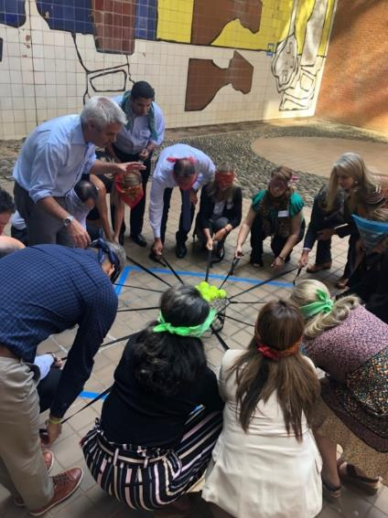

School of Leadership

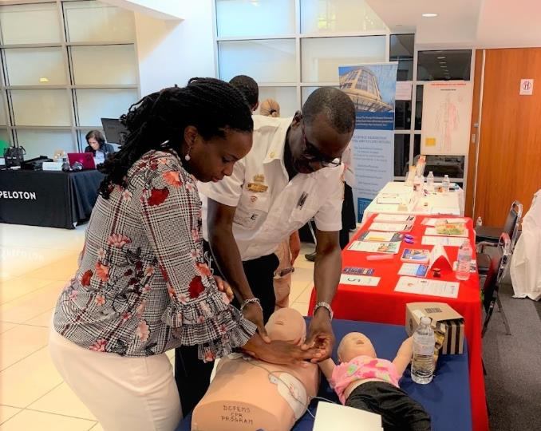

Health Fair

### 2.6.2 Department of Financial Services (DFS)

During 2019, the DFS maintained the quality of its services and internal controls, despite the staff reduction experienced by the department in recent years as well as the demands of implementing the ERP.

DFS completed nine new external audits of projects financed with specific funds, as requested by donors. One of the audits was directly coordinated by the donors, obtaining clean “unqualified opinion” reports, which is the best outcome that can be obtained from this type of audit. In addition, there has been periodic accountability regarding all the organization’s funds, via the financial statements published on the OAS website.

Nonetheless, DFS did not have additional capacity to reassign functions from frozen positions and is operating at full capacity and without optimum staffing levels. This situation puts adequate short-, medium-, and long-term functioning of the internal financial controls at risk.

***Financial results for the principal funds administered by the OAS General Secretariat:[[1]](#footnote-1)\****

***Regular Fund***

* On June 27, 2019, the General Assembly approved the January-December 2020 program-budget for a budget ceiling of 85,157,203, but with reduced execution of $82,700,000, a level equal to what was approved for execution of the January-December 2019 fiscal year; to finance this, a net allocation of quotas for $84,658,903 and other income of $498,300 was established.
* By the end of fiscal year 2019, the General Secretariat had executed $81.6 million, equal to 98.7% of the approved budget. The under execution of the budget by $1.1 million represents savings that help increase the Reserve Subfund of the Regular Fund.
* The Reserve Subfund ended 2019 with a deficit of $9.5 million. However, the balance would be significantly higher if the $32.0 million in quotas due were received. This would put the Reserve balance, including accrued quotas, at $22.5 million.
* As of December 31, 2019, there was a zero cash balance. This balance includes a temporary loan of $6.8 million from the OAS Treasury, pursuant to the approval of the Permanent Council under resolution CP/RES. 1105 (2168/18) rev. 1.

***Specific funds***

* Contributions to the specific funds amounted to a net of $61.3 million in 2019, compared to $41.4 million in 2018, which represents an increase of $19.9 million, or 48%.
* The three largest contributors in 2019 were the United States, with US$25.3 million (41.3% of total contributions), followed by the European Union with $5.0 million, or 8.1%, and Canada, with $3.3 million (5.4%)). Of the total contributions, the member states accounted for 55.1%, the permanent observers for 34.4%, and other donors and institutions for 10.5%.
* Compared to 2018, the member states increased their contributions by 58%, while contributions from permanent observers increased by 31%, with the contributions from other donors and institutions increasing by 63%.
* In 2019, total expenditures from Specific Funds amounted to $60.8 million, slightly more than in 2018. Of that total, 42.4% was for expenditures related to projects managed under Chapter 6 – Secretariat for Strengthening Democracy; followed by 27.7% under Chapter 8 – Secretariat for Multidimensional Security; and 12.9% under Chapter 3 – Principal and Specialized Bodies.
* Regarding total expenditure of $60.8 million, $24.7 million or 40.5% was for expenditures on performance contracts, while $11.9 million or 19.7% was for staff expenditures and $9.8 million or 16.2% was for travel expenses.

***Indirect Cost Recovery Fund (ICRF)***

* Revenue for the year totaled to $9.2 million, compared to $7.1 million in 2018, an increase of 29%. That was largely due to the timing of the programming of funds received in previous years and the receipt of increased cash contributions during 2019.
* By the end of fiscal year 2019, the General Secretariat had executed $5.4 million, equal to 98.6% of the approved budget. The under execution of the budget by $77,000 represents savings that help increase the Reserve Subfund of the Regular ICR.
* During 2019, $0.5 million was programmed from the reserve to supplement chapter 12 appropriations.
* The ICRF Reserve Fund ended with a positive balance of $6.6 million at end-2019.

### 2.6.3 Department of Information and Technology Services (DOITS)

During the reporting period, the Department of Information and Technology Services (SAF/DOITS) made every effort to maintain the level of services it provides to the OAS General Secretariat (GS/OAS) in the areas of networks infrastructure, communications, analysis and programming, data structuring, software quality, systems management, and computer security and thereby to meet the growing demand from GS/OAS areas for more and better services and technology tools to improve staff productivity, while meeting all of the new requirements of the substantive areas based on the OAS Modernization Plan and the mandates received and adhering as much as possible to the recommendations of the Board of External Auditors.

**Objectives met during this period:**

**Technology Infrastructure of Networks and Communications**

* The Department continued the project to consolidate the virtual infrastructure of servers, reducing the carbon footprint.
* HelpDesk activity remained at previous levels with around 7,700 tickets received.

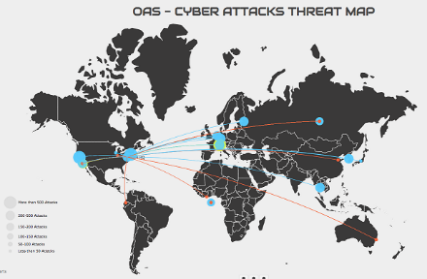

* The <http://doityourself.oas.org> tool was put in place for users to be able to unlock their accounts or change their passwords on their own at any time.
* Migration from File Share to a web-based organizational collaboration platform (SharePoint) continued, and is now some 95% completed.
* JABBER, the institutional communication and messaging system, was expanded to be accessed from any device outside the organization’s network.
* Implementation of the environmental monitoring of data centers and communications closets in the three buildings was completed.
* All the infrastructure needed by SMS/CICAD was implemented to connect an office in Mexico with headquarters infrastructure, maintaining security and connectivity with all the organization’s systems. This will serve us as a pilot project, which we will then be able to replicate with all national offices and projects outside of headquarters.
* Setup of technology for the CICIES office in El Salvador started.
* DOITS started the technological replacement of more than 550 obsolete workstations, whose operating system (Windows 7) posed a serious IT security risk for the Organization.

**Information Technology Security**

* Activity designed to prevent and trigger alerts in the event of cyberattacks increased 40%, with nearly 140,000 incidents analyzed during the year, compared to about 100,000 in 2018.
* Given the incorporation of new detection and early mitigation techniques and the increase in cyberattacks, the number of actions taken to mitigate potential attacks on the GS/OAS computer network increased from 50,000 to 75,000.

**Application development**

* New applications were launched, helping different areas of the Organization to facilitate their day-to-day activities as well as meet their organizational objectives. These applications include:

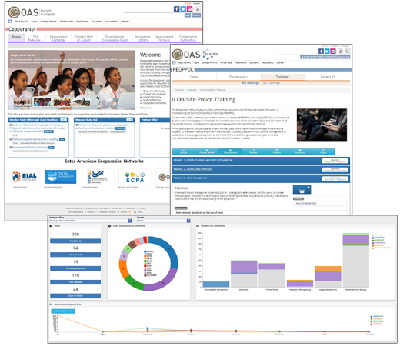

* CooperaNet for SEDI
* Strategic Plan System (STPS) for DPE
* Inter-American Network for Police Development and Professionalization system (REDPPOL) for SMS
* Inter-American SIMORE for IACHR

### 2.6.4 Department of Procurement Services

**Procurement management**

* 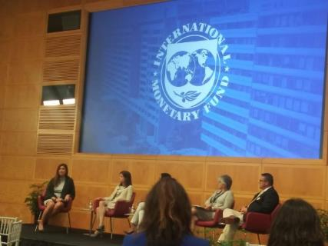The Department continued efforts to collaborate with multilateral organizations (IDB, WB, IMF, PAHO, and UN) on issues of shared interest and to enhance our bargaining power. The 2019 forum, hosted by the Inter-American Development Bank, reaffirmed the concern that the OAS was falling behind on certain issues related to procurement, modernization, and best practices.
* Approximately 35,000 transactions were recorded, valued at an estimated US$87.95 million.
* We began four formal bidding processes and two medium orders. Contract negotiations during this period resulted in savings of over $152,000.
* The GS/OAS insurance portfolio was successfully renewed, with System Failure coverage added to the portfolio, along with employer liability coverage against workplace accident for international staff of the MAPP.

**Travel management**

* 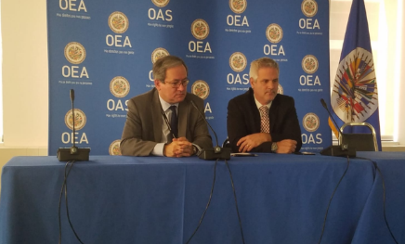Following an extensive and thorough competitive process, "Travel & Transport" was selected as the new travel management company for GS/OAS. It is already delivering satisfactory services. Training was offered to the entire organization.
* Savings in terms of both costs and time were recorded thanks to effective enforcement of official policies, continuous supervision, the use of reports, and constant expense reconciliation.
* Recovery of unused fares continued, and the Department was able to fully or partially reuse 134 airfares originally worth almost US$90,000 altogether.
* Corporate program swaps were used to purchase tickets to cover the Home Leave benefit, with savings of over US$40,000.

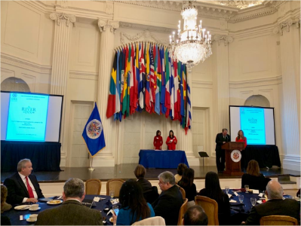**Supplier Management**

* There was an increase in the number of preferential rate agreements with the Organization’s key suppliers. We recorded savings of more than $376,000 by reviewing contract terms, setting preferential prices, and conducting other key negotiations with hotel chains, suppliers of office products, and the major airlines serving the Americas.
* The discount negotiated with the main supplier of computers was renewed, with estimated savings of more than $198,600 under this heading.
* Thanks to the business relationship with each supplier, 18 raffle prizes were won by GS/OAS staff at year's end.

**Other**

* Several tasks geared towards improvements and efficiencies continue to be pursued and upgraded, including: review of the corporate credit card program to explore the possibility of extending its benefits; renewal of the annual license of the online bidding management system; comprehensive review of the procurement regulations; review of policies and procedures; and creation of manuals, among others.

### 2.6.5 Department of General Services (DGS)

During 2019, the goals proposed in the annual operational plan were achieved. They were geared toward the management of general services for the operation of the General Secretariat and the security of its facilities, including actions in the area of building maintenance, security, inventory, messenger service, mail, transportation and copying service, and leasing of office space and event facilities. The specific achievements were:

**Building Management and Maintenance Section**

* 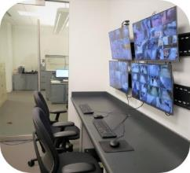Energy efficiency and waste management measures were put in place, and helped to cut energy use by 9% and the cost of garbage collection services by 60%. The work done included replacing all OAS lighting fixtures with LED systems and introducing a recycling initiative in the Secretariat, for estimated combined annual savings of $110,000.
* An agreement was reached with a solar energy system company for the installation and operation of solar panels in the GSB. The solar panels will cover, free of cost, some 10% of the energy consumption, saving an estimated $50,000 per year. The agreement also included providing $110,000 for the GSB roof replacement project, which was successfully completed in 2019.
* 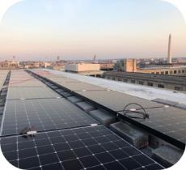The final bidding reports on the efforts to implement the Real Estate Strategy were submitted.
* A charging station for electric vehicles was installed in the OAS/GSB parking facilities, to facilitate and promote sustainable practices and reduce the Secretariat’s emissions.
* Water fountains in the GSB, MNB, and ADM were replaced with filter-based systems. The new bottle-count units are a major improvement on the original fountains, and help eliminate approximately 30,000 disposable plastic bottles per year.
* 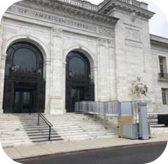Portable access ramps were installed and sidewalk improvements were completed, providing people with physical disabilities access to the MNB and AMA. Spaces such as neutral restrooms and nursing rooms were also created and outfitted in the GSB and MNB.
* The GSB, MNB, and ADM cafeterias were renovated. Improvements included the installation of new and modern food dispensers with an open market concept, and a new food service provider added in the GSB.

**Security Section**

* Work to improve the surveillance and monitoring systems was finalized, thus completing the implementation of the system monitoring the Museum of the Americas and ADM.
* Implementation of a Control Room to facilitate coordination and monitoring of the network of surveillance cameras installed at the Organization was completed.

**Messenger, Mail, and Transportation Section**

* The unit’s operational activities were performed, providing all messenger, mail, and transportation-related services. In addition, work was done to modernize and/or replace mail distribution machinery and equipment.

**Inventory Section**

* The asset records were updated, incorporating capital goods worth $1,414,385.58 and removing 1,193 items at headquarters and national offices/projects.
* Procedures were established for the periodic review of the inventory database to track assets with a recorded book value and useful life.

**Rents/Special Events/Photocopying**

* Efforts to consolidate available office spaces and to rent 1,393.28 square feet continued. Currently, total rental space amounts to 46,520.15 square feet, generating approximately US$2,015,724.28 during 2019.
* In coordination with the Office of Protocol and the Art Museum of the Americas (AMA), we continued efforts to rent OAS facilities for special events, particularly the Hall of the Americas and the Museum. In 2019, a total of 112 events were held in OAS buildings, yielding total estimated income of US$368,036.50.
* Multifunction photocopiers were acquired, improving the efficiency of operations in different areas. In addition, through an internal awareness campaign, we reduced the number of copies/prints by 110,498 compared to 2018.

# 2.7 SECRETARIAT FOR LEGAL AFFAIRS

This is the division of the General Secretariat that is responsible for advising on, developing, disseminating, and codifying inter-American international law, for supporting the related follow-up mechanisms, for legal and judicial cooperation in the Americas, and for internal legal counsel.

The Office of the Secretary for Legal Affairs, in addition to its advisory functions supporting the Secretary General and the other bodies of the Organization, supervised and coordinated the various departments, participated in activities to disseminate inter-American legal standards in various academic forums, technical publications, and encounters with attorneys, judges, and legislators in the Americas and in Europe. These activities provided a significant number of judges, lawyers, diplomats, and young students with a deeper understanding of the inter-American system and deeper cooperation therewith.

In 2019, among other activities, this Office and the Secretary for Legal Affairs participated and presented:

* At the Courts of Justice Meeting held in Córdoba, Argentina, bringing together the presidents of the Argentine provincial courts and foreign guests.
* On the inter-American system for diplomats at the Academies of Chile and Guatemala, as well as courses on the inter-American system at universities in Argentina, Barbados, Brazil, Colombia, and Uruguay.
* At the Meeting of the Institute of International Law, Hague session, with 100 internationalists, including judges of the International Court of Justice, arbitrators, and renowned professors.
* At the Annual Conference of the Inter-American Bar Association and the 50th Anniversary of the Argentine Association of International Law.
* At the First Forum of Representatives of the Judicial Branches of the Americas on Cooperation to Combat Corruption, organized by this Secretariat, in Buenos Aires, Argentina, with the presidents of courts of the OAS member countries.

### 2.7.1 Department of International Law (DIL)

The DIL continued to provide legal support to the member states at the meetings of OAS bodies, including the Meeting of the Organ of Consultation in Application of the TIAR, as well as to the Inter-American Juridical Committee, and continued to promote and disseminate both public and private international law, among the various actors in the system as detailed in the Biennial Report on the Inter-American Program for the Development of International Law.

Those activities included, notably:

* Extensive consultations involving over 200 government and nongovernmental actors, to update the Inter-American Model Law on the subject approved in 2010.
* Pursuing preparatory work to update the principles on the protection of personal data in order to reflect the latest developments in the field.
* Publicizing the inter-American system among various sectors, organizing training courses at diplomatic academies (more than 50 diplomats trained), public defender's offices (more than 30 defenders trained), and universities in the region (more than 130 young lawyers trained), and meetings with legal advisors to foreign ministries of member states (11 legal advisors participated in the meetings).
* The dissemination of inter-American legal instruments developed by the CJI, such as the model law on the simplified corporation, the model law on secured transactions, the principles on electronic receipts for agricultural products, and the Guide to the Law Applicable to International Commercial Contracts in the Americas (worked on with over 10 international organizations and over 200 academics from the region).

The DIL website with the most recent legal developments and the inter-American treaties and cooperation agreements database received 1,216,984 visits in 2019, double the number for 2018, demonstrating growing user interest.

### 2.7.2 Department of Legal Cooperation (DLC)

The Department of Legal Cooperation (DLC) continued to provide advisory and technical secretariat services to the legal cooperation processes, notably:

* Regional workshops for prosecutors, judges, and magistrates on electronic evidence and cybercrimes, under the auspices of the Meetings of Ministers of Justice and Other Ministers, Attorneys or General Prosecutors in the Americas (REMJA) in Costa Rica, Ecuador, and Paraguay (more than 160 participants trained).
* The Inter-American Convention against Corruption and its follow-up mechanism (MESICIC):*XXXII Meeting of the Committee of Experts of the MESICIC*, March 11 a 14, 2018. Adoption of United States, Antigua and Barbuda, Haiti, and Saint Kitts and Nevis reports.
* *In situ* visits to Guatemala, Trinidad and Tobago, and Saint Vincent and the Grenadines, April 2019.
* *XXXIII Meeting of the MESICIC Committee of Experts*, September 9 to 12, 2019. Adoption of the Guatemala, Trinidad and Tobago, and Saint Vincent and the Grenadines reports.
* *Consideration by the MESICIC Committee of Experts of:* 
  + *A Model Law on the Prevention of Conflicts of Interests pursuant to Recommendation 25 from the Fourth Meeting of the Conference of States Party to the MESICIC.*
  + *Indicators to detect, prevent, and eradicate impunity with respect to acts of corruption.*
  + *International anti-corruption mechanisms and best practices.*

**Cooperation with other international agencies:**

The DLC continues to work in close cooperation with other international organizations, such as the United Nations, the IDB, the Council of Europe, and the OECD, as well as with subregional bodies.

### 2.7.3 Department of Legal Services (DLS)

Highlights of advisory services provided by the Department of Legal Services included:

* Preparation and negotiation of contracts and agreements with private and government entities, NGOs, multilateral organizations, member states, permanent observers, and others, on issues of trade, cooperation, electoral observation, grants, specific projects, scholarships, real estate, etc.;
* Application, interpretation, and counsel provided on international law, the law of member states, and GS regulations on a variety of subject matters (e.g., taxes, audits, intellectual property, privileges and immunities, labor issues, pensions, etc.);
* Legal representation in extrajudicial disputes, including negotiations, special investigations, international arbitration, other judicial forums, and before the Administrative Tribunal;
* Preparation and counsel on GS regulations such as executive orders, administrative memos, directives, etc.; and
* Direction, participation, and counsel in internal investigations, supporting (for example) the Office of the Inspector General and the Office of the Ombudsperson.

Examples of achievements:

* Counsel provided on various important and sensitive matters, to the Mission to Support the Fight against Corruption and Impunity in Honduras; to the Administrative Committee on the OAS’ 401(m) Plan; to the Medical Benefits Trust Fund of the GS/OAS and others; and participation in various committees of the Organization.
* Collaboration with the Inspector General on various matters and investigations.
* It participated in and/or supported the electoral observation missions as a Legal Specialist in El Salvador and Guatemala; drafted documents, and participated in negotiating and evaluation special missions.
* It supported the CITEL at the last meeting of the Permanent Executive Committee.
* It counseled the SAF and the CAAP and their working groups on administrative, budgetary, and procedural matters.
* It developed projects related to the implementation of the Institutional Policy on Gender Equality, Diversity, and Human Rights of the General Secretariat.
  1. **SECRETARIAT FOR ACCESS TO RIGHTS AND EQUITY**

The Secretariat for Access to Rights and Equity continued in 2019 its work to consolidate the Comprehensive Regional Protection and Solutions Framework (MIRPS) for refugees and displaced persons in Central America and Mexico. Highlights of achievements in 2019 include the preparation and submittal of the SARE Strategic Plan 2020-2021, increased civil society participation in OAS activities, and strengthening national judicial facilitator services.

**Program for promoting and increasing civil society participation in OAS activities**

* A 143% increase in participation by civil society representatives at the forty-ninth regular session of the OAS General Assembly compared to the previous General Assembly and the number of civil society organizations (CSOs) attending the Assembly increased by 120%.
* A 204% increase in the participation of representatives of Indigenous peoples and people of African descent at the regular session of the General Assembly in 2019, with 64 participants in total, compared to 21 the previous year.
* 55 new CSO applications to be registered with the OAS and in the process of being registered.
* 27 new CSOs registered with the OAS, lifting the number of CSOs registered from 542 to 569.
* 33 ongoing coalitions organized among groups of organizations and actors with similar positions.

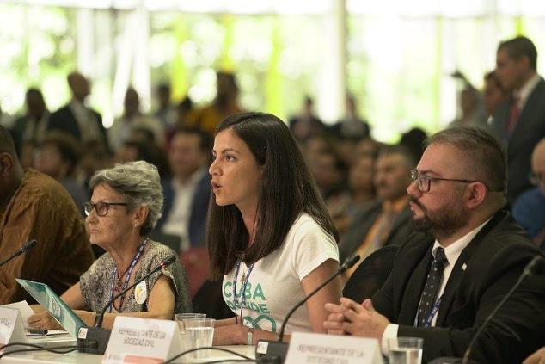

Dialogue of the Heads of Delegation and the Secretary General with representatives of civil society and other social actors.

Link: <http://www.oas.org/en/sare/civil-society/>

**Inter-American Judicial Facilitators Program:**

* Support provided for the preparation of a Best Practices Handbook for the National Judicial Facilitators Service (NJFS) and of national action plans for the program.
* Judges, justice system workers, and judicial facilitators enhanced their knowledge of communications strategies for delivery of NJFS and continuity policies during the First Inter-American Meeting of the National Judicial Facilitators Service, from September 24 to 25, in San José, Costa Rica.

Links: <http://www.oas.org/en/sare/access-justice/>

2.8.1 Department of Social Inclusion

The Department has continued to strengthen the inter-American policy dialogue on issues such as social development, migration, consumer rights, and rights of persons who are vulnerable. In 2019, strategic partnerships were established with organizations that promote inclusive education and social inclusion for vulnerable young people and organizations engaged in protecting the rights of indigenous peoples and consumer rights.

**Program on International Migration in the Americas**

* **Under the project “Socioeconomic Insertion in Host Countries in South America to Care for Mobile Populations Affected by the Crisis in Venezuela and other Migrant Populations,” a joint initiative of the OAS, the** [**United Nations Food and Agriculture Organization**](http://www.fao.org/home/es/) **(FAO), the** [**International Organization for Migration**](https://www.iom.int/) **(IOM), and the International Labour Organization (ILO), labor ministries in the region received recommendations on the socioeconomic integration of Venezuelan refugees and migrants in Latin America and the Caribbean.**
* **Technical advice provided to the Committee on Migration Issues (CAM) during thematic sessions and meetings of the Committee.**
* **18 recommendations shared among the ministers and ministry of health representatives of the 14 member states that participated in the conference of ministers of health on “Strengthening Regional Coordination in Response to the Impacts of Forced Displacement” in the region.**

Links:

<http://www.oas.org/en/sare/social-inclusion/vulnerable-groups/migration.asp>

<http://www.oas.org/en/cidi/cidi_CAM.asp>

**OAS-UNHCR Joint Unit**

* **Participation of the Secretary for Access to Rights and Equity in the High-Level Session of the First Global Refugee Forum, which took place in Geneva from December 17 to 18, 2019, to report on OAS contribution to protection for refugees and displaced persons under the Comprehensive Regional Protection and Solutions Framework (MIRPS), which comprises: Belize, Costa Rica, El Salvador, Guatemala, Honduras, Mexico, and Panama.**
* **Second Annual Meeting of the MIRPS, in Mexico, on November 8, 2019, with the Secretary of Access to Rights and Equity participating. There, the Second Annual Report was delivered and the seven MIRPS countries approved the Declaration of Mexico on International Protection, Shared Responsibility, and International Solidarity Efforts.**
* **First sub-regional meeting with civil society organizations from the MIRPS countries, on December 7 in Mexico, drawing participation from 25 civil society organizations and networks, to propose a mechanism for civil society participation in the MIRPS process.**
* **Proposal to establish a specific voluntary fund for MIRPS activities submitted to the OAS Committee on Juridical and Political Affairs (CAJP), pursuant to the Resolution on the “Promotion and Protection of Human Rights,” section 6.iii, which instructed the General Secretariat to prepare a proposal on the fund.**

**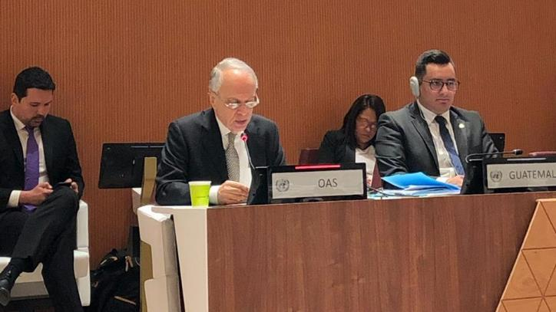**

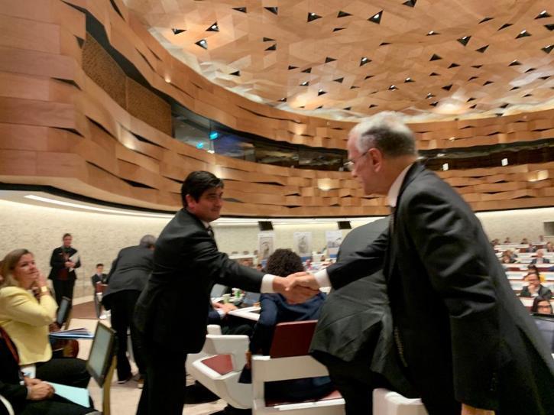

**High-Level Session of the First Global Refugee Forum**

Links:

<http://www.oas.org/en/sadye/inclusion-social/docs/II_Annual_Report_MIRPS.pdf>

**Program for the Promotion of Equity**

* Organization and holding, through CIDI and with support from SEDI, of the Fourth Ministerial Meeting on Social Development (REMDES), in Guatemala, bringing together 24 member state delegations, which agreed on 26 priorities for promoting social development in the region and identified opportunities for cooperation and synergies involving the OAS and other organizations such as the World Bank, ECLAC, the Pan American Development Foundation (PADF), EUROSOCIAL, the Secretariat for Central American Social Integration, etc.
* Adoption by the member states, for the first time under the OAS social development area, of a Plan of Action (2019-2021) that will serve as an inter-American social development agenda on a number of key issues for the region, including multidimensional poverty, strengthening social protection systems, and promotion of regional cooperation.
* The Working Group on the Protocol of San Salvador (WGPSS) submitted recommendations to Colombia and Uruguay to more effectively guarantee the economic, social, and cultural rights envisaged under the Protocol of San Salvador.
* Publication of the “Inter-American Guide on Strategies to Reduce Education Inequality” in coordination with Inter-American Dialogue and with support from the Andean Development Corporation (CAF). It offers strategies to deliver quality and equitable early childhood, primary, and secondary education through activities for diverse and marginalized populations to have access to quality instruction.

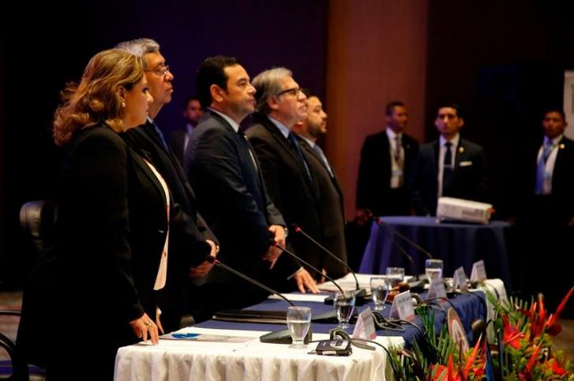

IV Ministerial Meeting on Social Development (REMDES)

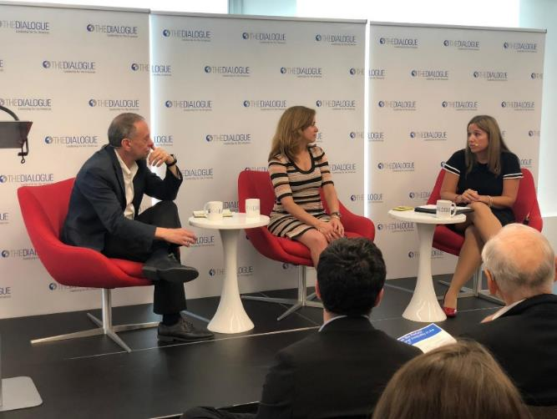

Presentation of the "Inter-American Guide on Strategies to Reduce Education Inequality.”

Links:

<https://www.oas.org/en/media_center/press_release.asp?sCodigo=E-018/19>

<http://www.oas.org/en/sare/social-inclusion/protocol-ssv/>

<http://www.oas.org/es/sadye/inclusion-social/guiainteramericana/content/index.html#/?_k=y9e4ak>

**Program to promote the rights of vulnerable persons**

* 150 GS/OAS staff and non-staff members increased their awareness about mainstreaming the LGTBI perspective into GS/OAS programs and projects and about intersectionality in addressing vulnerable groups, in collaboration with the Inter-American Commission of Women and the Inter-American Commission on Human Rights.
* 300 Ecuadorian public officials increased their awareness about the Inter-American Convention on the Protection of the Human Rights of Older Persons.
* 6,000 individuals increased their awareness about the Program of Action for the Decade of the Americas for the Rights and Dignity of Persons with Disabilities 2016-2026, rights of persons with intellectual disabilities and neurodiversity; inclusive education, legal capacity; access to justice; women with disabilities and prevention of gender violence, political leadership of persons with disabilities, and inclusive public policies on persons with disabilities.
* 30 people learned more about the contributions of the inter-American system to eliminating discrimination against persons with disabilities, at the Twelfth Conference of the States Parties to the Convention on the Rights of Persons with Disabilities.
* 400 people increased their awareness about inclusive education in Peru.
* Creation of the 360 VR Photographic Exhibition “People of African Descent in the Americas” in conjunction with the MERCOSUR Institute for Public Policies on Human Rights (IPPDH).

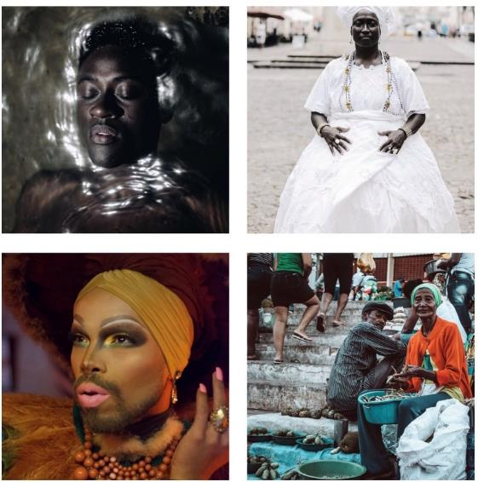

Upper left: © Salomao, Helen. March 29, 2018

Upper right: © Salomao, Helen. November 23, 2015

Lower left © Diaz-Cano, Andres. February 28, 2019

Lower right © Garcia Pereira, Rodrigo. January 19, 2019

Link: <https://oritel.org/oea/seminarios/>

**2.9 SECRETARIAT FOR HEMISPHERIC AFFAIRS**

**Summary of main achievements**

Pursuant to its mandate with respect to hemispheric and inter-sector coordination, the Secretariat for Hemispheric Affairs accomplished the following in 2019:

The Secretariat launched the Inter-American Open Data Program to Combat Corruption (PIDA) through the **Department for Effective Public Management (DEPM)**, pursuant to mandate No. 20 from the Eighth Summit of the Americas. The School of Governance also held the first OAS Diploma Program in Governance, Management, and Public Leadership in the Inter-American System, with significant representation of sectors and countries of the region.

Regarding the **Summits Secretariat**, the first year of the Mechanism for Follow-up and Implementation of the Lima Commitment was effectively executed in close coordination with the Government of Peru as Chair of the Summits process. The OECD joining the Joint Summit Working Group (JSWG) as a member relates to the Secretariat’s work to strengthen the JSWG institutions’ commitment to providing greater cooperation in implementing the Lima Commitment and the Summits of the Americas process.

With regard to the **Columbus Memorial Library**, in keeping with its mandate to preserve the institutional memory of the OAS and based on the cooperation agreement with HeinOnline, a project was launched to digitize the Organization's historical documents. This afforded users better and greater access to the Library’s archives, as well as better preservation of those documents.

The **Art Museum of the Americas (AMA)** secured conservation funds to restore the historic “Roots of Peace” mural by Uruguayan artist Carlos Páez Vilaró, located in the OAS Main Building tunnel. This enabled the launch of a program of guided tours and the opening of this important work to the public, which increased publicity and visibility for the Museum in the Washington DC and Latin American press and social media.

**Reference material relating to the work of the SHA**

* Democracy (CP/CAJP-3380/16 rev. 4):
* Promote transparent and effective public institutions and support mechanisms for citizen participation.
* Strengthen policy dialogue through the Summits of the Americas process.
* Institutional Strengthening (CP/CAAP-3426/16 rev. 1):
* Promote a coordinated programming approach that reflects the interdependence of the pillars of the Organization.
* Create synergies between the OAS and other institutions of the inter-American system.
* Modernize the Organization’s internal and external communication strategy.

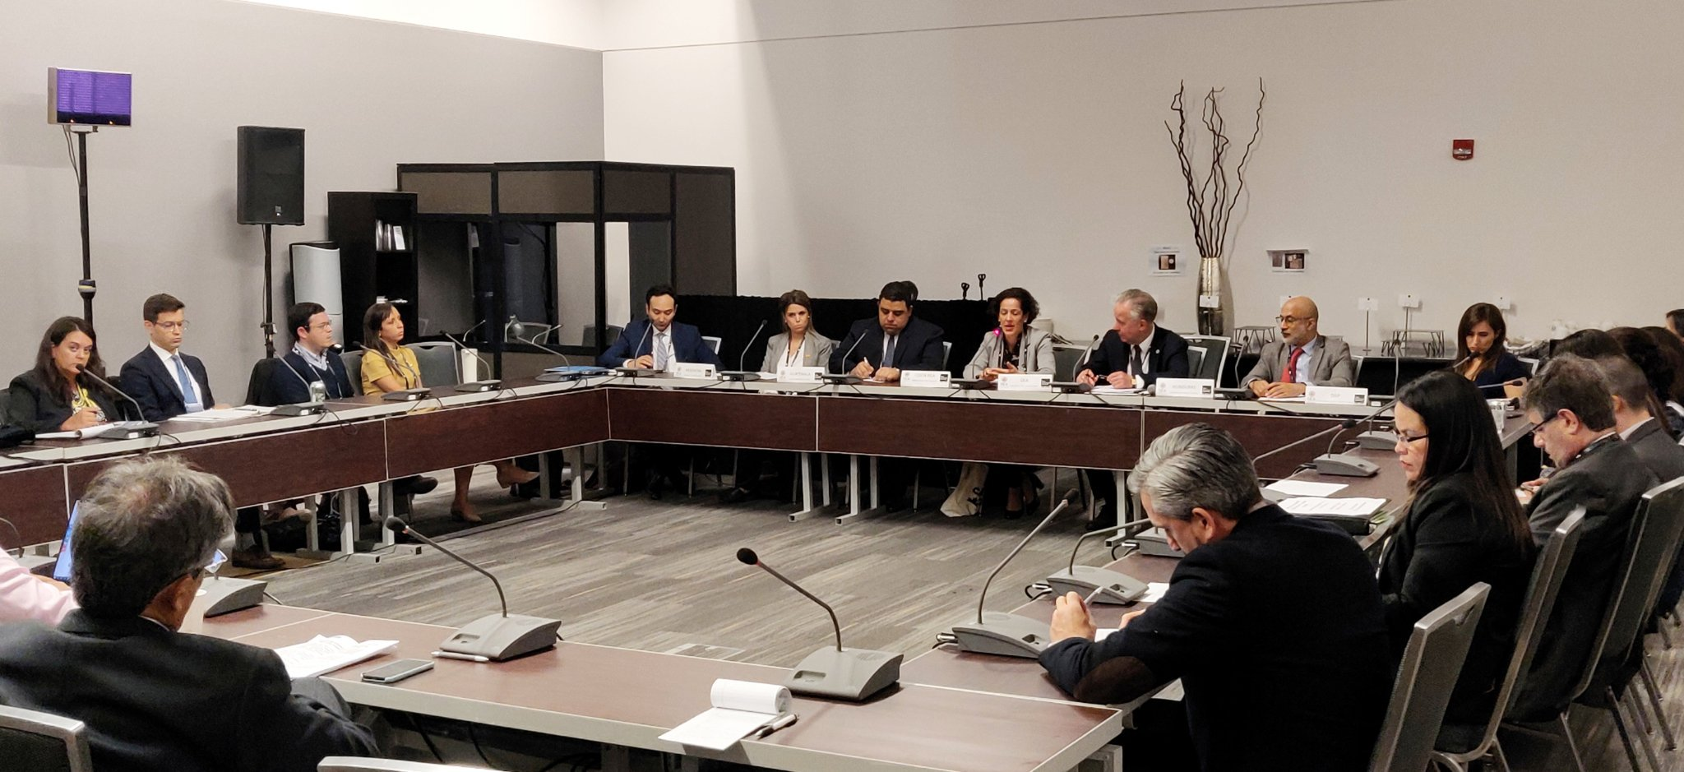

Hemispheric dialogue on “Contemporary Framework for Governance in the Americas: open and inclusive government,” led by the OAS Secretary for Hemispheric Affairs, at the 2019 Open Government Partnership Global Summit.

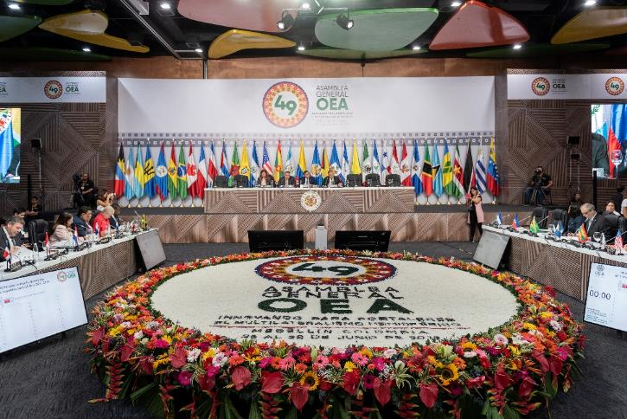

SIRG Ministerial-level meeting, forty-ninth regular session of the General Assembly

### 2.9.1 Department of Effective Public Management (DEPM)

Main achievements

Advances in 2019 included the development, approval, and launch of the Inter-American Open Data Program to Combat Corruption (PIDA), in fulfillment of a mandate from the Eighth Summit of the Americas. Likewise, through DEPM, technical assistance was provided on issues of open government, leading to the updating of the open data guidelines in Panama, the strengthening of the open government ecosystem in Belize, and approval of open data policies in Honduras. At the regional level, DEPM continued contributing to coordination of policies, strategies, and exchange of experiences in e-government, open data, and government procurement issues.

In 2019, under DEPM the OAS School of Governance implemented various offers of training aimed at promoting the OAS’ work on democracy, human rights, integral development, and multidimensional security. Training offers have been pursued in collaboration with other technical areas of the GS/OAS, such as the course for women candidates prepared and taught in collaboration with CIM, in seven countries. The Department also implemented the Open Government Fellowship Program in Honduras and the OAS Diploma Program that is a hybrid of virtual courses and one week onsite at OAS headquarters, on inter-American agenda issues.

Lastly, in 2019 the **Universal Civil Identity Program in the Americas** (PUICA) implemented a project focused on self-perceived gender identity – an innovative project because it was worked on together with civil society and because it was an issue on which the region was leading the global discussion. Through this project, dialogue was opened up with civil registry institutions about improving access to services for transgender persons.

**Outcomes**

**School of Governance**

* **930** citizens trained through the School of Governance in 2019.
* **220** women candidates running for a variety of political offices took part in the Course for Women Candidates for Elective Office, held in Panama, Bolivia, Colombia, and Costa Rica;
* **27** political leaders took part in the first edition of the OAS diploma Course in Governance, Management and Public Leadership in the Inter-American System;
* **657** public servants trained via online courses of the OAS School of Governance Virtual Campus;
* **25** youth leaders participated in the Open Government Fellowship in Honduras;
* **2, 000** visitors, in **68** groups comprising students, diplomats, military officers, and the public at large toured OAS headquarters in Washington DC and got guided tours of the Main Building and were briefed on the mission and the issues on the inter-American agenda.

**Open Government: Open Data and Government Procurement**

* 900 government and civil society participants in Belize and Panama enhanced their skills in opening up and leveraging public data.
* Mini-grants co-financing for eight innovation projects with open data in Belize
* 200 individuals from Panama trained in open data
* Updating of national open data guidelines and recommendations submitted for implementation of national open data policy in Panama.
* Co-creation and adoption of the national open data policy in Honduras.
* Increase in the number of civil society participants in the ABRELATAM and CONDATOS open data conferences organized in Quito, Ecuador;
* Publication [“Towards an Open Data Policy for the Public Procurement System”](http://ricg.org/es/publicaciones/hacia-una-politica-en-datos-abiertos-del-sistema-de-compra-publica/) done, proposing six guidelines for open data in the public procurement system.
* 145 officials from national public procurement agencies in 15 Latin American countries, trained through workshops on implementing new technologies in public procurement, sustainable public procurement, and public innovation.
* 26 action plans generated by the national public procurement agencies of 13 countries in the region for implementation of new technologies in public procurement, and inclusion of social, economic, and environmental criteria through public procurement processes.
* More interest on the part of the countries of the region in implementing disruptive technologies in public procurement systems.
* Stepped up implementation of sustainable criteria by procurement agencies, including implementation of a self-assessment tool for MSME suppliers in the Dominican Republic.

**Universal Civil Identity Program in the Americas (PUICA)**

* 75 civil registry officers from eight countries trained in basic concepts and best practices in recognizing self-perceived gender identity.
* Recommendations from two rounds of the Inter-American Cooperation Mechanism for Effective Public Management (MECIGEP) to amend self-perceived gender identity procedures for the National Population and Identity Registry of Mexico and of the state of Jalisco, Mexico.
* Inventory of self-perceived gender identity recognition practices published and put online as a digital tool.

**LINKS**

School of Governance: <http://www.oas.org/en/spa/depm/escuelagob/escuela-de-gobierno.asp>

Open Government: <http://www.oas.org/es/sap/dgpe/OpenGovFellowship/>; <http://ricg.org/es/home/>; <http://www2.redgealc.org/lineas-de-trabajo/datos-abiertos/>

PUICA: <https://www.oas.org/en/spa/depm/puica.asp>, [http://www.clarciev.com/](http://www.clarciev.com/;), [https://twitter.com/clarciev](https://twitter.com/clarciev;), [https://twitter.com/DGPE\_OAS](https://twitter.com/DGPE_OAS;)

**PHOTOS:**

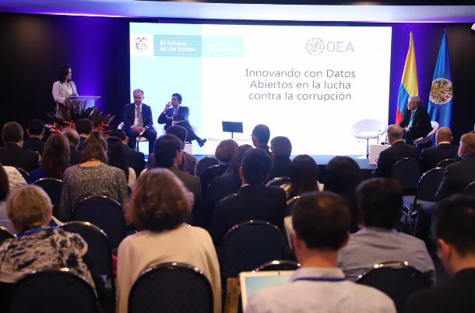

Photo featuring the Inter-American Open Data Program at the GA

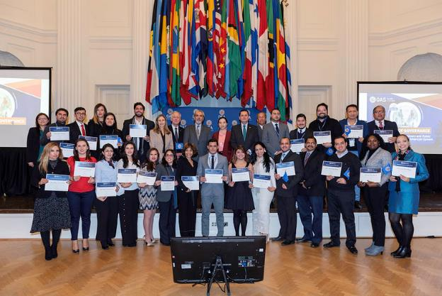

School of Governance – OAS Diploma Program

2.9.2 Summits of the Americas Secretariat

Main achievements

In 2019, the Summits Secretariat, as technical secretariat to and institutional memory for the Summits of the Americas process, coordinating closely with the Chair – the Government of Peru – continued strengthening and promoting policy dialogue and hemispheric cooperation through the Eighth Summit of the Americas follow-up and implementation.

Through the Summit Implementation Review Group (SIRG), it continued to provide substantive support to the Chair, thereby contributing to an enriching dialogue among the states; to awareness about their progress on the Lima Commitment and about progress by the JSWG entities; to progress in sharing good practices and regional capacities; and to promoting cooperation initiatives involving states, JSWG entities, and social actors, in preventing and combating corruption.

Coordination of the Joint Summit Working Group was also strengthened, as was its response, by building a cooperation model and a roadmap in fulfillment of the Lima Commitment mandates.

Lastly, in an effort to strengthen participation by civil society and social actors in the Lima Commitment follow-up, and taking into account a study conducted by the Summits Secretariat on the state of this sector’s participation, an innovative participation scheme was designed and is currently being formed: National Anticorruption Hubs.

**Summit Implementation Review Group (SIRG)**

* Ministerial-level meeting of the SIRG, held June 27, 2019, Medellín, Colombia, focusing on Lima Commitment follow-up
* Technical assistance in design and construction of the virtual platform of the Mechanism, including progress indicators
* Level of progress by 17 member states and nine JSWG institutions regarding the Lima Commitment, available
* Preliminary evaluation available on progress by states on Lima Commitment
* The Facility’s Regional Data Base of Best Practices and Capacity available with 160 national best practices
* Promotion of cooperation initiatives through technical assistance and policy discussions involving government experts, JSWG organizations, and social actors

**Joint Summit Working Group (JSWG)**

* Inclusion of the Organization for Economic Co-operation and Development (OECD) in the JSWG
* Formulation of the JSWG Plan of Action 2019-2021
* Two JSWG technical meetings held (May and June), to identify institutional offers and define work programming areas
* “Money Laundering and its Link to Corruption Investigation” Policy Dialogue held in Washington, DC, in September with DTOC/OAS, and MACCIH/OAS experts, IDB, and World Bank, Asset Recovery Inter-Agency Network, and government officials
* Support for the Government of Honduras with DEPM/OAS to promote and validate its National Open Data Policy. Sponsorship for experts from Colombia, El Salvador, and Dominican Republic
* Preparation and publication of the JSWG’s annual progress report on implementation of the Lima Commitment

**Civil society and social actors in the Summits process**

* The second phase of virtual briefing sessions with civil society and social actors engaged in preventing and combating corruption in seven states (Belize, Bolivia, Nicaragua, Mexico, Saint Kitts and Nevis, United States, and Uruguay) held between March and May. Seventy CSOs and social actors took part.
* Preparation of a study to identify the status of participation by civil society and social actors in the Summits process, which enhanced the work strategy with the sector.
* Convocation issued in September for the 34 member states to participate in national anti-corruption hubs to be established in the current phase of the Summits process. OAS Relations with Civil Society Section, IDB, and OECD are involved in developing this initiative.

Links:

* Summits Secretariat [SPAN](http://www.summit-americas.org/defaults.htm) | [ENG](http://www.summit-americas.org/default_en.htm)
* Virtual platform of the Mechanism for Follow-up of the Lima Commitment**.** [SPAN](http://compromisodelima.rree.gob.pe/compromiso/Consulta/Verificar) | [ENG](https://compromisodelima.rree.gob.pe/compromiso/Consulta/Verificar)
* Database of Best Practices and Regional Capacities [SPAN](http://www.viiicumbreperu.org/bancobuenaspracticas/) | [ENG](http://www.viiicumbreperu.org/us/database-of-good-practices/)

Twitter: <https://twitter.com/CumbreAmericas>

Facebook: <https://www.facebook.com/CumbreAmericas/>

Instagram: <https://www.instagram.com/summitamericas/>

Mandates:

AG/RES. 2931 (XLIX-O/19) AG/RES. 2920 (XLVIII-O/18)

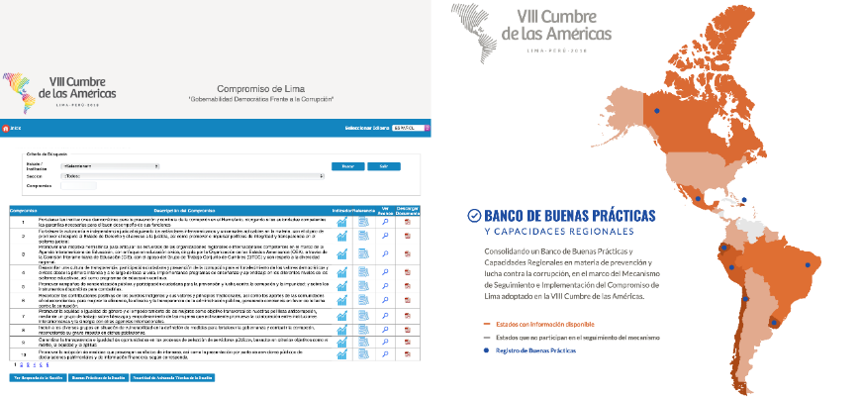AG/RES. 2933 (XLIX-O/19) AG/RES. 2924 (XLVIII-O/18)

Virtual Platform of the Lima Commitment Follow-up and Implementation Mechanism and its Database of Best Practices and Regional Capacities

|  |
| --- |
|  |

2.9.3 Department of Strategic Initiatives and Public Diplomacy

Columbus Memorial Library

Summary of Achievements

* As the single largest repository for the OAS and the inter-American system, the Library handled 3,821 requests for information and processed 73 inter-library loans through the reference, documents, access to information, and record administration services. The News Alert Service electronically sent out 34,360 articles and publications of interest.
* Notable dignitaries to visit included the former President of Panama, Arístides Royo; processing of the Luigi R. Einaudi Collection continued; and donations of library materials were received from Brazil, Panama, Mexico, and Dominican Republic, among others;
* Three Panamanian librarians were hosted for three weeks to provide them with unique documents used in celebrating the 500th anniversary of Panama City.
* As the exclusive institutional provider of the required international standardization, the Library assigned 92 classification codes and 143 International Standard Book Numbers (ISBN) and recorded 103 Cataloging in Publication (CIP) requests. In addition, 1,335 publications were acquired from various units of the General Secretariat.
* As part of the digitization project, over 18,500 pages of historical OAS documents were sent to HeinOnline.
* Several exhibitions were mounted, featuring among other things the 100th Anniversary of the International Labour Organization; MAPP: 15 years of peace; in addition to the various book launches, including for Ambassador Néstor Cerón Suero’s *Organization of American States (OAS) Electoral Observation in the Dominican Republic 1962 – 2016*; author Maria Werlau’s *Cuba’s Intervention in Venezuela*; and Cletus Springer’s *Sugar Blues*; culminating in December with an Open House for permanent representatives.

[www.oas.org/columbus](http://www.oas.org/columbus)

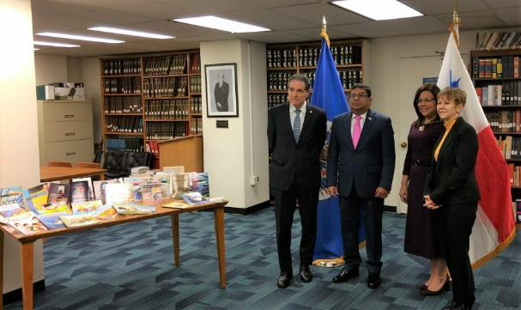

Visit by former President of Panama, Arístides Royo, November 22, 2019

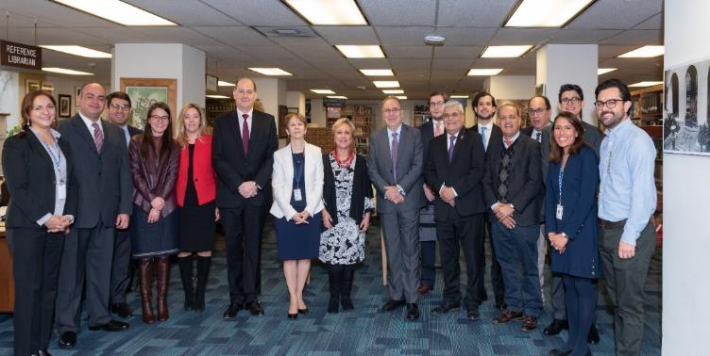

CML Open House – December 12, 2019

Art Museum of the Americas (AMA)

Main achievements

Proving to be a successful year for the Art Museum of the Americas, 2019 saw the Museum enhance its image and its importance within the OAS. Eleven exhibitions were mounted, featuring artworks from member states, which were reviewed by the media. AMA enjoyed significant coverage in the local and Latin American media, including outlets such as *El Nuevo* Herald (Miami), Washingtonian, The Washington Post, Metro Weekly, *Hola Cultura, Platforma Colectiva* (Chile), *CGTN America*, *Radio Television Marti* (Cuba), and InfoBae.

The exhibitions included: Carolina Mayorga: PINK Ranchos and Other Ephemeral Zip Codes (Colombia); A Gaze through the CINTAS Fellowship Program: a Selection of Works from the CINTAS Foundation and the Art Museum of the Americas Collections (Cuba/United States); Carlos Páez Vilaró: Roots of Peace (Uruguay); Rafael Soriano: “Cabezas/Heads (Cuba); Visual Memory: Home and Place (Dominican Republic); *Todo existe palpitando:*  Rodolfo Abularach in the Art Museum of the Americas (1959 -2019) (Guatemala); Vicente González Mimica: Del Sur, Portraits of Punta Arenas and Valparaíso (Argentina and Chile); Museum: A Haunted Medium: Paula Pedrosa, Traer Scott, and Andrés Wertheim (Brazil, United States, and Argentina); On the Move: Photographs by Juana Barreto Yampey, Helena Giestas, and Olivia Vivanco (Brazil, Paraguay, Argentina).

The mural entitled Roots of Peace, by Carlos Páez Vilaró, was mostly restored and enabled a series of guided tours of this masterpiece. This enabled more than 15 educational programs – between conferences and workshops, shedding new light on art and cultural diplomacy. The number of visitors to the Museum increased to more than 15,200 persons and an active program of guided tours was conducted to introduce AMA to key new audiences. This included a special program of visits to the “Roots of Peace” tunnel mural by Carlos Páez Vilaró.

More information can be obtained at the following links:

* <http://museum.oas.org>
* <http://museum.oas.org/collection.html>
* <http://museum.oas.org/rental.html>

Publications on the web or social media:

Carolina Mayorga (Colombia) — Arte al Dia —February 14, 2019

<http://www.artealdia.com/News/CAROLINA-MAYORGA-CREATES-A-PINK-UNIVERSE>

*Art Museum of the Americas (General) — Where Traveler* — March 1, 2019

<https://www.wheretraveler.com/washington-dc/play/dc-museums-open-during-government-shutdown>

*A Gaze through the CINTAS Fellowship Program: a Selection of Works from the CINTAS Foundation and the Art Museum of the Americas Collections (United States / Cuba)* — El Nuevo Herald — May 23, 2019, <https://www.elnuevoherald.com/vivir-mejor/artes-letras/article230439349.html>

*Museum: A Haunted Medium (Argentina / Brazil / United States)* — Washingtonian — July 18, 2019, <https://www.washingtonian.com/2019/07/18/at-this-new-exhibit-you-are-a-ghost-and-youre-haunting-the-museum/>

Carlos Páez Vilaró (Uruguay) — InfoBae— August 1, 2019

<https://www.infobae.com/america/cultura-america/2019/08/01/un-mural-secreto-del-artista-uruguayo-carlos-paez-vilaro-en-un-tunel-de-washington-fue-abierto-al-publico-tras-seis-decadas/>

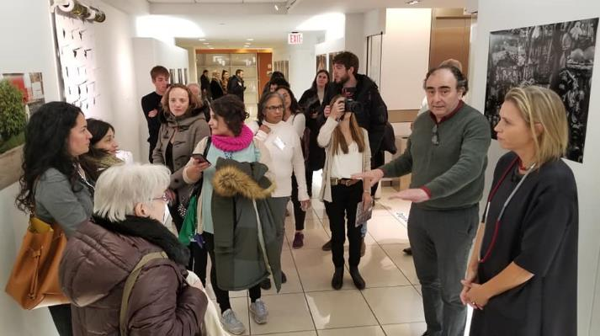

Exhibition “On the Move: Photographs by Juana Barreto Yampey, Helena Giestas, and Olivia Vivanco” (Brazil, Paraguay, Argentina) opened at the Photo Gallery at TL (GSB)

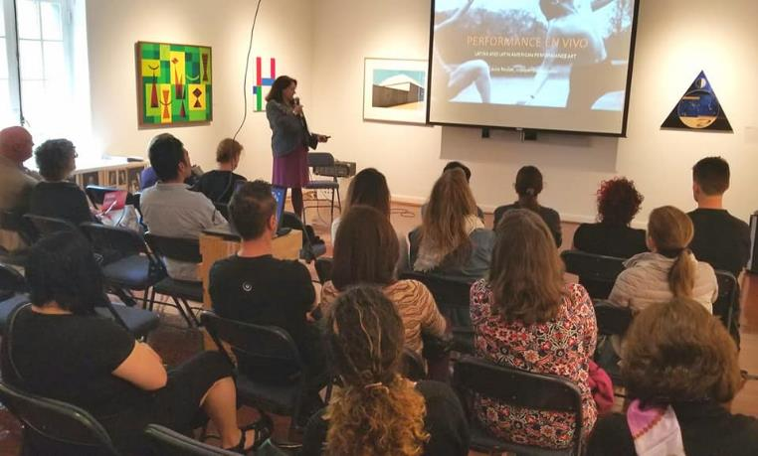

Talk on performance art at the Art Museum of the Americas, given by curator Laura Roulet as part of the Carolina Mayorga exhibition: PINK Ranchos and Other Ephemeral Zip Codes (Colombia)

**XII Private Sector Forum of the Americas**

On the sidelines of the forty-ninth General Assembly, the General Secretariat, the Government of the Republic of Colombia, and the Private Sector of the Americas organized the XII Private Sector Forum of the Americas, under the theme "Private Sector Innovation: Driving Development in the Americas.” This topic was explored via three panels: (i) The Fourth Industrial Revolution: Opportunities and Challenges for the Americas, (ii) The Future of Integration in the Americas, and (iii) Smart Energy in the Americas. The Forum sought to have representation from various sectors and countries in the composition of its panelists and moderators and brought together more than 300 private sector executives from 17 member states.

The Private Sector of the Americas delivered its recommendations to the President of the Republic of Colombia and to the OAS Secretary General, in a bid to encourage the OAS member states to implement public policies that are in line with them and to pledge to work together “for economic and social progress” in the countries and in the region.

GS/OAS is drawing up a work plan toward an Inter-American Business Charter to include all stakeholders and sectors of the Hemisphere.

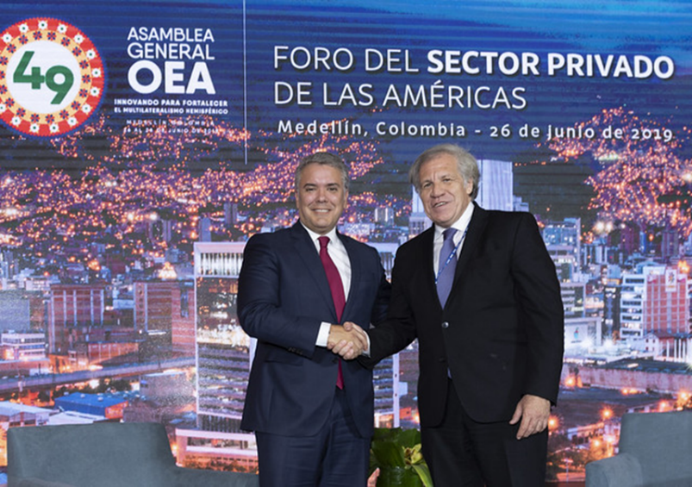

* 1. **OFFICE OF THE STRATEGIC COUNSEL FOR ORGANIZATIONAL DEVELOPMENT AND MANAGEMENT FOR RESULTS**

The Office of the Strategic Counsel for Organizational Development and Management for Results (SCODMR) continued to provide input to the policy bodies for clarifying supplementary information on the Comprehensive Strategic Plan of the Organization, as well as additional information on the current situation with the mandates of the Organization. The Office made significant progress in implementing the Organizational Development Program, to contribute to the process of transforming and strengthening the OAS, with a view to: i) realigning the human capital with the organizational goals; ii) breaking up silos, promoting innovation, and working more collaboratively; iii) improving efficiency in the Organization; and iv) improving the GS/OAS workplace environment.

SCODMR also helped build voluntary contributions for General Secretariat projects. These increased to a total of $61 million. The Office also made efforts to attract new observer states to the OAS, private sector stakeholders, and foundations in Observer countries in order to diversify donors and raise funds. It also moved forward with the implementation of the internal and external communication strategy aimed at helping to ensure that external and internal stakeholders perceive the OAS as a benchmark in issues related to democracy, human rights, multidimensional security, and integral development.

The Office of the Strategic Counsel for Organizational Development and Management for Results also addressed the needs of other areas of the GS, such as participation in special missions (e.g., CICIES), the School of Governance, SEDI's competitiveness projects, and publicizing GS/OAS programs when invited to various seminars and conferences.

The results achieved in 2019 are detailed below, by area of SCODMR:

### 2.10.1 Department of Planning and Evaluation

The Department of Planning and Evaluation (DPE) provided the Permanent Council and its permanent committees with technical advice, pursuant to General Assembly mandates and requests from the Permanent Council and its policy bodies; supported the technical areas responsible for the strategic lines and objectives in compiling the Comprehensive Strategic Plan. It also kept the Permanent Council abreast of progress on the process of the Strategic Plan, resolutions, and requests from the policy bodies.

Through its Project Management Section, DPE continued to build capacity in project formulation and follow-up by training officers and representatives of permanent missions to the Organization. With Project Evaluation Committee (PEC) support and coordination in independent external evaluation proceedings and development of tools for follow-up on the recommendations from external evaluations, the Organization’s oversight and accountability processes saw improvements, as did the use of results-based management.

Highlights of achievements:

**Mandates Planning, Budgeting, and Monitoring Support Section**

* One (1) Strategic Planning System (STPS): <http://services/stps/> developed. One hundred and nine (109) STPS users (GS staff) trained in collecting input related to the outcomes of the strategic plan.
* Documents updated and published on the Organization’s “Accountability” page:
* Compilation of the OAS Strategic Plan 2019, a document outlining the historical process of preparing the plan and its structure, and compiles matrices by pillar and support area: [CP/doc.5469/19](http://scm.oas.org/IDMS/Redirectpage.aspx?class=CP/doc.&classNum=5469&lang=e).
* Strategic Planning of the Organization: [CP/RES.](http://scm.oas.org/doc_public/SPANISH/HIST_19/CP40458S03.doc) [1121 (2209/19)](http://scm.oas.org/doc_public/english/HIST_19/CP40458e03.doc), resolution adopted by the Permanent Council on Wednesday, March 13, 2019 at its regular meeting.
* Report related to the Strategic Plan, document CAAP/GT/RVPP-422/19 [as of September 30, 2019](http://scm.oas.org/IDMS/Redirectpage.aspx?class=CAAP/GT/RVPP&classNum=422&lang=e) and Report on [Verified Accomplishments as of Dec 2019](http://www.oas.org/es/saf/rendicion_cuentas/docs/Logros-Verificados-por-Pilar-Esp-Dic2019.pdf).
* Report with principal program outcomes by GS/OAS chapter for January to December 2018 and January to June 2019, published.
* Report on Costs of GS/OAS Programs and services for 2020, prepared.

The member states had additional information on:

* Progress on the Comprehensive Strategic Plan of the Organization [CAAP/GT/RVPP-410/19](http://scm.oas.org/doc_public/english/HIST_19/CP41626e03.doc) as of November 2019 presented.
* General Secretariat Analysis on Incentives for Timely Payments, Quota Assessments, and Liquidity. Document (CAAP/GT/RTPP 186) presented. [CP40979E03.doc](http://scm.oas.org/doc_public/english/HIST_19/CP40979e03.doc)
* Report and table with cost estimates for 2019 resolutions adopted by the General Assembly, distributed and published. [Link](http://scm.oas.org/pdfs/2019/CP41537TAGCUADRORESUMEN2019.xls); [Link](http://scm.oas.org/pdfs/2019/CP41537TANEXOSCOMPILADOS2019.docx)
* Prioritization of Mandates and Creation of new mandates, presented. [CP41623EMandatos.pdf](http://scm.oas.org/pdfs/2019/CP41623Emandatos.pdf)

**Project Management Support Section:**

* Seven (7) external evaluation reports on twelve (12) projects, published and disseminated on the OAS accountability website.
* <http://www.oas.org/en/saf/accountability/evaluation.asp>
* Reports on the projects evaluated by the Project Evaluation Committee (PEC), prepared.
* Statistics available on projects submitted and evaluated by the PEC, by secretariat.
* The Project Evaluation Committee (PEC) assessed the relevance and technical feasibility of twenty-six (26) project profiles and Electoral Observation Missions.
* Technical assistance, review, and analysis of twelve (12) Project Documents, planned. (<http://services/PFME/Monitoring/MonitoringAll.aspx>)
* Nine (9) semiannual reports on the status of the execution of funds submitted to the Mission of the United States to the OAS and the Spanish Cooperation Agency, prepared.
* Forty (40) interim or final verification reports on projects financed by the Spanish Fund for the OAS, the United States OAS cooperation fund, and the United States OAS democracy fund, and other donors, prepared.
* General Secretariat Program and Project Evaluation Policy, prepared.
* Ten (10) independent external evaluations (formative and final), funded by external donors, coordinated and supervised.
* Technical assistance provided to implement recommendations from external evaluations on approximately twenty-five (25) new projects.
* Updated System for Monitoring Implementation of Recommendations from External Evaluations.
* 90 participants (GS staff and permanent representatives) increased their knowledge of Results-Based Management.
* PEC Decision Documents 2018 and 2019, published.
* Database of Lessons Learned from programs and projects, developed.
* SAF-DPE coordination on spending control for projects financed by specific funds for efficient use of resources, improved.
* Procedures and guidelines for institutional project management (project formulation, monitoring, and evaluation) developed, documented, and published.

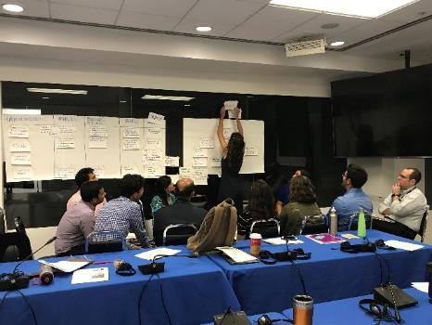**Images of project management training workshops held in May 2019**

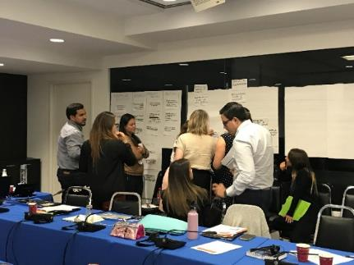

**Organizational Development**

The Organizational Development (OD) section continued working in collaboration with different areas of the Organization to execute components of the Organizational Development Program, to have a greater impact on responses to the policy guidelines from member states, in order to: ) realign the human capital with the organizational goals, with emphasis on strengthening organizational competences; ii) break down silos, promote innovation, and increase levels of collaboration by implementing collaborative working methods; iii) improve the Organization’s efficiency levels by developing methodologies, protocols, and documentation and optimizing processes; and iv) improve the GS/OAS work environment through training to prevent workplace harassment and conflict.

The Section focused its efforts on the four work areas referenced above, and started the process of institutionalizing the Competencies Framework, guiding the staff training courses and the recruitment processes. It applied the methodology of approaching hemispheric challenges from the perspective of the four pillars in developing programs, and sought the collaboration of highly specialized entities in areas that complement GS/OAS efforts. It adapted methodologies designed to: avoid repeating mistakes and disseminate best practices to improve the quality of programs, projects, and services; measure the impact of training and encourage application of on-the-job learning; and develop protocols to reduce the number of meetings to a sufficient minimum and maximize their effectiveness. The Section implemented an online course on the OAS Code of Ethics and Conduct and a pilot project with volunteers from the organization, seeking to build a working environment conducive to professional growth and to achieving optimum efficiency.

Prominent among the outcomes are:

* Beginning of the incorporation of the Competencies Framework into existing Human Resources tools.
* Documentation of the process of building the GS/OAS Competency Framework to institutionalize it.
* Organizational competency gaps in administrative management issues addressed through training for Secretaries, Directors, and Section Chiefs (80 staff members benefited).
* Design of the GS/OAS first quantitative methodology to support the Integrated Anti-Corruption Program.
* Standardization and normalization of the first-ever GS/OAS database to support implementation of the Lima Commitment.
* Negotiations well underway to secure *pro bono* support from Bain & Company for constructing quantitative anti-corruption indicators.
* Adaptation of documentation methodologies and application of lessons learned to promote knowledge transfer among the GS/OAS areas.
* Knowledge Management (KM) Network with WB, IMF, and IDB experts strengthened and informing the development of the GS/OAS KM Strategy.
* 3 pilots initiated with different areas of the Organization to learn on a small scale and inform the Knowledge Management Strategy.
* Protocol for effective meetings developed jointly with the staff in order to reduce the number of meetings, their length, and cost to the Organization.
* Methodology to measure impact and make training programs more effective, adapted for GS/OAS.
* Diagnosis conducted on the project formulation, review, and approval process to inform their future optimization.
* Review of the EARS process and proposal for improvement, developed.
* Implementation of the Pilot Program for the Promotion of a Respectful Working Environment (guided by SCODMR, CIM, and Ombudsperson) and conducting of: i) workshops on constructive feedback; ii) workshops on interpersonal relations; and iii) awareness campaign with DPC to be implemented in 2020.
* Virtual course on ethics and code of conduct for all staff, implemented jointly with DHR and the Portal of the Americas (775 staff members benefited).

**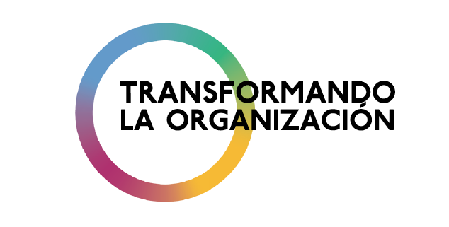**

**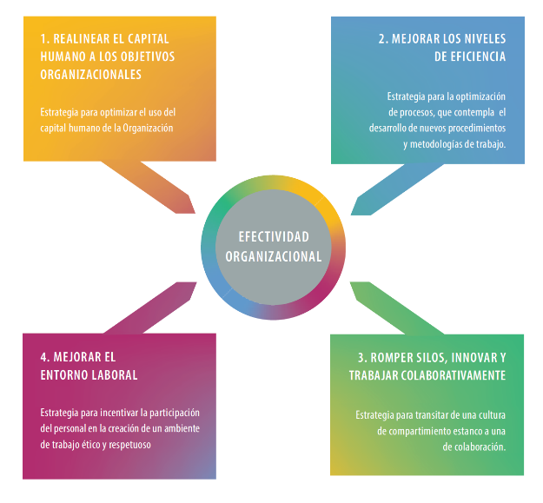**

### 2.10. 2 Department of External and Institutional Relations (DEIR)

The Department of External and Institutional Relations (DEIR) helped to increase voluntary contributions for General Secretariat projects to a total of $61 million. Of this amount, $21 million in contributions came from permanent observers, or 30.6% more than in 2018. This significant increase came about through 250 bilateral meetings organized between General Secretariat areas and permanent observers, the private sector, and foundations. The Department also organized 30 meetings between the Secretary General and high-level authorities of the permanent observers, including three visits to the capitals of these strategic partners.

The DEIR promoted projects of the various Secretariats and Committees through 10 donor roundtables. It strengthened policy dialogue and cooperation between member states and permanent observers through the General Assembly and the annual meeting of the heads of delegation with the observers, fostering an exchange of ideas and increased funding for OAS programs. Two new observer countries (Ukraine and Georgia) became donors to the Organization, and the relationship with observer countries in Asia and the Middle East was reactivated.

In coordination with the Chairs of the Permanent Council (United States and Guatemala), the DEIR organized two special Permanent Council meetings devoted to the observer states, to promote an exchange of information on common objectives and projects and alliances with these OAS partners. Lastly, in 2019 the DEIR sought to attract to the OAS new observer states, as well as private sector actors and foundations from observer countries, with a view to diversifying donors, leveraging resources, and taking advantage of experiences and best practices.

* The $21,072,075 in contributions from permanent observers is the largest increase since 2008 – and a 30.6% increase over the 2018 figure.
* Project promotion was intensified through more than 250 bilateral meetings between General Secretariat areas and permanent observers, the private sector, and foundations.
* 30 meetings between the Secretary General and ministers, vice ministers, and heads of the Americas divisions for observer states, including 3 visits to capitals of observers.
* 10 donor roundtables to present the General Secretariat's project offerings to member states and permanent observers.
* Annual Dialogue of the General Assembly (Medellín) Heads of Delegation and the permanent observers, with 44 high-level observer states participating.
* Two special Permanent Council meetings devoted to permanent observers.
* Partnership with the Netherlands and the Clingenda Diplomatic Academy, which trained 14 representatives of the Permanent Missions to the OAS at The Hague.
* Fifth High-Level OAS-EU Policy Dialogue at OAS headquarters to strengthen partnerships and increase collaboration and coordination to advance democracy, security, human rights, and sustainable development in the Americas.
* Greater coordination with member states, observers, and General Secretariat areas, to seek external financing.
* 40 meetings with 11 private sector companies from observer states, to promote partnerships on development and security projects.
* Two observer countries (Ukraine and Georgia) became new donors.
* Outreach made to potential new Observers, to diversify donors, leverage resources, and take advantage of experiences and best practices.

<http://www.oas.org/saf/DFAMS/2019/12/SF_TABLE_CONTPO_20191231_EN.pdf>

<http://www.oas.org/en/ser/dia/perm_observers/countries.asp>

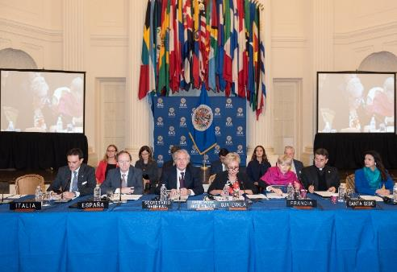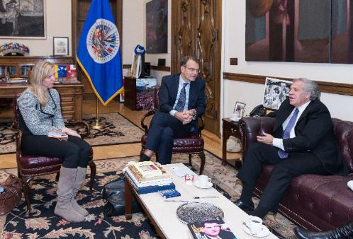

Third special meeting of the Permanent Council dedicated to Permanent Observers (November 2019)

Permanent Observer of the Kingdom of the Netherlands André Haspels meets with Secretary General Luis Almagro

### 2.10.3 Department of Press and Communication

The Department of Press and Communications (DPC) continued to work toward the purpose set forth in the November 2015 Communications Strategy, which is to ensure “that the OAS is perceived by key (internal and external) actors as a facilitator of solutions in issues relating to democracy, human rights, security and integral development.”

Using available information as a proxy for measuring impact, the results reveal the Organization’s importance. The increase in the publication of articles with mentions of the OAS in leading newspapers in the region, for example, saw a significant up tick. Year-on-year increase was 85 percent, which triggered a 161 percent increase since 2015 (see breakdown below). Therefore, the Organization continues to maintain a historically high presence in the leading media outlets.

The Organization's social media platforms continued to register very high figures. The following on the Spanish-language Twitter account grew 51 percent (223,000 new followers), and by 79 percent (almost 14,000 more followers) on the English account. On Facebook, the growth in Spanish-language followers slowed slightly (-7 percent, 80,000 new followers compared to 86,000 new followers in 2018). Even so, the reach grew by 11 per cent. The number of new followers In English grew by 47 percent (about 9,000 additional followers in 2019, up from about 6,000 in 2018), although the reach shrank by 9 percent.

The OAS website, which is in the process of being revamped, saw a significant increase in unique visitors (21.80 percent), while page views increased by 17.22 percent. Email transmissions registered a 6 percent decrease in terms of open ratio (0.8 points) and the same figure for the click rate (0.03 points), suggesting a maturing of the email distribution list and perhaps of even email as a distribution channel.

In terms of video production, there was an overall increase: 6 percent more live webcasts (183 in 2019 versus 159 in 2018); 6 percent more video news produced (118 versus 111); and 170 percent more short videos (389 versus 144) were cut and distributed.

Likewise, corporate communication management (editing of speeches, preparation of interviews, design and implementation of communications plans) was strengthened and the overhaul and standardization of the General Secretariat’s image.

**Results obtained by DPC**

**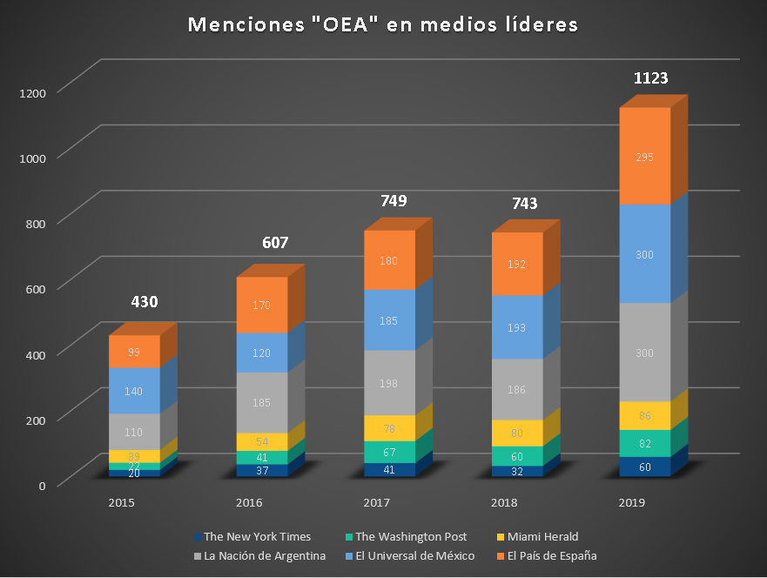**

|  |  |  |  |  |  |  |  |  |  |  |  |  |  |  |  |
| --- | --- | --- | --- | --- | --- | --- | --- | --- | --- | --- | --- | --- | --- | --- | --- |
| **“OAS” mentions in leading media outlets** | | | | | | | | | | | | | | | |
| **Media outlet** | **2015** | **2016** | **Increase 2015-2016** | **2017** | **Increase 2016-2017** | **Increase 2015-2017** | **2018** | **Increase 2017-2018** | **Increase 2016-2018** | **Increase 2015-2018** | **2019** | **Increase 2018-2019** | **Increase 2017-2019** | **Increase 2016-2019** | **Increase 2015-2019** |
|
| **The New York Times** | 20 | 37 | 85.00% | 41 | 10.81% | 105.00% | 32 | -21.95% | -13.51% | 60.00% | 60 | 87.50% | 46.34% | 62.16% | 200.00% |
| **The Washington Post** | 22 | 41 | 86.36% | 67 | 63.41% | 204.55% | 60 | -10.45% | 46.34% | 172.73% | 82 | 36.67% | 22.39% | 100% | 272.73% |
| **Miami Herald** | 39 | 54 | 38.46% | 78 | 44.44% | 100.00% | 80 | 2.56% | 48.15% | 105.13% | 86 | 7.50% | 10.26% | 59.26% | 120.51% |
| **La Nación - Argentina** | 110 | 185 | 68.18% | 198 | 7.03% | 80.00% | 186 | -6.06% | 0.54% | 69.09% | 300 | 61.29% | 51.52% | 62.16% | 172.73% |
| **El Universal - Mexico** | 140 | 120 | -14.29% | 185 | 54.17% | 32.14% | 193 | 4.32% | 60.83% | 37.86% | 300 | 55.44% | 62.16% | 150% | 114.29% |
| **El País - Spain** | 99 | 170 | 71.72% | 180 | 5.88% | 81.82% | 192 | 6.67% | 12.94% | 93.94% | 295 | 53.65% | 63.89% | 73.53% | 197.98% |
| **Total** | **430** | **607** | **41.16%** | **749** | **23.39%** | **74.19%** | **743** | **-0.80%** | **22.41%** | **72.79%** | **1123** | **51.14%** | **49.93%** | **85.01%** | **161.16%** |

* Impact of the website:
  + Unique visitors increased by 21.80 per cent.
  + Page views increased 17.22 per cent.
* Impact in videos:
  + 118 Video News pieces were produced in both languages (6.30 percent more than the previous year)
  + 183 OAS events were webcast, a 15 per cent increase over the previous year
  + 389 video clips were produced and distributed, 170 per cent more than the previous year
* Impact in corporate communication:
  + 124 talking point documents were edited, as were 48 interviews.
  + 15 communication plans for OAS events and programs were prepared and implemented
  + Materials prepared for 21 interviews of senior officers in the Organization
* Impact in photographic production:
  + 394 photo galleries of OAS events and programs were produced
* Impact in social media:

|  |  |  |  |
| --- | --- | --- | --- |
| **Twitter @OEA\_oficial** | **2018** | **2019** | **Change 2018-2019** |
| **New followers** | 147,995 | 223,565 | **51%** |
| **Likes** | 56,042 | 251,400 | **349%** |
| **Impressions** | 19,494,000 | 50,534,000 | **159%** |

|  |  |  |  |
| --- | --- | --- | --- |
| **Twitter @OAS\_official** | **2018** | **2019** | **Change 2018-2019** |
| **New followers** | 7,815 | 13,987 | **79%** |
| **Likes** | 7,870 | 18,179 | **131%** |
| **Impressions** | 2,887,000 | 6,656,000 | **131%** |

|  |  |  |  |
| --- | --- | --- | --- |
| **Facebook @OEAoficial** | **2018** | **2019** | **Change 2018-2019** |
| **Likes** | 86,815 | 80,436 | **-7%** |
| **Reach** | 19,221,000 | 21,423,862 | **11%** |

|  |  |  |  |
| --- | --- | --- | --- |
| **Facebook @OASofficial** | **2018** | **2019** | **Change 2018-2019** |
| **Likes** | 6,399 | 9,387 | **47%** |
| **Reach** | 619,420 | 565,264 | **-9%** |

|  |  |  |  |
| --- | --- | --- | --- |
| **Mailchimp** | **2018** | **2019** | **Change 2018-2019** |
| **Open Rate** | 12.7 | 11.94 | **-6%** |
| **Click Rate** | 0.49 | 0.46 | **-6%** |

Links:

Website: <http://www.oas.org/en/default.asp>

Twitter: <https://twitter.com/oas_official>

Facebook: <https://www.facebook.com/OASofficial/>

Flickr: <https://www.flickr.com/photos/oasoea/>

Vimeo: <https://vimeo.com/channels/oasvideonews>

YouTube: <https://www.youtube.com/user/OASVideos>

Press releases: <https://www.oas.org/en/media_center/press_releases.asp>

Remarks: <http://www.oas.org/en/media_center/speeches.asp>

**3. AUTONOMOUS ENTITIES AND ORGANIZATIONS**

**3.1 SECRETARIAT OF THE INTER-AMERICAN COURT OF HUMAN RIGHTS**

The Inter-American Court of Human Rights is a treaty-based body formally established on September 3, 1979, as a result of the entry into force of the American Convention on Human Rights on July 18, 1978. According to its Statute, it is an “autonomous judicial institution” whose purpose is to apply and interpret the American Convention. Based in San José, Costa Rica, it is made up of seven judges who are nationals of member states of the Organization of American States.

In 2019, its composition was as follows: Eduardo Ferrer Mac-Gregor Poisot (Mexico), President; Eduardo Vio Grossi (Chile), Vice President; Humberto Antonio Sierra Porto (Colombia); Elizabeth Odio Benito (Costa Rica); Eugenio Raúl Zaffaroni (Argentina); Patricio Pazmiño Freire (Ecuador); and Ricardo Pérez Manrique (Uruguay). The judges are assisted in their functions by the Court Secretariat. The Secretary to the Court is Pablo Saavedra Alessandri (Chile).

Judge Elizabeth Odio Benito was elected on November 22, 2019 as President and Judge Patricio Pazmiño Freire as Vice President. Their term commenced on January 1, 2020 and will run until December 31, 2021.

* **Principal activities and achievements in 2020**

In 2019, the Court held four regular sessions in San José, Costa Rica, and three special sessions – in Montevideo, Uruguay; Buenos Aires, Argentina; and Barranquilla and Bogotá, Colombia. It held 18 public hearings on contentious cases,[[2]](#footnote-2) three public hearings on monitoring of compliance with its judgments,[[3]](#footnote-3) and 13 closed hearings on monitoring of compliance with its judgments.[[4]](#footnote-4)

The Court issued 25 judgments in the course of the year: 21 on preliminary objections and/or merits, reparations, and costs in contentious cases,[[5]](#footnote-5) and four interpretations of its judgments.[[6]](#footnote-6) The Court issued 54 orders on compliance with its judgments and 19 on provisional measures, and currently has under its supervision 28 provisional measures that are in effect. And lastly, 32 new contentious cases[[7]](#footnote-7) and four requests for advisory opinion[[8]](#footnote-8) were submitted to the Court.

* **Relations and forms of cooperation with other inter-American, extra-regional, or global organizations in the execution of activities**

The Court maintains excellent relationships with regional courts for dialogue concerning protection of international human rights. The International Human Rights Forum was held in Kampala, Uganda, in 2019. It brought together the African Court on Human and Peoples’ Rights, the European Court of Human Rights, and the Inter-American Court of Human Rights. An outcome of the meeting was the signing of the Kampala Declaration, which, together with the 2018 San José Declaration, consolidates the spaces for exchange between the courts.

The Court also interacts on an ongoing basis with the Inter-American Commission in the context of their respective spheres of competence and mandates, and also holds an annual Forum on the Inter-American Human Rights System for both bodies to have dialogue and to also discuss with institutions and civil society present and future challenges to the system. The third edition of the Forum was held in Quito, Ecuador, in 2019.

Regarding dialogue with the United Nations, the Court hosted the United Nations High Commissioner for Human Rights, Ms. Michelle Bachelet; the United Nations Under Secretary-General for Human Rights, Mr. Andrew Gilmour; as well as the Executive Secretary of the Economic Commission for Latin America and the Caribbean (ECLAC), Ms. Alicia Bárcena. These meetings involved, respectively, discussions on areas of cooperation and convergence between the universal and inter-American systems, as well as on the human rights challenges facing the world. A meeting was also held with the Director of UNESCO, Ms. Audrey Azoulay, and a cooperation agreement was signed to disseminate the Court’s jurisprudence on freedom of expression and protection of journalists.

The year also saw the first meeting between the Court and the European Committee on Social Rights, and the Court participated in more than 50 training and dissemination activities relating to international human rights instruments. Likewise, in 2019 the Court concluded 21 cooperation agreements with different domestic courts, ministries, ombudsmen, universities, and human rights centers. These agreements are especially important for strategic coordination of work done at the domestic and inter-American levels to guarantee more extensive and comprehensive protection of human rights in the Americas.

**3.2 EXECUTIVE SECRETARIAT OF THE INTER-AMERICAN COMMISSION ON HUMAN RIGHTS (IACHR)**

In 2019, the year in which it marked its 60th anniversary, the IACHR made strides in reducing procedural backlog and adopted more reports on merits and admissibility, announced more new petitions, took less time to assess requests received concerning precautionary measures, and sent an unprecedented number of cases and requests for advisory opinions to the Inter-American Court of Human Rights. The IACHR strengthened its monitoring work as well, responding effectively and immediately to human rights situations that arose in several countries, including Ecuador, Chile, Bolivia, and Haiti.

Notable among those responses was the creation of the [Interdisciplinary Group of Independent Experts (GIEI)](http://www.oas.org/es/cidh/prensa/comunicados/2020/013.asp) in Bolivia. Mechanisms for follow-up on existing recommendations were enhanced and new ones created, pertaining to Venezuela and Honduras. The IACHR also increased its presence in the region by conducting two onsite visits - to El Salvador and Haiti - and working visits to 18 countries and held three sessions away from headquarters. It also published 10 thematic reports, 1 country report, and 2 resolutions on declarations of principles, signed 11 inter-agency cooperation agreements, and organized training and promotional activities that reached more than 6,500 persons.

For the first time, the IACHR took part in the High-Level Segment of the United Nations Human Rights Council in Geneva. It also strengthened cooperation with international and regional human rights agencies. In addition, it launched the IACHR Channel, held campaigns to promote standards, launched the User Assistance Center, and created the IACHR Impact Observatory, among other important achievements.

* **Petitions and cases:** increase in the approval of admissibility and merits reports (215), and increase in the evaluation of petitions under initial study (6,750); real-time evaluation of requests for precautionary measures received (1,158), granting of 64 new measures and extension of 10 existing measures; signing of 14 new friendly settlement agreements and progress in the implementation of 111 reparation measures.
* **Monitoring**: preparation and approval of 10 thematic reports and one country report; publication of 221 press releases on monitoring; installation of Rapid and Integrated Response Coordination Units (SACROIs) for Haiti, Ecuador, Chile, and Bolivia, and maintenance of SACROIs for Brazil, Guatemala, Honduras, Nicaragua, and Venezuela; on-site visits to El Salvador and Haiti conducted.
* **Public presence in the region**: three sessions organized away from headquarters (in Bolivia, Jamaica, and Ecuador); conducted 22 working visits to 18 countries; published two resolutions ([principles on public policy on memory in the Americas](https://www.oas.org/es/cidh/prensa/comunicados/2019/333.asp)  and [on the human rights of all migrants, refugees, stateless persons, and victims of trafficking in persons](http://www.oas.org/es/cidh/prensa/comunicados/2019/345.asp)); outreach to the Caribbean (held one session and one public consultation, and organized visits to six Caribbean countries).
* **Follow-up on recommendations**: Existing special mechanisms strengthened —Ayotzinapa Case (MESA), Nicaragua (MESENI), Dominican Republic— and nine new mechanisms created (Venezuela, MESEVE and Honduras, MESAT); approval and publication of [General Guidelines for Follow-up on Recommendations and Decisions.](https://www.oas.org/es/cidh/actividades/seguimiento/pdf/Directrices-es.pdf)
* **Promotion and training:** 67 training events and 254 promotional activities were held in 23 countries, reaching 6,254 persons, in addition to 15 training sessions for 257 persons from Nicaraguan civil society; promotional visits to Argentina and Chile to mark the IACHR's 60th anniversary.
* **Technical cooperation:** 11 new agreements signed; 5 national human rights institutions acceded to the IACHR's Declaration of Commitment on Technical Cooperation.
* **Social participation:** participation by states of the region and 330 civil society organizations in 109 hearings during the four sessions; 16 portfolio review meetings; public consultations on Memory, Truth, and Justice, inclusion of LGBTI persons in the economic, social, and cultural spheres in the Caribbean, citizen security, corruption, and human rights, and the situation of the rights of the peoples of the Pan-Amazon region.
* **Communication:** launch of the [IACHR Channel,](https://www.canalcidh.org/) a website with multimedia products on IACHR activities; implementation of 9 campaigns to disseminate standards
* Annual report on implementation of the IACHR Strategic Plan 2017-2021:

<http://www.oas.org/es/cidh/prensa/comunicados/2020/033A.pdf>

* Reports on cases: <http://www.oas.org/en/iachr/decisions/cases_reports.asp>
* Thematic reports: <http://www.oas.org/en/iachr/reports/thematic.asp>
* Country reports: <http://www.oas.org/en/iachr/reports/country.asp>
* Sessions held: <http://www.oas.org/en/iachr/activities/sessions.asp>
* Resolutions: <http://www.oas.org/en/iachr/decisions/resolutions.asp>
* IACHR Twitter: <https://twitter.com/IACHumanRights>
* IACHR Channel: <https://www.canalcidh.org/>
* IACHR Flickr: <https://www.flickr.com/photos/cidh/albums>

Promotional visit to Argentina, to commemorate the 60th anniversary of the IACHR (September 2019)

**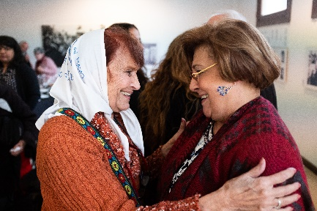**

Onsite visit to El Salvador (December 2019)

**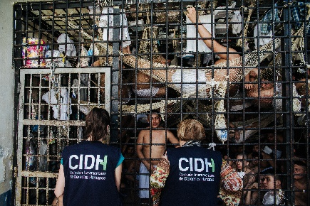**

**3.3 SECRETARIAT OF THE ADMINISTRATIVE TRIBUNAL**

The Administrative Tribunal of the OAS is an autonomous body established by the General Assembly via resolution AG/RES. 35 of 1971, for the purpose of examining disputes arising between the General Secretariat and its staff for alleged violation of the contractual conditions of the latter or because of infringement of the General Standards to Govern the Operations of the General Secretariat of the OAS and other applicable provisions. In 2019, the Administrative Tribunal comprised the following judges: Wilson Vallejo, President (Ecuador); Vice President (Ecuador); Magali Rojas, Vice President (Peru); Homero Bibiloni (Argentina); T. Michael Peay (United States); and Israel Campero (Bolivia).

The Tribunal ruled on two cases in 2019, namely:

1. Complaint 305, “Paola Cárdenas v. *Secretary General,”* submitted on July11, 2018*,* concerning classification level of a post occupied by the complainant. On June 20, 2019, the Tribunal issued Judgment 166 declaring the claim inadmissible and order the parties to resume, implement, and complete the internal administrative process that involves conducting a new audit of the post occupied by the complainant, within 60 days following the date of notification of that decision.
2. Complaint 306, “Richard Huber v. *Secretary General,”* submitted on December 7, 2018*,* concerning due process guarantees. On December 5, 2019, the Court issued Judgment 167 concluding that the complainant did not properly submit his claims at the previous administrative stages, thereby preventing the Tribunal from hearing and resolving the substance of his allegations.

The Administrative Tribunal convened its first special session from April 9 to 11, 2019 in Washington, D.C., to hold hearings as part of the incidental proceedings on admissibility that were opened for Complaints 305 and 306. Subsequently, from August 26 to 28, 2019, this Tribunal held its sixty-ninth regular session to consider the documents submitted by the parties under Appeal 306 and to begin deliberations on the case. During these sessions, the members of the Tribunal met with the Staff Committee and discussed the importance of informing the staff about the various mechanisms available for settlement of disputes within the organization; the database of case law currently in development; and the operational needs of the Tribunal, among other matters.

The Administrative Tribunal attended meetings of the OAS Permanent Council Committee on Administrative and Budgetary Affairs on two occasions: on April 9, 2019, to present its comments on the proposed program-budget that was being negotiated for 2020, through its President, Judge Wilson Vallejo; and on April 16, 2019, to deliver its annual report for 2018, through Judge T. Michael Peay. As well, on April 12 and July 26, 2019, the Tribunal visited with Secretary General Luis Almagro, to discuss administrative and budgetary matters.

The Administrative Tribunal also promoted other activities aimed at preventing conflicts and strengthening its internal and external cooperation relationships, including:

1. Participation on a panel discussing discrimination, harassment, and hostile work environment. This event was sponsored by the American Society of International Law and brought together the Secretaries of the Administrative Tribunals of the World Bank, the International Monetary Fund, the Inter-American Development Bank, and the OAS. They shared relevant case law on discrimination, harassment, and the hostile work environment (May 2019).
2. Meeting with the OAS Ombudsperson to discuss workplace harassment policy, alternatives for facilitating understanding of the justice administration system, and independent budget options, among other topics (December 2019).

In 2019, work also continued on developing the platform that will host the Tribunal’s new decision search engine.

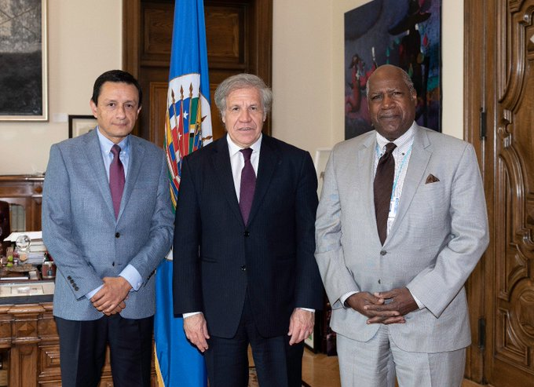

**3.4 INTER-AMERICAN CHILDREN’S INSTITUTE**

The transition from the 2015-2019 Plan of Action to the new 2019-2023 Plan, approved at the 94th Meeting of the Directing Council[[9]](#footnote-9) took place in 2019. In preparing it, states, civil society, and children’s and youth organizations were consulted.

Achievements:

* Colombia: XXII Pan American Child Congress, III Civil Society Forum, and III Pan American Forum of Children. In this context, III Civil Society Forum
* Benchmark agency in children’s policy in the region:
  + Committee on the Rights of the Child
  + Office of the UN Special Representative on violence against children
  + Technical assistance to Niñ@Sur Commission
  + Agreement with SIC
* We assumed Leadership of the Secretariat of the Global Movement for Children of Latin America
* June 9, “Americas Children and Youth Day” celebrated in: Chile, Colombia, Ecuador, El Salvador, Mexico, Panama, Paraguay, Peru, and Uruguay
  + “Not Favors, But Rights” Proclamation – drafted by CORIA Network
* Ecuador: push for an Inter-American Convention to eradicate violence against children and adolescents
* 319 people trained, covering all the states of the inter-American system
* Installation of training centers on children’s policies
* Paraguay, Guatemala, and Costa Rica
* 1st subregional gathering on alternative care: Costa Rica, Dominican Republic, Guatemala, Nicaragua, Honduras, Panama, Mexico, Haiti, Brazil.
* Hybrid course on violence, held jointly with Chile, Ecuador, El Salvador, Guatemala, Honduras, Mexico, and Paraguay, reaching 188 persons.
* Agreement with NNAPES Platform: Technical guidelines to protect the rights of children with parents incarcerated.
* ESNNA:
  + Americas Regional Action Group.
  + Hybrid course, jointly with Chile, Ecuador, El Salvador, Guatemala, Mexico, Panama, Paraguay, and Uruguay, reaching 198 persons.
  + IV Subregional gathering: *Exchange of experiences on sexual exploitation of children and adolescents on the Internet in travel and tourism* – Southern Subregion. Brazil, Bolivia, Chile, Ecuador, Paraguay, and Uruguay
  + Technical assistance agreement with Panama (COPREDES)
* SINNA: International Coordination Gathering of Central Authorities – South America: Argentina, Bolivia, Chile, Colombia, Ecuador, Paraguay, Peru
  + Subregional Gathering of Central Authorities of Central America, Mexico, and Dominican Republic
* Agreement with Citizen Horizon Foundation: Migration and early childhood
* Right to Participation. Technical assistance: Argentina, Brazil, Chile, Colombia, Costa Rica, Dominican Republic, El Salvador, Ecuador; Honduras, Mexico, Panama; Paraguay; Peru, and Uruguay
  + 421 children and adolescents involved in activities
  + Paraguay: 125 staff members of public institutions trained
  + Promotion of secure Internet use through RIAMUSI[[10]](#footnote-10)
* Strong IIN presence in social media continued

Links of interest:

* IIN-OAS website - <http://www.iin.oea.org/>
* IINfancia Newsletter - <http://www.iin.oea.org/boletines.html> Inter-American Program of Cooperation to Prevent and Remedy Cases of International Abduction of Children by One of Their Parents - <http://sinna.org/>
* NNAPES: Technical guidelines to protect the rights of children with parents incarcerated: <http://www.nnapes.org/docs/OTIIN-NAPPES-Version-Final.pdf>
* Inter-American Cooperation Program for the Prevention and Eradication of the Sexual Exploitation, Smuggling of and Trafficking in Children. <http://www.annaobserva.org/>
* Inter-American Program of Cooperation to Prevent and Remedy Cases of International Abduction of Children by One of Their Parents: <http://sinna.org/>
* Our Voice in Colors – space for promoting the participation of children and adolescents. [www.nuestravozacoloresiinoea.org](http://www.nuestravozacoloresiinoea.org)

**3.5 EXECUTIVE SECRETARIAT OF THE INTER-AMERICAN COMMISSION OF WOMEN (CIM)**

In 2019 the OAS Inter-American Commission of Women (CIM) held its 38th Assembly of Delegates in the Dominican Republic, where the Declaration of Santo Domingo on Equality and Autonomy in the Exercise of Women’s Political Rights for the Strengthening of Democracy was adopted,[[11]](#footnote-11) underscoring parity as a measure for justice, including three dimensions: (i) women and men participating on an equal footing (50/50) in decision-making positions in the public and private sectors, from the international to the local level; (ii) equal exercise of power, i.e., free from discrimination and violence based on gender and/or sex; and (iii) mainstreaming the women’s rights and gender equality agenda. In 2019, CIM began a process of strengthening dialogue with feminist and women’s civil society organizations, and positioned itself on a number of fast-track issues for women’s rights and gender equality in the Americas within the framework of its main lines of work:

1. **Women’s Political Rights for the Strengthening of Democracy**

* Training of 200 women official registered in four editions of the Course for Women Candidates in Panama, Bolivia, Colombia, and Costa Rica, in coordination with the OAS School of Governance[[12]](#footnote-12)
* Publication of the Model Protocol for political parties: Preventing, addressing, punishing, and eradicating violence against women in political life; and training for more than 150 political party members and staff in El Salvador, Ecuador, and Dominican Republic
* Training for more than 40 representatives of electoral institutions and tribunals and other key institutions in the first Inter-American Course on “Electoral Governance from a Gender Perspective” implemented in the Dominican Republic
* Political positioning of women’s leadership in multiple forums and agreements through the work of the Inter-American Task Force on Women’s Leadership.
* Participation of 13 organizations from the United States, Colombia, Guatemala, Mexico, Panama, Paraguay, and Peru in the think tank “Training for women in politics in review: What we do, what we know, what works.”

1. **Women's economic rights for integral development**

* Conceptual and policy position on: (i) the need to strengthen the inter-American legal framework on women's economic rights; and (ii) the importance of re-conceptualizing work to make unpaid and care work visible at the domestic level and to promote care as a shared social responsibility among women, men, the state, and the private sector.

1. **Institutionalization of the gender equality and human rights approach in the work of the OAS**

* Training for Ministry of Industry and Commerce staff, led by the Ministry of Women’s Affairs, for implementation of the Methodological Transfer for the Implementation of Participatory Gender Diagnostics in the Dominican Republic[[13]](#footnote-13)
* Training of more than 100 persons during the 17th and 18th editions of the online course “A Rights and Gender Equality Perspective in Policies, Programs, and Projects”[[14]](#footnote-14)
* Training of more than 100 persons during the 8th and 9th editions of the online course “Strategic Planning with a Gender Perspective”[[15]](#footnote-15)
* Training of 20 persons during the 5th edition of the Diploma in Communication, Gender, and Human Rights[[16]](#footnote-16)
* Training of more than 300 OAS staff members in the Massive Open Online Course (MOOC) on Institutional Policy on Gender Equality, Diversity, and Human Rights of the OAS General Secretariat and the Plan of Action for implementing it,[[17]](#footnote-17) for GS/OAS staff members
* Preparation of the OAS Inclusive Communication Guide

1. **Follow-up Mechanism to the Belém do Pará Convention (MESECVI )**

* Conclusion of the follow-up phase of the Third Round of Multilateral Evaluation, based on the *Progress indicators system for measuring implementation of the Convention of Belém do Pará*,[[18]](#footnote-18) with the approval of 17 national reports and one hemispheric report on the situation of violence against women
* Holding of the Sixteenth Meeting of the MESECVI Committee of Experts in Washington, D.C., where violence against women with disabilities was given visibility;
* Organization of outreach and training events with over 150 lawyers in Ecuador, Dominican Republic, and El Salvador on gender-based litigation and the Model Laws to Prevent, Punish and Eradicate Violence against Women in Political Life[[19]](#footnote-19) and to Prevent, Punish, and Eradicate the Violent Death of Women (Femicide/Feminicide);[[20]](#footnote-20)
* Commemoration of the twenty-fifth anniversary of the Inter-American Convention on the Prevention, Punishment, and Eradication of Violence against Women (1994 Convention of Belém do Pará);
* Preparation of a subregional report on violence against women in the OECS countries (Antigua and Barbuda, Dominica, Grenada, Saint Kitts and Nevis, Saint Lucia, Saint Vincent and the Grenadines).

**3.6 SECRETARIAT OF THE INTER-AMERICAN TELECOMMUNICATION COMMISSION (CITEL)**

The year 2019 was particularly significant for cooperation and the signing of agreements on telecommunications/information and communication technologies (ICTs) in the Americas, especially because CITEL concluded 309 inter-American agreements, **98% of which agreements (IAPs) were adopted on being defended by CITEL** at the United Nations/International Telecommunication Union World Radiocommunication Conference (WRC-19) in Egypt. These agreements were enshrined in the Radio Regulations - the international treaty governing radio frequencies and satellites worldwide.

Continuing efforts to connect the unconnected, CITEL held face-to-face and virtual roundtable discussions with more than 20 member states and private enterprise, resulting in recommendations for the establishment of policies that allow for flexibility in regulation to reach regions of our countries that do not have ICTs.

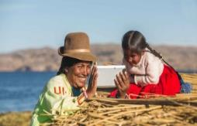Thanks to the implementation of the **2030 ICT ALLIANCE** **FOR THE AMERICAS**, digital inclusion has been brought to more than 1,500 remote areas in the Americas and digital literacy expanded with STEM programs for more than 140,000 children/youth. **ALLIANCE EMPOWERING RURAL WOMEN THROUGH ICTs** has been taking concrete action that generates new opportunities for women and girls through the use of ICTs.

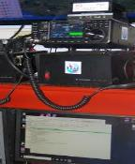Implementation of the **USE OF ICTs FOR EMERGENCY AND DISASTER SITUATIONS IN THE AMERICAS REGION**, a joint project involving ITU, CITEL, COMTELCA, and CTU, continued. This Alternative Regional Emergency Telecommunications Network based on amateur radio and the Internet is improving the response capacity in: Costa Rica, El Salvador, Guatemala, Honduras, Nicaragua, and Panama in the completed phase; and Antigua and Barbuda, Bahamas, Barbados, Belize, Dominica, Dominican Republic, Grenada, Guyana, Haiti, Jamaica, Saint Kitts and Nevis, Saint Lucia, Saint Vincent and the Grenadines, Suriname, and Trinidad and Tobago in the second phase.

**OTHER RESULTS OBTAINED:**

* OAS General Assembly support for CITEL initiatives, adopting three resolutions, related to: HEMISPHERIC EFFORTS TO COMBAT THE USE OF MOBILE EQUIPMENT THAT HAS BEEN STOLEN, LOST, OR TAMPERED WITH; THE USE OF ICTS FOR EMERGENCY AND DISASTER SITUATIONS IN THE AMERICAS REGION; AND THE LEADING ROLE IN DEVELOPING TELECOMMUNICATIONS/ICTs THROUGH CITEL in the Americas as an essential tool for the development in the countries.
* **Profuturo-Telefónica**: through the Digital Classrooms in the Caribbean program, signing completed and implementation started, with 92 schools, 1,212 teachers, 23,993 students and 59 trainers in the Bahamas, Barbados, Belize, Guyana, and Saint Lucia.
* **Millicom:** fulfilling the ICT 2030 Alliance commitments, it has connected 1,416 educational institutions in Latin America, including to equip educators in these institutions with safety programs for children and young people online, benefiting 3,713 teachers, 71,058 parents/tutors, and 120,099 children/adolescents.
* **VIASAT**: agreement signed to connect 8,000 schools to the Internet. Deployment of 100 experimental sites with satellite broadband including WiFi access points in marginal communities in rural areas of Central America and Northern Colombia.
* **ISOC:** awarded 150 scholarships for the online course **“Building wireless community networks**” and four scholarships in total for the onsite workshop on Community Networks in **Guatemala.**
* **OAS-Telefónica** **Award** given in the “**Rural Businesswoman”** category to the Curi-Maki Craftswomen Association of Peru.
* **Hispasat/Hispamar:** launched pilot project to provide satellite connectivity via open WiFi access points in a number of rural zones in Colombia’s Caribbean region.
* **Cabase:** awarded 88 scholarships for webinar on telecommunications through CCTLAT
* **343 scholarships** were awarded, benefiting participants from **18 member states** ***(Argentina, Bolivia, Brazil, Chile, Colombia, Costa Rica, Dominican Republic, Ecuador, El Salvador, Guatemala, Honduras, Mexico, Nicaragua, Panama, Paraguay, Peru, Uruguay, and Venezuela)*** through the CITEL, ICT 2030 Alliance, and PAEC training centers.

**Links:**

* <https://digitalpolicylaw.com/cmr19-como-se-preparo-la-region-para-el-mundial-del-espectro/>
* <https://www.iaru-r2.org/reconocimiento-de-citel-por-el-trabajo-efectuado-en-la-cmr-19/>
* <http://venamerica.org/web/viasat-y-la-oea-unen-esfuerzos-para-reducir-la-brecha-digital-en-las-americas/>
* <https://thecaribbeanpost.com/oas-telefonica-and-fundacion-profuturo-signs-ict-agreements-with-latin-american-and-the-caribbean-caribbean-news-now/>
* <https://www.gob.pe/institucion/mtc/noticias/27930-mtc-inaugura-la-34-reunion-del-comite-consultivo-permanente-i-telecomunicaciones-tic>
* <https://www.gob.pe/institucion/mtc/noticias/28007-firman-adhesion-a-la-alianza-de-mujeres-rurales-en-lima>
* <https://www.facebook.com/243991155727808/posts/2232162216910682/>
* <https://digitalpolicylaw.com/uruguay-se-une-a-alianza-en-pro-de-mujeres-rurales-conectadas/>
* <https://www.huawei.com/mx/press-events/news/mx/2019/enero/nuevas-adhesiones-a-la-alianza-de-mujeres-rurales-de-la-citel>
* <https://computerworld.co/alianza-de-mujeres-rurales-de-la-citel/>
* <https://www.agronegocios.co/agricultura/las-mujeres-rurales-en-colombia-tendran-mas-oportunidades-con-las-tic-2916520>
* <https://www.conatel.gov.py/conatel/paraguay-fue-escenario-de-eventos-de-nivel-internacional-de-las-telecomunicaciones/>
* <https://andina.pe/agencia/noticia-amplian-convocatoria-para-emprendedores-utilizan-tecnologias-de-informacion-761034.aspx>

<http://www.inictel-virtual.edu.pe/presentacion>

**3.7 OFFICE OF THE INSPECTOR GENERAL**

The main activities covered by the OIG in 2019 were:

* **Audits**

The following audits were performed in 2019:

Staff transfers, competitions, and reclassifications (one review per six-month period); Administration of Major Contracts of the GS/OAS; Review of the General Secretariat's 401(m) Plan; Operations Audit of 5 National Offices; IACHR disbursements and staff recruitment; Disbursement of CICTE's Cyber-Security Program; and Audit of the GS/OAS Medical Benefits Fund.

* **Recommendations**

Quarterly monitoring and reporting to the CAAP continued, with recommendations arising from audits of the OIG.

Over the course of the year, the General Secretariat took the necessary action to close the 15 open recommendations. As of December 31, 2019, there were 14 recommendations remaining to be implemented, five of them requiring completion of the new Information System (OAS/CORE Project) to be properly implemented.

* **Investigations**

The OIG completed 16 cases of investigation during the course of the year. Four of them involved purported workplace harassment and 12 involved alleged misconduct unrelated to workplace harassment.

* **External evaluation of Quality**

In the first quarter of 2019, the OIG was evaluated by the Institute of Internal Auditors, the global governing body for the internal audit profession. The results obtained were very satisfactory. The areas of Code of Ethics, Management, Personnel, and Internal Audit Processes received the highest scores possible.

**3.8 OFFICE OF THE OMBUDSPERSON**

One of the OAS’ four control and oversight bodies, the Office of the Ombudsperson is the only mechanism apart from the formal channels to which all members of the human capital (employees, consultants, associates, interns, etc.) can turn with work environment issues in an effort to report, mitigate, or prevent them. This includes individual issues and such cases as the OMB may, after due verification and analysis, consider as trends or systemic cases. The OMB operates in pursuance of its founding mandate, the standards of practice of the profession: Independence, confidentiality, impartiality, and informality and within the legal framework established by the General Assembly in 2019.

As an overview of case management for 2019, the OMB provided services to 132 users, who reported – or whose cases identified – 2,673 problems related to the work environment (classification based on International Ombudsman Association (IOA) standardized categories). Among the 132 users, four (4) systemic problems were identified, each affecting more than ten individuals. Systemic problems are problems or situations that affect several people in terms of their performance or work environment based on one or more common elements. Because of their scope, these become problems requiring urgent OMB attention and follow-up. One of the four systemic problems was resolved in 2019, another is at the initial stage, and due recommendations were given regarding two of them, which are being followed up.

The main issues raised or identified in 2019 relate to the following categories:

1) Assessment ratios (27% in 2018 and 30% in 2019);

2) Organizational, strategic, and mission/principle-related issues (20% in 2018 and 16% in 2019);

(3) Career advancement and professional development (11 per cent in 2018 and 11 per cent in 2019)

(4) Administrative and service issues (6% in 2018 and 9% in 2019); and

(5) Legal, regulatory, financial, and compliance issues (9 per cent in 2018 and 9 per cent in 2019).

As an overview, the results or achievements of OMB in 2019 were:

* General Assembly adoption of Subchapter H: The Ombudsperson, under the General Standards of the OAS.
* Promotion of the OMB and its services via campaigns, events, field visits, and presentations, covering nearly 95% of the human capital at headquarters, all national offices, and two missions – the Mission to Support the Peace Process in Colombia (MAPP) and the Program for Comprehensive Action against Antipersonnel Mines (AICMA).
* Establishment or continuity of productive relationships with the different key actors for resolution and improvement of equity and work environment issues, as well as for prevention of risks to human capital and the organization.
* Expansion of coverage and service delivery to 132 users.
* The number of users increased in 2019 compared to 2018.
* Four system-wide problems identified.
* Resolution of a systemic problem, recommendations to the various areas and to the Office of the Secretary General, and monitoring of systemic problems, trends, and open cases.
* First meeting of the network of ombudsmen of international organizations, under the aegis of the OAS, with the Secretary General taking part.

For more information on the OMB:

<https://www.oas.org/en/ombuds/>

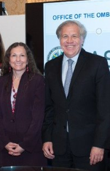

**3.9 BOARD OF EXTERNAL AUDITORS**

Pursuant to General Assembly resolution AG/RES. 123 (III-O/73), adopted on April 14, 1973, and Permanent Council resolution CP/RES. 124 (164/75) of June 10, 1975, the Board of External Auditors is responsible for the external auditing of the accounts of the General Secretariat of the Organization of American States (GS/OAS).

The Board held its annual meeting from April 4 to 17, 2019, to prepare its report on the external audit of the accounts and comparative financial statements of the GS/OAS for the years ended December 31, 2018 and 2019.

The Board submitted its observations to the Permanent Council on May 8, 2019 (OEA/Ser.S/ JAE/doc.49/19 of May 8, 2019). The report has four sections: (a) Report of the Board of External Auditors; (b) Financial Statements of the OAS; (c) Financial Statements of Agencies and Entities related to the OAS; and (d) the OAS Retirement and Pension Fund.

Based on the unqualified opinions issued by BDO, LLP, the financial statements corresponding to the audited entities tally with the books, documents, and vouchers of the GS/OAS.

The recommendations were, in summary, that:

1. Existing mandates should be prioritized, with a view to ensuring that sufficient resources are available for efficient and effective programming, including OAS administrative requirements.
2. The OAS identify the costs associated with its goals, activities, and indicators for 2019, 2020, and the current budgets. This should include sufficient budget allocation to ensure institutional strengthening and administrative management.
3. Financial measures should be examined in terms of the timeliness of quota contributions, cost-of-living adjustment, and salary increases.
4. A replacement plan for the Sub-fund should be developed to raise the required amounts, in keeping with the General Standards.
5. The budgetary framework for the Regular Fund includes activities financed under the ICR Fund.
6. The OAS only maintains a reserve fund within the ICR Fund that is representative of the future administrative reinvestment requirements of the organization.
7. The General Assembly approve and fully fund the human resources strategy.
8. The OAS develop a multi-year plan with evaluation programs that take into consideration all OAS-related activities and funding.
9. The SAF consider implementing more active monitoring of the ERP system.
10. The OAS consider additional adjustments to the Medical Benefits Trust Fund to ensure its sustainability.

The Board highlighted the fact that in the case of the following 2018 financial statements, the firm of independent auditors Ernst & Young, LLC had issued unqualified or “clean” opinions, which is the best possible outcome of an audit:

* Regular Fund, Development Cooperation Fund, Specific and Service Funds of the OAS
* Leo S. Rowe Pan American Fund and Rowe Memorial Benefit Fund
* Trust for the Americas
* Medical Benefits Trust Fund
* Inter-American Defense Board

The Board highlighted the fact that in the case of the 2018 financial statements of the Retirement and Pension Fund, the firm of independent auditors Mitchell Titus, LLP had issued unqualified or “clean” opinions, which is the best possible outcome of an audit:

**4. SPECIALIZED ENTITIES AND ORGANIZATIONS**

**4.1 INTER-AMERICAN DEFENSE BOARD**

**Introduction**

To fulfill its statutory purpose, the Inter-American Defense Board (IADB) promoted active involvement of its staff in various events.

They attended two seminars, 15 conferences, one summit, two brainstorming sessions, three forums, two study tours, one symposium, and 10 meetings, at the hemispheric, regional and subregional levels. These events covered security and defense, gender, human rights, and international humanitarian law, as well as issues on the new hemispheric security agenda: cyber-defense, natural disasters, comprehensive mine action, weapons stockpile management, securing and destruction, confidence- and security-building measures, preparation of studies on defense doctrine and policy, and the delivery of courses on military issues. These activities were geared toward fulfilling the mandates from the Organization of American States (OAS) and the Board's strategic objectives, helping to strengthen collaboration, cooperation, and security in the Hemisphere concerning defense and military matters.

Ecuador’s return as an IADB member state and the inclusion of the United Kingdom as an observer country are notable developments.

The Inter-American Defense College (IADC) continues to provide an accredited, tuition-free Master of Science program for military and police officers and civilians designated by OAS member nations. In 2019, the Higher Education Licensing Commission in Washington, DC, granted the IADC a permanent license to operate as a higher education institution. In the year under review, the IADC focused on writing a self-study report with the goal of being accredited by the Middle States Commission on Higher Education (MSCHE) in 2020, while remaining accredited by the Accrediting Council for Independent Colleges and Schools (ACICS) until 2022. The publication of key academic events of interest to OAS member states is highlighted.

Based on the foregoing, the following can be identified as the most salient achievements in 2019:

1. Technical assistance in humanitarian demining for "Mine-Free Americas.”

* Training for 10 officers and noncommissioned officers from five countries of the Americas through the International Course on Demining and Explosives Clearance at the International Demining Centre of the Kingdom of Spain was coordinated during 2019.
* The Group of Inter-American Monitors in Colombia evaluated 703 persons from the Humanitarian Demining Organizations and verified 65 documents from these organizations.
* The Inter-American Technical Advisors Group graduated 36 national humanitarian demining monitors and created the course for the Humanitarian Demining Instructor and Advisor Mission to begin in 2020.

1. Advice and monitoring of confidence- and security-building measures (CSBMs) among the states of the Hemisphere.

* A comparative study of the UN and OAS global CSBM repositories was done, as a result of which 27 measures were identified, which the OAS, specifically the Committee on Hemispheric Security, could implement.

1. Humanitarian assistance in natural disasters.

* Conferences were held on search and rescue and on the experience with coordination and interaction for natural disaster relief.
* The IADB participated in a meeting of the Inter-American Committee on Natural Disaster Reduction (IACNDR), in connection with Hurricane Dorian.
* A disaster response simulation exercise was conducted to test existing instruments through the OAS Disaster Response System.

1. XIV Conference of Defense Ministers of the Americas (CDMA).

* IADB participated in two Ad Hoc Groups: "Cooperation in Humanitarian Assistance and Disaster Relief" and "Evolution of the Armed Forces' Role in Defense and Security."

1. Advice on Emerging Threats and Other Relevant Issues.

* The Board took part in the OAS brainstorming session on new threats; in the lectures on "Combating corruption in Brazil and the implications for the Americas"; the seminars "The hemispheric perspective on gender mainstreaming in defense and security"; and the "Seminar on Human Rights and International Humanitarian Law.
* The "First Cyber Defense Conference: Western Hemisphere" was held in Bogotá, Colombia, and the "Cyber Defense and Cybersecurity Seminar" at the IADC.

1. Linkages among different organizations.

* IADB attended five Conferences of American Armies (CAA) events, two for the Inter-American Naval Conferences (IANC), one Conference of Chiefs of the Air Forces of the Americas (CONJEFAMER), and one Conference of Central American Armed Forces (CFAC). Of note was the signing of a technical cooperation agreement with the Advanced Institute for Defense (INSUDE) of the Dominican Republic.

1. Education Area.

* On June 26, 2019, the IACD’s 58th Class graduated 67 students, including 46 military officers, 14 police officers, and seven civilians – six women among them – from 14 OAS countries.
* The 59th IACD class began in July 2019 with 58 students from 13 nations, 40 military officers, 12 police officers, and six civilians, including seven women, in that number.
* Cooperation was embarked upon with the OAS Department of Human Development, Education and Employment through the OAS scholarships program to benefit IACD students and evaluation of future online education in security and defense via the Educational Portal of the Americas.
* The Washington D.C. Higher Education Licensure Commission granted the IACD a permanent license to operate as a higher education body.
* Digital and hard copy publication of IACD academic events across the Hemisphere began.

**Links of interest**

1. Link to information on activities of the Inter-American Defense Board: <http://www.jid.org/>

B. Link to information on activities of the Inter-American Defense College: https://iadc.edu/

**Photos**

**Conference on search and rescue**

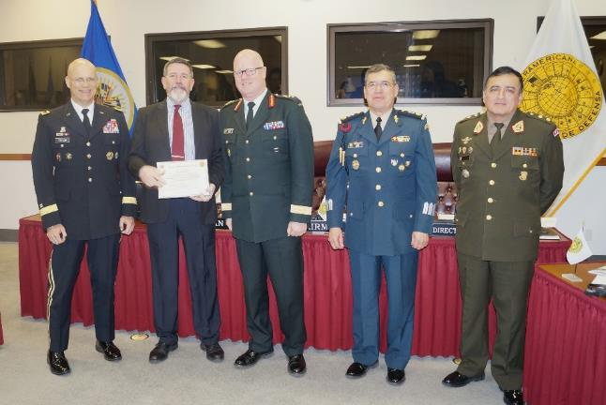

**Conference on coordination and interaction for disaster assistance**

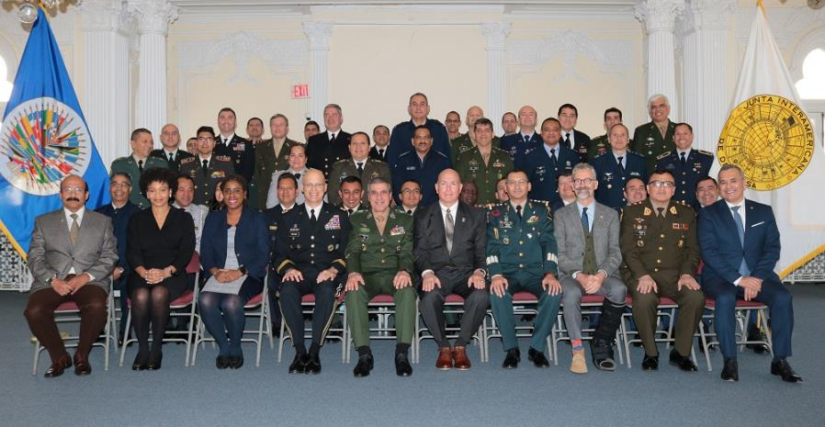

**Commencement Ceremony 58th IACD Class, June 2019**

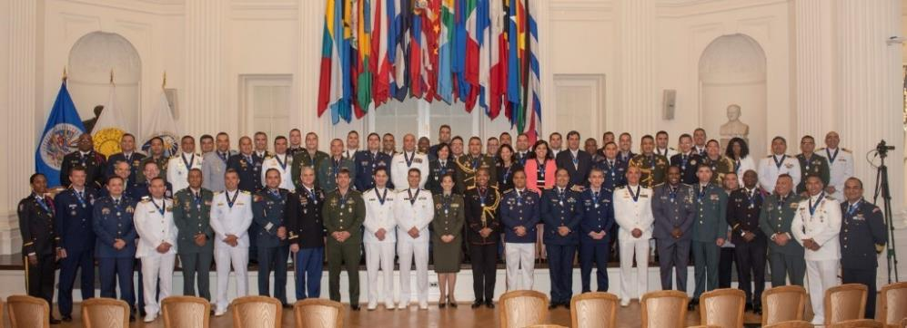

**4.2 INTER-AMERICAN INSTITUTE FOR COOPERATION ON AGRICULTURE (IICA)**

Since 1942 the mission of the Inter-American Institute for Cooperation on Agriculture (IICA) has been to promote agricultural development and rural wellbeing in its member states by providing top quality technical cooperation. Under its Medium-Term Plan (MTP) for the 2018-2022 period, the Institute offers this cooperation through five hemispheric programs: in bio-economics, land development, international trade, climate change, and agricultural health, as well as two cross-cutting issues (gender and youth, and innovation and technology), which provide the member countries with contextualized, innovative solutions to the main challenges posed by the development of agriculture and the rural milieu in the Americas.

The 2019 agenda comprised 13 direct technical cooperation initiatives executed with IICA's own resources, complemented by 189 activities or projects financed with external resources for nearly US$114 million. The main funding sources were the agricultural agencies of the United States and Mexico, programs of Brazil and Argentina, the European Union, multilateral banks, and cooperation agencies of Australia, Korea, Spain, Japan and New Zealand, and other donor organizations. This was complemented by a larger-scale agenda with private-sector institutions such as Bayer, Microsoft, and Corteva Agriscience.

In its bid to mobilize resources to enhance an offer of quality technical cooperation, the Institute prepared at least 20 project proposals and concept papers, which led to negotiations for nearly US$100 million.

The cooperation focused on providing support for capacity building, coordinating forums for dialogue, exchanging experiences, and preparing policy proposals and studies of national interest. IICA also worked closely with a variety of stakeholders in the productive sector – among them trade unions and producers' organizations – to promote agriculture with greater business opportunities, value added, resilience, and sustainability.

Among the main achievements of technical cooperation were:

* More than 4,000 officials and technicians from public and private institutions were educated about the potential of a bioeconomy, and emerging out of this were steps for future businesses to promote bioeconomy-based agriculture.
* Thousands of family farmers in Argentina, Brazil, Chile, Colombia, Costa Rica, Ecuador, El Salvador, Guatemala, Haiti, Honduras, Mexico, Nicaragua, Saint Lucia, Uruguay, and Venezuela improved their capacity to make their agri-food and land systems more dynamic through better linkages to markets, innovation, extension, cooperatives, and leadership.
* Belize, Nicaragua, Panama, Suriname, Trinidad and Tobago, Venezuela, and Chile, among other countries, strengthened their capacity for resilient production with efficient technologies, recovery of degraded areas and increased soil fertility. Some 2,000 technicians, extension workers, farmers, and students received training in water and soil management, climate change, and risk mitigation. The inter-ministerial dialogues prior to PRE-COP 25 and the participation of several countries in this meeting led to new proposals for action on sustainable and climate change-resilient production.
* In the area of health, hundreds of technicians from Latin America and the Caribbean were trained in the application of good agricultural practices, sanitary and phyto-sanitary measures, Codex Alimentarius, and antimicrobial resistance. Focus was also placed to high-impact threats such as Fusarium Tropical 4, huanglongbing, fruit flies, foot and mouth disease, and brucellosis, among other pests and diseases.

|  |  |
| --- | --- |
|  |  |
| IICA has promoted the System of Rice Intensification (SRI) in Chile, Panama, Nicaragua, Suriname, Trinidad and Tobago, and Venezuela.  A Venezuelan farmer demonstrates the differences in production between the SRI and the traditional system. | Climate-smart agricultural technology projects for small and medium-scale horticultural production are helping to deal with the impacts of climate change in the Caribbean. |

The Institute maximized its institutional efficiency by implementing integrated strategies and plans for the period 2020-2022, adopting a process culture, optimizing the use of US$4 million of its funds, and promoting leadership in its human talent.

Lastly, under its "An open doors IICA” strategy, a series of demonstration spaces on rural life and digital agriculture were set up, in addition to the bestowing of "Goodwill Ambassador" designation upon five citizens of the Americas who, given their high-level of culture and entrepreneurial spirit, are benchmarks for the type of agriculture that we promote.

Further information on [IICA projects](http://apps.iica.int/dashboardproyectos/) is available at <https://www.iica.int/en>.

**4.3 INTER-AMERICAN JURIDICAL COMMITTEE (CJI)**

In 2019, the Inter-American Juridical Committee held two working sessions at its headquarters the city de Río de Janeiro, Brazil. The first one, from February 18 through 22, was the CJI’s ninety-fourth regular session; while the second, the ninety-fifth regular session, was held July 31 to August 9.

During the reporting period, the Committee advanced discussion on its agenda issues, among them Validity of foreign judicial decisions; Electronic warehouse receipts for agricultural products; Binding and non-binding agreements; Access to public information; Cybersecurity (cybernetic security); Conventionality control; and Protection of personal data. Five new topics were added to its agenda: one of them, “Model Law on the use of fireworks, for either personal use or in mass firework displays,” was in fulfillment of a General Assembly mandate. The other four topics were included on the Committee’s initiative: “Guidelines for further normative development of diplomatic asylum”; “Electoral fraud as an international crime in the inter-American system”; “Private customary international law in the context of the Americas”; and “Legal aspects of foreign debt of states.” Finally, it should be noted that the topic “Dissolution and winding up of simplified corporations” was removed from the agenda.

An element of international importance was the adoption of a "Guide to the Law Applicable to International Commercial Contracts in the Americas,” which aims to promote substantive aspects in this area, and to that end put forward recommendations to a wide range of domestic actors, including legislators, jurisdictional bodies, and parties to a contract. This instrument encourages economic integration, growth, and development in the Hemisphere, and is involved in the harmonization of the internal legal regimes in the countries of the region (where disparities in contractual matters can be observed). Since its adoption, the Committee has been working on the dissemination of the Guide. Accordingly, on Tuesday, August 6, the Committee’s "Guide to the Law Applicable to International Commercial Contracts" was officially launched at the National Law School at the Federal University of Rio de Janeiro. Brazil. The event’s subject rapporteur, Dr. José Moreno, presented the Committee members, experts in the field of international contracts, professors, and students in attendance with an overview of the Guide.

The Committee received a variety of internationalists representing academia and the diplomatic arena, as well as from international organizations interested in establishing cooperation links, notably the Secretary General of the Institute for the Unification of Private Law, Ignacio Tirado, and the African Union delegation, headed by Professor Hajer Gueldich and Judge Mohammed Barakat.

It is worth noting that OAS Secretary General Luis Almagro was also in attendance. He held discussions with Committee members concerning the Organization's current agenda and the Committee's interest in pursuing issues of practical value to states.

In conclusion, the Committee as usual conducted a new edition of the Course on International Law in Rio de Janeiro, Brazil, from July 22 to and August 9, 2019, with support from the Department of International Law. This Course serves for reflection, discussion, and provides updates on various issues under public and private international law, as well as new legal developments in the inter-American system. This time, it brought together 43 students from 14 countries of the Americas, who financed their own participation in the event. Importantly, the Course on International Law was hosted at the Federal University of Rio de Janeiro Law School, thanks to support from the University's Inter-American Human Rights Hub (NIDH).

## 4.4 PAN AMERICAN HEALTH ORGANIZATION (PAHO)

The Pan American Health Organization, the regional office of the World Health Organization for the Americas, in 2019 continued its technical cooperation activities at the national, subregional, and regional levels, supporting health development in the countries.

Technical cooperation work over the course of the year was guided by three intersecting strategic planning documents that found a point of contact in 2019. They are the PAHO Strategic Plan 2014-2019, the Sustainable Health Agenda for the Americas 2018-2030 (SHAA2030), and the new PAHO Strategic Plan 2020-2025. As part of the programming, that intersection was central to ensuring that the three instruments smoothly overlapped and complemented one another, avoiding the creation of planning gaps, while consolidating the progress made in each area. Incorporating SHAA2030 as a guiding instrument for five-year planning toward 2030 helps the Organization to be better aligned with the global health policies set forth in the 2030 Sustainable Development Goals at the global level.

The Organization's governing bodies debated and approved a variety of resolutions that will be central to the scenario of progress towards strengthening health systems, universal coverage and access, eradication of diseases, emergency and disaster response, closing health gaps, and care for the most vulnerable population groups, among others. PAHO will continue to tackle the region's multiple health challenges in strong partnership with the member states, other actors in the inter-American system, and the communities of the Americas.

**Some achievements by category**

**Communicable diseases and environmental health determinants**

* One country in the Region was newly certified as malaria-free (Argentina) while two other countries where it was endemic (Belize and El Salvador) reported no cases.
* 11 countries and territories signed on to the health commitments at the Climate Change Summit.
* All countries and territories of the region developed action plans on antimicrobial resistance.

**Non-communicable diseases and mental health**

* 19 countries and territories came up with multi-sector strategies to control non-communicable diseases.
* Eight countries and territories passed laws for taxation of sugar-sweetened beverages
* 19 countries and territories developed and enacted national suicide prevention plans.

**Health over life cycle**

* The Region again saw the adolescent fertility rate (61.9 per thousand) decline.
* Eight countries and territories saw reductions in their maternal mortality ratios
* Overall, the region continues to have the largest number of new vaccines included on national schedules

**Health Systems**

* The number of countries and territories taking action towards achieving universal health coverage increased to 33
* 24 countries and territories implemented policies to expand access to quality health services
* All member states have signed agreements to use the Strategic Fund for medicines and health technologies

**Emergencies and Disasters**

* PAHO achieved timely and appropriate responses within the first 48 hours of request for support from 22 countries and territories.
* 39 countries and territories developed national emergency medical team initiatives
* Haiti reports no cholera cases for the year.

**Primary mandates**

* [Strategic Plan 2014-2019](http://iris.paho.org/xmlui/handle/123456789/7654)
* [Strategic Plan 2020-2025](https://iris.paho.org/handle/10665.2/51599?locale-attribute=en)
* [2018-2030 Agenda for Sustainable Health in the Americas](http://www.paho.org/hq/index.php?option=com_content&view=article&id=13246:health-agenda-americas&catid=9277:contents&Itemid=42349&lang=en)
* [2030 Agenda for Sustainable Development](https://www.un.org/sustainabledevelopment/)
* [Resolutions and other documents of the governing bodies](http://www.paho.org/hq/index.php?option=com_content&view=article&id=42&Itemid=189)
* [Strategy for Universal Access to Health and Universal health Coverage](https://www.paho.org/hq/dmdocuments/2014/CD53-R14-e.pdf)

**Useful links**

* [Health topics – A number of links from PAHO website](http://www.paho.org/hq/index.php?option=com_topics&view=topics&Itemid=40241&lang=en)

**Photos**

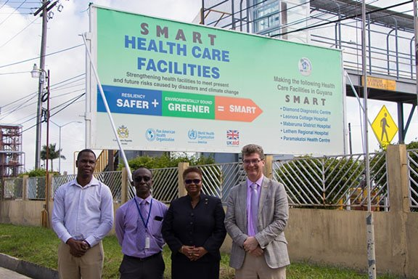

Smart hospitals in Guyana: safe and environmentally appropriate

Chateaubellair Smart Hospital, Saint Vincent

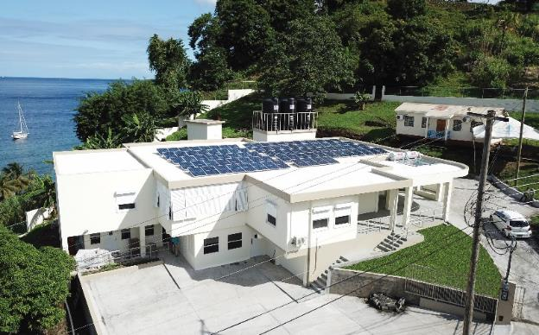

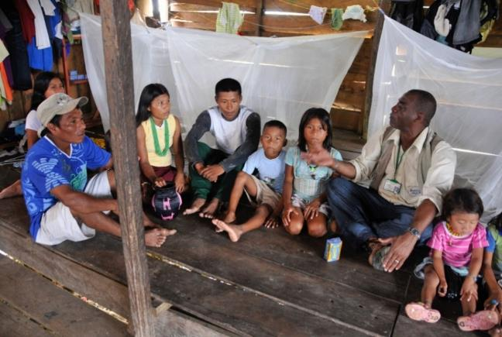

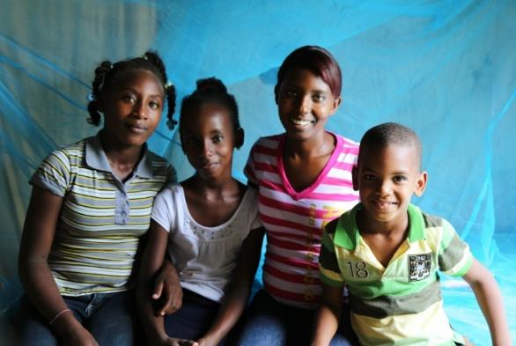Progress in fighting malaria in the Americas

**4.5 PAN AMERICAN INSTITUTE OF GEOGRAPHY AND HISTORY (PAIGH)**

PAIGH's work in 2019 was underpinned by the following considerations that were needed in moving to modernize the Institute: Why is the PAIGH useful to its member states? What did it do in 2019 in that connection? How can it become even more useful? These questions thus offered a different perspective from which to pursue activities in the scientific, administrative, and financial areas.

In the science arena, the scholarship program was expanded and, when implemented in 2020, will open up more opportunities and equip new generations of researchers with tools, while providing support for research in the Americas under the Technical Assistance Program that funded 18 proposals. Other highlights included efforts embarked upon to develop a joint project for Central America, to integrate geospatial information with statistics and knowledge dissemination through scientific journals and social media. This did improve quality, visibility, and interaction.

In the administrative area, significant effort was made to find new partners, such as the Republic of Korea (a new observer state). Significant as well were the activities of the Strategic Advisory Group, whose work is geared towards modernizing the PAIGH through amendments to its Statute.

As regards the financial side, from a realistic standpoint it must be noted that the PAIGH is in a critical situation due to the fall-off in contributions representing the financial obligations of the member states. Thanks to prudent management of its finances, it has operated even amidst significant quota arrears, which is why it is facing such a dire situation.

Lastly, and knowing this situation, the PAIGH has worked hard to keep delivering benefits to its member states the way it has done for over 90 years.

**Scientific Area**

* Technical Assistant Program (TAP): The number of new TAP applicants increased by 63%, thanks to new outreach strategies and a 6% increase in participation by PAIGH member states.[[21]](#footnote-21)
* The scholarship program for the Commissions on Cartography, Geography, and History was expanded.
* 21 scholarships for training in “Geographic Names” were awarded by the Republic of Korea for one participant from each member state.
* Scientific Journals: The edition saw a 20% increase compared to 2018. A total of 10 issues were published.[[22]](#footnote-22) Transition from print to digital with the use of open-access platforms for submitting articles and inclusion in academic indexes.
* Some 50% of the scientific journals (319 issues)[[23]](#footnote-23) published since the Institute began are available in digital format, in addition to five featured issues, which are considered invaluable due to their content and age.[[24]](#footnote-24)
* About 40,000 followers joined the community via social media. They represented 45 different countries, 23 of them being states of the Americas. This was an increase of more than 60% over the previous year.

**Administrative Area**

* The Republic of Korea came on board as a permanent observer.
* Strategic Advisory Group: In a bid to modernize the Institute, a preliminary draft of new PAIGH Organic Statutes was produced.

**Financial Area**

* Income derived from member state quotas was 79% of the budget in 2019.
* Of the total arrears in member states’ assessed contributions in 2019, the debt accrued by two member states accounted for 89 per cent.[[25]](#footnote-25)
* Membership dues were 2.9% of total PAIGH income, a 151% increase compared to 2018.[[26]](#footnote-26)

|  |  |
| --- | --- |
|  | IMG_4018 |
| *4th Technical Meeting of the Commissions. July 8-10.* | *PAIGH Editorial Committee.* |

Financial Area Documents: <<https://ipgh.org/financiero.html#cuotas>>.

PAIGH cooperation partners: <<https://ipgh.org/socios-cooperadores.html>>.

**5. ACTIVITIES OF THE SECRETARY GENERAL AND ASSISTANT SECRETARY GENERAL AWAY FROM HEADQUARTERS**

**5.1 ACTIVITIES OF THE SECRETARY GENERAL AWAY FROM HEADQUARTERS**

**January**

No travel was done.

**February**

17-21 Madrid and Pamplona, Spain

26 (WJA) Congress in Madrid

Agreement signed with University of Navarro

21-25 Bogotá, Colombia

Lima Group

25-26 Mexico City

Oslo Freedom Forum. Rómulo Betancourt Award for Democratic Diplomacy

**March**

1-2 Boston, MA

Agenda Latin American Conf. Harvard Kennedy School of Government

25-27 Buenos Aires, Argentina

Official visit

27-28 Guatemala City

IV Meeting of Ministers and High-Level Officials of Social Development (REMDES)

28-29 Cartagena, Colombia

Inter-American Press Association (IAPA)

**April**

28-29 Lima, Peru

Health Ministerial. Improving Regional Coordination in Response to the Impacts of Forced Displacement

**May**

16-18 La Paz, Bolivia

Official Visit

18-21 Buenos Aires, Argentina

Inter-American Council for Trade and Production

21-22 Santiago, Chile

Official Visit and Talks at Chilean Council

26-28 Medellin, Colombia

Official Visit and EAFIT University-OAS Memorandum of Understanding

**June**

11-12 New York, NY

Americas Society/Council of the Americas Symposium. 2019 Gold Medal Award.

15-18 Florence, Italy

EUI School of Transnational Governance

23-29 Medellin, Colombia

Forty-ninth regular session of the OAS General Assembly

**July**

2-4 Saint Lucia

Meeting of the Heads of State of CARICOM

5-7 Luxemburg

OSCE Parliamentary Assembly

28-29 Panama City, Panama

25 Years of the Convention of Belem do Pará

**August**

6 -9 Río de Janeiro, Brazil

95th Regular Session of the Inter-American Juridical Committee

18-19 Mexico City

International Congress of Agencies Certified in Quality Control

20-21 Santiago, Chile

ODCA-KAS International Seminar “Latin America-Europe Relations: Strengthening and New Outlook.”

**September**

5-6 Toronto, Canada

International Economic Forum of the Americas “Leading the New Economy”

9-13 Warsaw, Poland

Second Edition “Latin America Day”

18-19 Bridgetown, Barbados

Eighth Culture Ministerial in Barbados

23 New York, NY

Meeting of Lima Group Foreign Ministers

**October**

7 Boston, MA

Conference: Analysis and Outlook for Democracy in the Region. Boston College Law School

13-14 San José, Costa Rica

World Business ForumLatinoamérica 2019

17-18 Nassau, Bahamas

Meeting with the Prime Minister of The Bahamas, Dr. Hubert Minnis

19 Miami, FL

Conference “The Future of Democracy in the Americas” and Executive Mastermind Latino 2019 Award.

25 Miami, FL

Ceremony for Ratification of the Agreement for Democracy by Lincoln Diaz-Balart and the Organizing Committee of the Cuban Opposition, Resistance and Exile

29-31 Quito, Ecuador.

VII Meeting of Ministers Responsible for Public Security. MISPA VII.

**November**

3-5 Berlin, Germany

Conference on the Status of Democracy and Sustainable Development in Latin America

5-7 London, England

Conference: *Cannin House and All Party Parliamentary Group: “Update on Human Rights in Venezuela.”* And University of Cambridge: Presentation on “Defending Democracy and Human Rights in Latin America”

9-10 Nassau, Bahamas

Visit to disaster areas. Evaluation of damage done by Hurricane Dorian

18-19 Asunción, Paraguay

International Forum “Paraguay Dialogue: Managing Governance, Development, and Transparency.” Launch of OAS-News in Paraguay

**December**

3-4 Bogotá, Colombia

Lima Group Foreign Ministers Meeting

4-6 Ottawa, Canada

Visit to Indigenous Communities. Native Women’s Association of Canada

9-10 Cartagena, Colombia

Commemoration of International Human Rights Day

**5.2 ACTIVITIES OF THE ASSISTANT SECRETARY GENERAL AWAY FROM HEADQUARTERS**

**January**

15-18 Medellin, Colombia

The Assistant Secretary General made an advance trip in preparation for the forty-ninth regular session of the General Assembly. This was one of the pre-scheduled visits in preparation for the General Assembly, and was done to examine the site and evaluate preparations. Accompanying the Assistant Secretary General on that visit was the Director of the Department of Conference and Meetings Management, Ambassador Francisco Lainez. They held meetings with various representatives within the Colombian Ministry of Foreign Affairs, including Vice-Minister Adriana Mejía. The Assistant Secretary General also met with the Mayor of Medellín, Federico Gutiérrez, and the Governor of Antioquia, Luis Pérez Gutiérrez, and visited two local universities to identify a host for the MOAS.

29-30 Kingston, Jamaica

At the invitation of the Minister of Tourism of Jamaica, ASG Mendez traveled to Montego Bay, Jamaica, to keynote the United Nations World Tourism Organization/Government of Jamaica Global Conference on Jobs and Inclusive Growth and the launch of the Global Tourism Resilience and Crisis Management Centre, held January 29 and 30, respectively. ASG Mendez also gave a keynote address to inaugurate the OAS initiative "Building Resilience of Small Tourism Enterprises in the Caribbean," held on the sidelines of the Conference. The ASG also took part in the launch of a traveling exhibition on the 70th Anniversary of the OAS, organized by the National Library of Jamaica in collaboration with the OAS Country Office in Jamaica, and also addressed a group of high school students in Kingston on the work of the OAS in the Hemisphere.

During his visit, ASG Mendez met with the Minister of Tourism of Jamaica, Hon. Edmund Bartlett, as well as with the Minister of State in the Ministry of Foreign Affairs and Foreign Trade, Senator the Honorable Pearnel Charles, Jr., with whom he discussed issues of common interest. Advisor Kendall Belisle accompanied ASG Mendez on this trip.

**February**

7-8 Mexico City, Mexico

As Chair of the Pan American Health Organization's High Level Commission "Universal Health in the 21st Century: 40 years of Alma-Ata," the Assistant Secretary General traveled to Mexico to review and finalize with the other Commissioners the report of the High-Level Commission on universal health (this report was formally launched on April 9, 2019). The ASG declared the event open, alongside the Mexican Secretary of Health, Dr. Jorge Alcocer, and the PAHO/WHO Representative in Mexico, Cristian Morales. Lastly, the ASG moderated the discussions of the commissioners' working groups.

**March**

10-12 San José, Costa Rica

The Assistant Secretary General participated as keynote speaker at the opening ceremony for the 34th Model Assembly for University Students (MOAS) of the Hemisphere. During his visit to Costa Rica, he met with H.E. Manuel Ventura Robles, Minister of Foreign Affairs and Worship of Costa Rica, to discuss the Costa Rica-OAS bilateral and cooperation agenda, as well as issues of pressing regional interest, and also met with Ambassador Rita Hernández, Director of International Cooperation for the Ministry of Foreign Affairs. The ASG also visited the offices of the "Central American Educational and Cultural Coordination (CECC)" of the Central American Integration System (SICA), where he discussed issues related to the Inter-American Educational Agenda with Dr. Carlos Staff, Executive Secretary of CECC-SICA, and Mr. Jorge Rivera Pizzaro, Technical Advisor. Ambassador Jacinth Henry-Martin accompanied the ASG on this visit.

**April**

7-10 Mexico City, Mexico

In his capacity as Chair of the Pan American Health Organization High-Level Commission on “Universal Health in the 21st Century: 40 years of Alma-Ata," the Assistant Secretary General traveled to Mexico to present the report of the High-Level Commission on Universal Health with President Andrés Manuel López Obrador, PAHO Director Dr. Carissa Etienne and the High Commissioner for Human Rights, Ms. Michele Bachelet. While in Mexico, he visited the OAS National Office in Mexico City and met with staff. On this mission, Assistant Secretary General Nestor Mendez was accompanied by Ms. Claudia González of the Secretariat for Access to Rights and Equity. The costs of the visit were underwritten by the Pan American Health Organization.

**May**

6-7 Santo Domingo, Dominican Republic

The Assistant Secretary General attended the thirty-eighth Assembly of Delegates of the Inter-American Commission of Women, where he delivered the opening address. During the visit, he also met with H.E. Janet Camilo, Minister of Women’s Affairs of the Dominican Republic, and joined Minister Camilo on a radio program on gender parity in the workplace.

21-23 San Juan, Puerto Rico

Assistant Secretary General Nestor Mendez, in his capacity as Vice Chair of the Pan American Development Foundation (PADF) Board, delivered the opening address and participated in the Board’s semi-annual meeting in San Juan, Puerto Rico. During the visit, he participated in an event on entrepreneurship with Parallel 18, a very successful acceleration program that helps emerging businesses grow and expand their operations from Puerto Rico to global communities outside the island. The ASG also took part in field trips for PADF disaster resilience projects in vulnerable communities in San Juan. Mayuriel Pérez, from the Office of the ASG, accompanied him on his trip. The costs for the visit were covered by the Pan American Development Foundation.

**June**

1-3 San Salvador, El Salvador

At the invitation of the Government of El Salvador, Assistant Secretary General Nestor Mendez represented the General Secretariat at the events related to the official swearing-in of President Nayib Bukele. While in El Salvador, he met with His Excellency Feliz Ulloa, incoming Vice President, with incoming Foreign Minister Ms. Alexandra Hill, and with outgoing Foreign Minister Carlos Castaneda.

3-5 Belize City, Belize

From El Salvador, the Assistant Secretary General traveled to Belize to meet with Prime Minister the Rt. Hon. Dean Barrow, and with Minister of Foreign Affairs Hon. Wilfred Elrington. During his stay in Belize, the ASG visited the OAS National Office to meet with staff there.

16-18 Santo Domingo, Dominican Republic

The ASG delivered opening remarks and attended the "Meeting of Young Political Leaders of the Republic," an event organized by the OAS and the Ministry of Foreign Affairs of the Dominican Republic. The purpose of this event was to generate a dialogue to enable young Dominicans to have a direct and effective impact on the issues of digital transformation, transparency and accountability among citizens, and to assist them in their growth as young political leaders. During his visit, the ASG held meetings with the Minister of Foreign Affairs, Mr. Miguel Vargas, and with Mr. Armando García, Director General of the Presidential Office of Information and Communication Technologies.

22-30 Medellín, Colombia

The ASG attended the forty-ninth regular session of the General Assembly of the Organization of American States.

June 30-July 2 Panama City, Panama

At the invitation of the Government of Panama, ASG Nestor Mendez represented the General Secretariat at events related to the official swearing-in of President Laurentino Cortizo.

**July**

3-5 Castries, Saint Lucia

The Assistant Secretary General attended the fortieth regular Meeting of the Conference of Heads of Government of the Caribbean Community in Saint Lucia. On the margins of that conference, Ambassador Mendez met with the Minister of Education, Innovation, Gender Relations and Sustainable Development. They explored such issues as challenges to building resilience to natural disasters, as well as the impact sargassum was having on the tourist and fisheries industries. A meeting was also held with the Minister of Tourism, Information and Broadcasting, Culture and Creative Industries to explore new opportunities for collaboration in the areas of tourism, culture, and the creative industries. He was accompanied by Kendall Belisle, Advisor.

**September**

9-11 Mexico City, Mexico

During this official visit, the Assistant Secretary General met with a number of senior officials of ministries and states bodies that were involved in a range of OAS projects and initiatives. Those officials included, notably: Maximiliano Reyes Zuñiga, Undersecretary for Latin America and the Caribbean; Marta Delgado Peralta, Undersecretary for Multilateral Affairs and Human Rights; Noel González Segura, Director General of MEXCID, and María Edith Bernáldez Reyes, Director General at the Secretariat for Education. He also visited the OAS country office in Mexico, where he received a full report from the staff. Among the issued discussed with various officials were OAS-Mexico relations; cooperation mechanisms Mexico made available to the OAS and the member states, including the Mexico scholarship programs; the Inter-American Teacher Education Network; human rights and empowerment of women; available opportunities for young people in the areas of innovation and competitiveness, and OAS work in the field of migration. The Assistant Secretary General was accompanied by Cinnamon Bottaro, Advisor. Administrative officer Pamela Contreras paid a parallel visit to the OAS National Office in Mexico, where she conducted an administrative audit and conducted a training course on administrative protocols.

19-21 Bridgetown, Barbados

The Assistant Secretary General attended the VIII Inter-American Meeting of Ministers of Culture in Barbados, and delivered closing remarks.

23 New York, NY

The Assistant Secretary General took part in the Thirtieth Meeting of Consultation of Ministers of Foreign Affairs serving as the organ of consultation in application of the Inter-American Treaty of Reciprocal Assistance (TIAR).

**October**

6-9 Saint Kitts and Nevis

During an official visit to Saint Kitts and Nevis, the Assistant Secretary General met with Prime Minister His Excellency Dr. Timothy Harris, Deputy Prime Minister Mr. Shawn Richards, Minister of Education, Youth, Sports and Culture, Minister of Agriculture and the Environment Mr. Eugene Hamilton, and Minster of Foreign Affairs Mr. Mark Brantley. During a series of meetings, they explored such issues as Saint Kitts and Nevis-OAS relations; opportunities for youth empowerment, especially in the context of education/scholarships, the entrepreneurial spirit, innovation, and competitiveness; progress toward bilingualism for competitiveness; climate change and building resilience to natural disasters. The Assistant Secretary General also made a presentation on the OAS to high school students in Saint Kitts and Nevis and toured the National Office, where he met with staff. The Assistant Secretary General was accompanied on this mission by Ambassador Jacinth Henry-Martin, Advisor. Ms. Gloria Uribe, Administrative Officer, paid a parallel visit, during which she conducted an administrative audit of the National Office and gave training sessions on administrative protocols.

**November**

1-2 Quito, Ecuador

The Assistant Secretary General attended the Sixth Meeting of Ministers Responsible for Public Security in the Americas (MISPA-VI) and delivered closing remarks.

18–20 Saint Vincent and the Grenadines

The Assistant Secretary General paid an official visit to Saint Vincent and the Grenadines, where he met with Prime Minister His Excellency Dr. Ralph E. Gonsalves, Minister of Education St. Clair Prince, and Minister of Agriculture Sabato Caesar. Matters discussed strengthening bilingualism for Vincentians through OAS programs, the Inter-American Teacher Education Network (ITEN), and the quest for creative solutions to tackle the challenge posed by sargassum that has been affecting tourism and fisheries in the Caribbean. The Assistant Secretary General met as well with the Director of the Business Development Centre to explore opportunities for collaboration in the areas of entrepreneurship and innovation among young people. He also addressed a conference at the Saint Vincent and the Grenadines Community College. He was accompanied on the mission by Chief of Staff, Ambassador La Celia Prince.

20-22 Trinidad and Tobago

On this official visit to Trinidad and Tobago, the Assistant Secretary General promoted the visibility of the OAS in that country, particularly in the absence of a country representative. Meetings were also held with the Minister of Education Anthony Garcia and Minister of Foreign Affairs Dennis Moses. Issues discussed included the Inter-American Teacher Education Network (ITEN), getting the population to be bilingual, and promotion of innovation and entrepreneurship among young people. Both ministers declared an interest in more collaboration with the OAS in education, capacity-building, and access to technology. The Assistant Secretary General also met with the Secretary General of the Association of Caribbean States, Dr. June Soomer. Dr. Soomer took the opportunity to raise crosscutting issues, such as gender, young people, and education, on which the ACS would like to collaborate with the OAS. She also endorsed the Assistant Secretary General’s proposal for a platform to be created for collaboration among international organizations, including the ACS. ASG was accompanied by Ambassador La Celia Prince, Chief of Staff.

**December**

2-4 Bogotá, Colombia

The Assistant Secretary General attended the Thirtieth Meeting of Consultation of Ministers of Foreign Affairs, which served as the organ of consultation in application of the Inter-American Treaty of Reciprocal Assistance (TIAR). During that visit, he met with representatives of the Pan American Development Foundation (PADF) to hear about that organization's activities in Colombia and explore concrete avenues for greater collaboration between it and the OAS General Secretariat. The Assistant Secretary General was accompanied by Executive Assistant Mayuriel Pérez.

5-6 San Salvador, El Salvador

The Assistant Secretary General attended the SICA Regional Forum 2019, “Toward Development of Central America: Building a Region of Opportunity.” He participated as a panelist in the dialogue “Migration and development: A transformative View.” He also visited the OAS National Office and the new facilities at the International Commission against Impunity in El Salvador (CICIES). The Assistant Secretary General was accompanied by Executive Assistant Mayuriel Pérez.

8-10 Nassau, Bahamas

The Assistant Secretary General led an advance mission to The Bahamas, one of the scheduled visits to prepare for the fiftieth regular session of the OAS General Assembly. The Assistant Secretary General also met with His Excellency Darren Henfield, Minister of Foreign Affairs, and with Permanent Secretary Peter Deveaux Isaacs, to examine the relevant preparations. The OAS team also visited the proposed General Assembly sites and met with the Bahamian General Assembly coordinating team. The Assistant Secretary General was accompanied by Ambassador La Celia Prince, Chief of Staff; Cinnamon Bottaro, Advisor; Sandra Guáqueta, Deputy Director of Conferences; and Luiz Coimbra, Conference Specialist. The Secretary General's Special Envoy for the Bahamas, Chet Neymour, also accompanied the ASG. The team worked with the Ministry of Foreign Affairs of the Bahamas on all relevant aspects of the plans to deliver a successful outcome from the next General Assembly.

**6.** **APPENDICES**

**APPENDIX A: ORGANIZATIONAL CHART**

Office of the Strategic Counsel for Organizational Development and Management for Results

Office of the Ombudsperson

Secretary General

Assistant Secretary General

General Assembly

Permanent Council

Secretariat for Multidimensional Security

Secretariat for Access to Rights and Equity

Secretariat for Administration and Finance

Secretariat for Hemispheric Affairs

Secretariat for Strengthening Democracy

Executive Secretariat for Integral Development

Secretariat for Legal Affairs

Executive Secretariats/Secretariats of the principal and specialized organs (autonomous and decentralized) and Oversight bodies

(in compliance with Article 53 of the OAS Charter]

**APPENDIX B: FINANCIAL STATEMENTS**

**TABLE 1**

**COMBINED FINANCIAL STATEMENTS OF THE ORGANIZATION OF AMERICAN STATES**

**Combined Statement of Assets, Liabilities, and Fund Balances**

As of December 31, 2019, with comparative totals for 2018

Preliminary unaudited

in thousands of US$)

**Regular Fund**

**Development**

**Cooperation**

**Fund**

**Specific Funds**

**Service Funds**

**(A)**

**Elimination of**

**transactions between**

**funds**

**2019**

**2018**

**Assets**

Cash and deposits in escrow in the OAS Treasury Fund

-

6,204

52,991

13,561

-

72,756

92,530

Deferred charges related to future years' appropriations

**(B)**

8,280

-

-

-

-

8,280

8,280

Accounts receivable for temporary loan from the Treasury Fund

(C)

-

-

5,472

1,357

(6,829)

-

-

Other assets

359

-

-

56

-

415

541

Investment in asset funds

46,996

-

-

-

-

46,996

46,740

**Total Assets**

55,635

6,204

58,463

14,974

(6,829)

128,447

148,091

**Liabilities and fund balances**

Unliquidated obligations

2,068

499

12,546

6,778

-

21,891

24,286

Advance quota collections/pledges

51

-

-

-

-

51

21

Appropriations to be charged in future years

**(B)**

8,280

-

-

-

-

8,280

8,280

Accounts payable for temporary loan from the Treasury Fund

(C)

6,829

-

-

-

(6,829)

-

-

Accounts payable and other liabilities

736

6

2,379

1,045

-

4,166

3,387

Reserve for payment of terminations

178

-

-

4,060

-

4,238

4,524

Notes payable on demand

16,830

-

-

-

16,830

17,600

Total Liabilities

34,972

505

14,925

11,883

-

55,456

58,098

**Fund Balances**

Unrestricted reserve subfund

(9,503)

-

-

-

-

(9,503)

7,051

Fund Balance

-

5,699

43,538

3,091

-

52,328

53,802

Total fund balance

(9,503)

5,699

43,538

3,091

-

42,825

60,853

Equity in restricted fixed assets

30,166

-

-

-

-

30,166

29,140

**Total liabilities and fund balances**

55,635

6,204

58,463

14,974

-

128,447

148,091

(A) Includes the tax reimbursement account

(B) Present value of OAS annuities (lifetime payments to former Secretaries General and former Assistant Secretaries General)

(C) Temporary loan from the Treasury Fund as approved under CP/RES. 1105 (2168/18) rev. 1 .

**Combined**

**TABLE 2**

**COMBINED FINANCIAL STATEMENTS OF THE ORGANIZATION OF AMERICAN STATES**

**Combined Statement of Changes in Fund Balances**

As of December 31, 2019, with comparable totals for 2018

Preliminary, unaudited

(in thousands of USD)

**Regular Fund**

**Development**

**Cooperation Fund**

**Specific Funds**

**Service Funds**

**(A)**

**Elimination of**

**inter-fund transactions**

**2018**

**Increases**

Quota collection/pledges

64,637

222

-

-

(17)

64,842

85,511

Minus: Credits for early payment

(175)

-

-

-

-

(175)

(440)

Contributions

-

-

61,313

-

-

61,313

41,405

Tax reimbursement

-

-

-

1,025

-

1,025

5,079

Transfers

-

-

8

103

(108)

3

12

Interest

105

99

1,095

80

-

1,379

1,514

Contributions for administrative and technical support

-

-

-

9,158

(9,158)

-

-

Rental

-

-

-

2,362

-

2,362

2,623

Other income and reimbursements

512

39

509

2,941

(2,260)

1,741

2,081

Total Increases

65,079

360

62,925

15,669

(11,543)

132,490

137,785

**Decreases**

Spending and obligations

81,608

357

60,850

**(B)**

11,278

**(B)**

(10,325)

143,768

144,654

Special Appropriations - AG XLVIII

-

-

-

-

-

-

180

Reimbursement Transfers

-

-

-

4,196

-

4,196

4,271

Transfers

-

-

1,377

126

(1,218)

285

358

Reimbursement to donors

-

-

2,244

-

-

2,244

544

Appropriations FONDEM

25

-

-

-

-

25

25

Total Decrease

81,633

357

64,471

15,600

(11,543)

150,518

150,032

**Net increase (decrease) during the period**

(16,554)

3

(1,546)

69

-

(18,028)

(12,247)

7,051

5,696

45,084

3,022

-

60,853

73,100

**Fund Balance at end of period**

(9,503)

5,699

43,538

3,091

-

42,825

60,853

(A)

Includes the tax reimbursement account

(B)

The net execution comprises 2019 spending plus 2019 obligations minus obligations with balances from previous years.

**Combined**

**2019**

**Balance at start of period**

**TABLE 3**

**DETAILS OF REGULAR FUND EXPENSES AND OBLIGATIONS BY CHAPTER**

**For the year ended December 31**

**(in thousands of US$)**

**2019**

**2018**

Office of the Secretary General

2,618.1

$

2,675.7

$

Office of the Assistant Secretary General

12,610.5

12,646.6

Principal and Specialized Agencies

17,806.1

15,293.7

Strategic Counsel for Organizational Development and management for Results

2,754.1

2,822.2

Secretariat for Access to Rights and Equity

1,698.8

1,687.7

Secretariat for Strengthening Democracy

3,937.8

4,012.5

Executive Secretariat for Integral Development

7,113.3

6,786.9

Secretariat for Multidimensional Security

4,245.1

4,034.6

Secretariat for Hemispheric Affairs

2,449.7

2,471.0

Secretariat for Legal Affairs

3,961.6

3,652.9

Secretariat for Administration and Finance

9,684.9

9,562.9

Basic Infrastructure and Common Costs

11,319.3

12,781.8

Management Oversight Bodies Total

1,408.5

1,409.3

TOTAL \*

81,607.8

$

79,837.7

$

\* The total individual amounts may include differences due to rounding off.

**Approved Quotas LEVELS OF EXECUTION**

\* Includes current quotas and quotas from previous years

84.8

84.8

84.8

84.8

84.8

84.8

84.8

84.8

84.8

84.8

84.8

84.8

0.7

10.1

10.2

11.5

39.0

45.3

55.2

57.7

58.1

68.4

72.1

85.3

66.0

66.4

67.5

68.0

69.0

70.2

73.2

74.2

75.7

76.6

78.2

79.8

7.5

13.4

20.0

25.8

32.3

39.1

45.5

51.3

57.0

64.0

70.9

77.4

0.0

10.0

20.0

30.0

40.0

50.0

60.0

70.0

80.0

90.0

100.0

Jan

Feb

Mar

Apr

May

Jun

Jul

Aug

Sep

Oct

Nov

Dec

USD Millon

Month

Regular Fund 2018

Execution Report January to December and Quotas collected

Approved

Quotas \*

Execution

Spending

CP42384E04

\* Includes current quotas and quotas from previous years

85.3

85.3

85.3

85.3

85.3

85.3

85.3

85.3

85.3

85.3

85.3

85.3

11.4

12.8

27.3

27.3

40.7

42.9

42.9

48.7

51.4

51.4

64.6

71.1

71.8

72.4

72.9

74.1

74.5

75.5

77.1

78.2

80.1

81.6

14.0

21.2

26.9

32.9

39.5

46.5

52.3

58.8

66.6

72.8

79.6

0.0

10.0

20.0

30.0

40.0

50.0

60.0

70.0

80.0

90.0

100.0

Jan

Feb

Mar

Apr

May

Jun

Jul

Aug

Sep

Oct

Nov

Dec

USD Million

Month

Regular Fund 2019

Execution Report January to December and Quotas collected

Approved

Quotas \*

Execution

Spending

1. \* Preliminary, unaudited. [↑](#footnote-ref-1)
2. . Case of Álvarez Ramos v. Venezuela; Case of Perrone and Preckel v. Argentina; Case of Díaz *et al*. v. Venezuela; Case of Jenkins v. Argentina; Case of Rosadio Villavicencio v. Peru; Case of Arrom Suhurt *et al*. v Paraguay; Case of Ruiz Fuentes *et al*. v. Guatemala; Case of Valenzuela Ávila v. Guatemala; Case of Rodríguez Revolorio *et al*. v. Guatemala; Case of López *et al*. v. Argentina; Case of Indigenous Communities Members of the Lhaka Honhat Association v. Argentina; Case of Hernández v. Argentina; Case of National Association of Retirees of the National Superintendency for Tax Administration (ANCEJUB-SUNAT) v. Peru, Case of Gorigoitia v. Argentina; and Case of Romero Feris v. Argentina; Case of Rojas Marín *et al.* v. Peru, Case of Noguera *et al.* v. Paraguay; and Case of Montesinos Mejía v. Ecuador. [↑](#footnote-ref-2)
3. . Case of Yean and Bosico Girls and Case of Expelled Dominicans and Haitians v. Dominican Republic; Case of Molina Theissen v. Guatemala; and Case of Acosta *et al*. v. Nicaragua. [↑](#footnote-ref-3)
4. . Case of Torres Millacura et al v. Argentina, Case of Furlan and Family v. Argentina, Case of Fornerón and Daughter v. Argentina, Case of Garrido and Baigorria v. Argentina; Case of Bueno Alves v. Argentina; Case of Bulacio v. Argentina, Case of 19 Traders v. Colombia, Case of the Mapiripán Massacre v. Colombia, Case of Las Palmeras v. Colombia, Case of Rodríguez Vera et al. (Palace of Justice Missing Persons) v. Colombia, Joint Monitoring of compliance with judgment in cases of searching for whereabouts in Colombia, Joint Monitoring of compliance with judgments in cases of medical and psychological treatment; and Case of Gelman v. Uruguay. [↑](#footnote-ref-4)
5. . Case of Colindres Schonenberg v. El Salvador. Merits, Reparations, and Costs, Judgment of February 4, 2019. Series C No. 373; Case of Villaseñor Velarde et al. v. Guatemala. Merits, Reparations, and Costs, Judgment of February 5, 2019. Series C No. 374; Case of Muelle Flores v. Peru. Preliminary Objections, Merits, Reparations, and Costs. Judgment of March 6, 2019. Series C No. 375; Case Martínez Coronado v. Guatemala. Merits, Reparations, and Costs, Judgment of May 10, 2019. Series C No. 376; Case of Arrom Suhurt et al. v. Paraguay. Merits, Judgment of May 13, 2019. Series C No. 377; Case of Álvarez Ramos v. Venezuela. Preliminary Objection, Merits, Reparations and Costs. Judgment of August 30, 2019. Series C No. 380; Case of Gorigoitía v. Argentina. Preliminary Objection, Merits, Reparations and Costs. Judgment of September 2, 2019. Series C No. 382; Case Rica v. Argentina. Preliminary Objection and Merits Judgment of September 2, 2019. Series C No. 383; Case of Perrone and Preckel v. Argentina. Preliminary Objections, Merits, Reparations, and Costs. Judgment of October 8, 2019. Series C No. 384; Case of Ruiz Fuentes et al. Guatemala. Preliminary Objection, Merits, Reparations and Costs. Judgment of October 10, 2019. Series C No. 385; Case of Valenzuela Ávila v. Guatemala. Merits, Reparations, and Costs, Judgment of October 11, 2019. Series C No. 386; Case of Rodríguez Revolorio et al. v. Guatemala. Preliminary Objection, Merits, Reparations and Costs. Judgment of October 14, 2019. Series C No. 387; Case of Rosadio Villavicencio v. Peru. Preliminary Objections, Merits, Reparations, and Costs. Judgment of October 14, 2019. Series C No. 388; Case of Girón et al. v. Guatemala. Preliminary Objection, Merits, Reparations and Costs. Judgment of October 15, 2019. Series C No. 390; Case of Romero Feris v. Argentina. Merits, Reparations, and Costs, Judgment of October 15, 2019. Series C No. 391; Case of Díaz Loreto et al. v. Venezuela. Preliminary Objections, Merits, Reparations, and Costs. Judgment of November 19, 2019. Series C No. 392; Case of Gómez Virula et al. v. Guatemala. Preliminary Objection, Merits, Reparations and Costs. Judgment of November 21, 2019. Series C No. 393; Case of National Association of Retirees of the National Superintendency for Tax Administration (ANCEJUB-SUNAT) v. Peru. Preliminary Objections, Merits, Reparations, and Costs. Judgment of November 21, 2019. Series C No. 394; Case of Hernández v. Argentina. Preliminary Objection, Merits, Reparations and Costs. Judgment of November 22, 2019. Series C No. 395; Case of López et al. v. Argentina. Preliminary Objections, Merits, Reparations, and Costs. Judgment of November 25, 2019. Series C No. 396; and Case of Jenkins v. Argentina. Preliminary Objections, Merits, Reparations, and Costs. Judgment of November 26, 2019. Series C No. 397. [↑](#footnote-ref-5)
6. . **Case of Cuscul Pivaral et al v. Guatemala. Interpretation of the Judgment on Preliminary Objection, Merits, Reparations and Costs. Judgment of May 14, 2019. Series C No. 378; Case of López Soto et al. v. Venezuela. Interpretation of the Judgment on merits, reparations, and costs. Judgment of May 14, 2019. Series C No. 379; Case of Alvarado Espinoza et al. v. Mexico. Interpretation of the Judgment on merits, reparations, and costs. Judgment of August 30, 2019. Series C No. 381; and Case of Espinoza al. v. Colombia. Interpretation of the Judgment on merits, reparations, and costs. Judgment of October 14, 2019. Series C No. 389.** [↑](#footnote-ref-6)
7. . Case of Spoltore v. Argentina; Case of Urrutia Laubreaux v. Chile; Case of Guzmán Albarracín et al. v. Ecuador; Case of Mota Abarullo et al. v. Venezuela; Case of Olivares Muñoz et al. v. Venezuela; Case of Acosta Martínez et al. v. Argentina; Case of Roche Azaña et al. v. Nicaragua; Case of Hernández et al. v. Honduras; Case of Martínez Esquivia v. Colombia; Case of Lemoth Morris et al. v. Honduras; Case of Guerrero et al. v. Venezuela; Case of Aldea Los Josefinos Massacre v. Guatemala; Case of Guachalá Chimbo *et al*. v. Ecuador; Case of Barbosa de Souza et al. v. Brazil; Case of Bedoya Lima et al. v. Colombia; Case of Grijalva Bueno v. Ecuador; Case of Garzón Guzmán v. Ecuador; Case of National Federation of Maritime and Port Workers (FEMAPOR) v. Peru; Case of Manuel *et al.* v. El Salvador; Case of Casa Nina v. Peru; Case of Cuya Lavy *et al*. v Peru; Case of Almeida v. Argentina; Case of González et al. v. Venezuela; Case of Cordero Bernal v. Peru; Case of Vera Rojas v. Chile; Case of Pavez v. Chile; Case of Villarroel Merino et al. v. Ecuador; Case of Ochoa et al. v. Mexico; Case of Ríos Ávalos et al. v. Paraguay; Case of Urrutia *et al*. v. Ecuador; Case of Julien Grisonas et al. v. Argentina; and Case of Teachers of Chañaral and other municipalities v. Chile. [↑](#footnote-ref-7)
8. . Two petitions brought by Colombia on May 6, 2019 and October 21, 2019 and two brought by the Inter-American Commission on July 31, 2019 and November 25, 2019. [↑](#footnote-ref-8)
9. . Approved at the 90th Regular Meeting of the Directing Council (Antigua, Guatemala 2015). [↑](#footnote-ref-9)
10. . Intergenerational Network of Multiplier Agents for the Safe Use of Internet [↑](#footnote-ref-10)
11. . CIM (2019). *Declaration of Santo Domingo on Equality and Autonomy in the Exercise of Women’s Political Rights for the Strengthening of Democracy*. Available at: <https://www.oas.org/en/cim/docs/DeclaracionSANTODOMINGO-EN.pdf> [↑](#footnote-ref-11)
12. . Course for women electoral candidates: <http://www.oas.org/es/sap/dgpe/escuelagob/cursos_preparada-para-la-campaña-curso-de-fortalecimiento-mujeres-candidatas.asp> [↑](#footnote-ref-12)
13. . CIM (2016). Manual for Methodological Transfer to National Mechanisms for the Advancement of Women: Participatory Gender Assessment. Available at: <http://www.oas.org/en/cim/gender.asp> [↑](#footnote-ref-13)
14. . Online course “A Rights and Gender Equality Perspective in Policies, Programs, and Projects.” Available at: <http://portal.portaleducoas.org/es/cursos/enfoque-derechos-igualdad-g-nero-en-pol-ticas-programas-proyectos> [↑](#footnote-ref-14)
15. . Strategic Planning with a Gender Perspective. Available at: <http://portal.portaleducoas.org/es/cursos/planificaci-n-estrat-gica-enfoque-g-nero> [↑](#footnote-ref-15)
16. . Diploma in Communication, Gender, and Human Rights Available at: <http://www.comunicarigualdad.com.ar/diploma-de-comunicacion-y-genero/> [↑](#footnote-ref-16)
17. . OAS (2017). Plan of Action for implementing the Institutional Policy on Gender Equality, Diversity, and Human Rights of the OAS General Secretariat. Available at <http://www.oas.org/en/cim/docs/GPAP-EN.pdf> [↑](#footnote-ref-17)
18. . MESECVI (2014). *Progress indicators system for measuring implementation of the Convention of Belém do Pará.* Available at: <http://www.oas.org/en/mesecvi/indicators.asp> [↑](#footnote-ref-18)
19. . MESECVI (2017). *Model Inter-American Law to Prevent, Punish, and Eradicate Violence against Women in Political Life*. Available at <http://www.oas.org/en/mesecvi/docs/LeyModeloViolenciaPolitica-EN.pdf> [↑](#footnote-ref-19)
20. . MESECVI (2018). *Inter-American Model Law to Prevent, Punish and Eradicate the Violent Death of Women (Femicide/Feminicide)* Available at: <https://www.oas.org/en/mesecvi/docs/LeyModeloFemicidio-EN.pdf> [↑](#footnote-ref-20)
21. . 2019 Technical Assistance Projects: <<https://ipgh.org/pat-2019.html>>. [↑](#footnote-ref-21)
22. . PAIGH Scientific Journals, OJS platform: <<https://www.revistasipgh.org/>>. [↑](#footnote-ref-22)
23. . Historical archives of PAIGH publications: <<https://bibliotecas.inah.gob.mx:8092/INICIO_IPGH.html>>. [↑](#footnote-ref-23)
24. . PAIGH “José Toribio Medina” Bibliographic Fund: <<http://bit.ly/2Sd8kik>>. [↑](#footnote-ref-24)
25. . Financial Area Documents: <<https://ipgh.org/financiero.html#cuotas>>. [↑](#footnote-ref-25)
26. . PAIGH Cooperation Partners: <<https://ipgh.org/socios-cooperadores.html>>. [↑](#footnote-ref-26)